Final

EFET Electronic Confirmation Matching

Rel3 - version3 (v3.3 final)

Created by EFET

Revision History

Version | Date | Changes | Author of changes
2.1 | April 04 | Gathered Doc. 1-7 of EFET eCM standards and combined into one
3.0 | Sep 04 | Issued | EFET eCM Project Work Group
3.1 | Jul 05 | Issued.  Updated to include Broker Confirms | EFET eCM Project Work Group
3.1.1 | Jan 06 | Corrections to V3.1. This version contains no process enhancements. | EFET eCM Project Work Group
3.2 | Feb 06 | Updated to include Emissions Confirmation and minimum compliancy requirements to Chapter 7 | EFET eCM Project Work Group
3.3 | Dec 07 | Updated to include financial instruments. Final review by KEMA Consulting. | EFET eCM Project Work Group

Copyright notice

Copyright © EFET 2008. All Rights Reserved.
This document and translations of it may be copied and furnished to others, and derivative works that comment on or otherwise explain it or assist in its implementation may be prepared, copied, published and distributed, in whole or in part, without restriction of any kind, provided that the above copyright notice and this paragraph are included on all such copies and derivative works. However, this document itself may not be modified in any way, such as by removing the copyright notice or references to EFET except as required to translate it into languages other than English.
The limited permissions granted above are perpetual and will not be revoked by EFET or its successors.
This document and the information contained herein is provided on an "as is" basis.
EFET DISCLAIMS ALL WARRANTIES, EXPRESS OR IMPLIED, INCLUDING BUT NOT LIMITED TO ANY WARRANTY THAT THE USE OF THE INFORMATION HEREIN WILL NOT INFRINGE ANY RIGHTS OR ANY IMPLIED WARRANTIES OF MERCHANTABILITY OR FITNESS FOR A PARTICULAR PURPOSE.

Content

1 Executive Summary 9
1.1 The Need for EFET Standards 9
Problem Definition 9
The Solution: EFET Standards 9
1.2 The eCM initiative 9
eCM as a pilot 9
EFET Compliant eCM Processes 10
The EFET eCM Standards 10
1.3 Conclusions 11
2 Overview 12
2.1 Roles and Responsibilities in Standardisation 12
2.2 Version Control 12
3 Current Processes and Business Requirements 14
3.1 Current Business Processes 14
Description of Current Trade Confirmation Process 14
Issues linked to Current Process 15
3.2 Requirements for Electronic Business Processes 15
eCM Business Process Scope 15
4 Electronic Business Processes – Overview 17
4.1 Actors and Roles 17
4.2 High Level Business Document Flows 17
High Level Counterparty Trade Confirmation Dialogue 17
High Level Broker Confirmation Dialogue 18
High Level Counterparty Trade Confirmation Amendment Dialogue 19
High Level Broker Confirmation Amendment Dialogue 19
High Level Broker Fee Information Amendment Dialogue 20
High Level Counterparty Trade Confirmation Cancellation Dialogue 20
High Level Broker Confirmation Cancellation Dialogue 20
High Level Broker Fee Information Cancellation Dialogue 20
High Level Acknowledgement/Rejection Dialogue 20
High Level Time Out Dialogue 21
4.3 Detailed Business Document Flows 21
Detailed Counterparty Trade Confirmation Dialogue 21
Detailed Brokered Trade Confirmation Dialogue 23
Detailed Counterparty Trade Confirmation Amendment Dialogue 26
Detailed Broker Confirmation Amendment Dialogue 26
Detailed Broker Fee Information Amendment Dialogue 26
Detailed Trade Confirmation Cancellation Dialogue 26
Detailed Broker Confirmation Cancellation Dialogue 26
Detailed Acknowledgement and Rejection Dialogue 27
Detailed Time Out Dialogue 27
Legal and Confidentiality Issues 27
4.4 Business Document Processing 27
‘Suggested Match’ Processing 27
‘Suggested Match Acceptance/Refusal’ Processing 28
‘Trade Data’ and Broker ‘Match’ Processing 28
Avoiding Race Conditions between two EFET Boxes+ 29
Trade Confirmation document Time Outs 29
Matching Process and State Transitions 29
5 Electronic Business Processes – by Document Types 30
5.1 Naming and Typing Conventions 30
5.2 Trade Confirmation 31
Overview 31
Trade Confirmation – Document Root 31
Trade Confirmation Section XML Schema 40
Trade Confirmation – EUA Trade Details 42
EUA Trade Details Section XML Schema 42
Trade Confirmation – Option Details 42
Options Details Section XML Schema 46
Trade Confirmation – Delivery Periods Details 47
Delivery Periods Section XML Schema 47
Trade Confirmation – Fixed Price Information 48
Fixed Price Information Section XML Schema 49
Trade Confirmation – Float Price Information 49
Float Price Section XML Schema 53
Document specific Business Rules – Trade Confirmation 54
Trade Confirmation document Field Specifications 57
Section Time Interval Quantities 58
Calculation and Delivery Periods 58
Trade Confirmation document XML Schema 60
5.3 Match Suggestion Document 62
Overview 62
Match Suggestion Document XML Schema 63
5.4 Match Suggestion Acceptance Document 64
Match Suggestion Acceptance Document XML Schema 64
5.5 Match Suggestion Refusal Document 65
Match Suggestion Refusal Document XML Schema 66
5.6 Cancellation Document 67
Document specific Business Rules 67
Cancellation Document XML Schema 68
5.7 Acknowledgement Document 69
Acknowledgement Document XML Schema 70
5.8 Rejection Document 71
Rejection Document XML Schema 72
Document specific Business Rules for Rejections 72
5.9 Broker Confirmation 73
Overview 73
Broker Confirmation Section XML Schema 82
Broker Confirmation – EUA Trade Details 83
EUA Trade Details Section XML Schema 83
Trade Confirmation – Option Details 83
Options Details (Broker) Section XML Schema 86
Broker Confirmation – Delivery Periods Details 87
Delivery Periods (Broker) Section XML Schema 87
Broker Confirmation – Fixed Price Information 88
Fixed Price Information (Broker) Section XML Schema 89
Broker Confirmation – Float Price Information 89
Float Price Section XML Schema 92
Document specific Business Rules – Broker Confirmation 92
Broker Confirmation document Field Specifications 95
Broker Confirmation document XML Schema 96
5.10 Broker Fee Information Document 97
Broker Fee Information Document XML Schema 99
Document specific Business Rules for Broker Fee Information 99
5.11 Broker Match Notification Document 101
Broker Match Notification Document XML Schema 102
Document specific Business Rules for Broker Match Notification 102
6 State Processing 104
6.1 Business Document State Processing 104
6.1.1. State Processing for the Trade Confirmation in the Counterparty Dialogue 104
6.1.2. State Processing for the Trade Confirmation in the Broker Dialogue 106
6.1.3. State Processing for the Broker Fee Information in the Broker Dialogue 108
6.1.4. State Processing for the Broker Confirmation in the Broker Dialogue 110
6.2 General Document Exchange State Processing 111
6.3 Acknowledgement/Rejection Document State Processing 113
6.4 Detailed Transition Processing 114
6.4.1. Trade Confirmation in the Counterparty Dialogue 114
6.4.1.1. Start to Pending 114
6.4.1.2. Pending to Potential Match 114
6.4.1.3. Potential Match to Match Suggested 115
6.4.1.4. Potential Match to Error 115
6.4.1.5. Pending to Match Suggested 115
6.4.1.6. Pending to Error 115
6.4.1.7. Match Suggested to Error 115
6.4.1.8. Match Suggested to Matched 116
6.4.1.9. Pending to Amended 116
6.4.1.10. Pending to Timed Out 116
6.4.1.11. Pending to Cancelled 116
6.4.1.12. Timed Out to Amended 116
6.4.1.13. Timed Out to Error 117
6.4.1.14. Error to Amended 117
6.4.2. Trade Confirmation in the Broker Dialogue 117
6.4.2.1. Start to Pending 117
6.4.2.2. Pending to Potential Match 118
6.4.2.3. Potential Match to Preliminary Matched or Matched 118
6.4.2.4. Potential Match to Pending 118
6.4.2.5. Preliminary Matched to Matched 119
6.4.2.6. Preliminary Matched to Pending 119
6.4.2.7. Pending or Preliminary Matched to Timed Out 120
6.4.2.8. Pending or Preliminary Matched to Amended 120
6.4.2.9. Timed Out to Amended 120
6.4.2.10. Pending or Preliminary Matched to Cancelled 120
6.4.3. Broker Confirmation in the Broker Dialogue 120
6.4.3.1. Start to Pending 120
6.4.3.2. Pending to Potential Match (Trader instance only) 121
6.4.3.3. Potential Match to Preliminary Matched or Matched (Trader instance only) 121
6.4.3.4. Potential Match to Error 121
6.4.3.5. Pending to Preliminary Matched or Matched (Broker instance only) 121
6.4.3.6. Preliminary Matched to Matched 121
6.4.3.7. Preliminary Matched to Pending 122
6.4.3.8. Pending or Preliminary Matched to Timed Out 122
6.4.3.9. Pending or Preliminary Matched to Amended 122
6.4.3.10. Timed Out to Amended 122
6.4.3.11. Pending or Preliminary Matched to Cancelled 122
6.4.3.12. Pending to Error 123
6.4.3.13. Preliminary Matched to Error 123
6.4.3.14. Error to Amended 123
6.4.4. Broker Fee Information in the Broker Dialogue 123
6.4.4.1. Start to Pending 123
6.4.4.2. Pending to Potential Match 124
6.4.4.3. Potential Match to Preliminary Matched or Matched 124
6.4.4.4. Preliminary Matched to Matched 124
6.4.4.5. Preliminary Matched to Pending 124
6.4.4.6. Pending or Preliminary Matched to Timed Out 124
6.4.4.7. Pending or Preliminary Matched to Amended 124
6.4.4.8. Timed Out to Amended 125
6.4.4.9. Timed Out to Pending 125
7 Communication Protocol and Interfaces 126
7.1 Technical Requirements for Communication Protocol 126
7.2 Standards and References Used 126
Well Received 127
Well Processed 127
7.3 ebXML Architecture – Communicating with Outside Partners 127
eCM Standard ebXML Profile 127
Transport Protocols and Related Issues 127
Payload and Related Issues 130
Mandated ebXML Envelope settings: 130
SOAP Packaging Specification 131
MIME and its extensions (S/MIME and S/MIME Certificates) 132
SOAP and SOAP with Attachments 132
ebXML extensions to SOAP 132
Compression 132
Reliable Messaging 132
SOAP – ebXML Envelope Documentation 132
Example for an EFET ebXML Envelope 135
7.4 ebXML Architecture – Integration into Enterprise Architecture 136
7.5 Central Registry Service 137
7.6 PKI and Certificate Management 138
Appendix A. Definition of eCM Types and Codes 139
A.1. Core Components 139
A.2. eCM Field Types 139
A.3. Reason Code Types 146
A.4. Use of Code Standards 148
A.5. EFET Coding Scheme 149
Appendix B. Glossary of Data Elements and Terms 150
B.1. Context Specific Data Elements in Alphabetic Order 150
B.2. Glossary of Terms 159

List of Tables
Table 1: Specification of Trade Confirmation Elements 31
Table 2: Business Rules for Trade Confirmation Documents 54
Table 3: Element Specification for Match Suggestion 62
Table 4: Element Specification for Match Suggestion Acceptance 64
Table 5: Element Specification for Match Suggestion Refusal 65
Table 6: Element Specification for Cancellation 67
Table 7: Business Rules for Cancellation 67
Table 8: Element Specification for Acknowledgement 69
Table 9: Element Specification for Rejection 71
Table 10: Business Rules for Rejections 72
Table 11: Specification of Broker Confirmation Elements 73
Table 12: Business Rules for Broker Confirmation Documents 92
Table 13: Element Specification for Broker Fee Information 98
Table 14: Business Rules for Rejections 99
Table 15: Element Specification for Broker Match Notification 101
Table 16: Business Rules for Rejections 102
Table 17: eCM Field Types 139
Table 18: List of Error Codes 147
Table 19: Used Code Standards 148
Table 20: Context-specific Data Elements in alphabetic Order 150
Table 21: Glossary of Terms 159

List of Figures
Figure 1: XML Schema for the TradeConfirmation Document 61
Figure 2: XML Schema for the MatchSuggestion Document 63
Figure 3: XML Schema for the MatchSuggestionAcceptance Document 64
Figure 4: XML Schema for the MatchSuggestionRefusal Document 66
Figure 5: XML Schema for the Cancellation Document 68
Figure 6: XML Schema for the Acknowledgement Document 70
Figure 7: XML Schema for the Rejection Document 72
Figure 8: XML Schema for the BrokerConfirmation Document 97
Figure 9: XML Schema for the Broker Fee Information Document 99
Figure 10: XML Schema for the Broker Match Notification Document 102
Figure 11: Logical structure of an ebXML message. 126
Figure 12: ebXML Standard Message Header Format 131
Figure 13: Schema for ebXML MessageHeader Format 133
Figure 14: ebXML Schema for Manifest Format 135
Figure 15: ebXML Schema for SyncReply Format 135
Figure 16: Flow of business messages 137
Figure 17: Partner Profile Structure 138

Executive Summary

The Need for EFET Standards

Problem Definition
Communication is an essential key to the successful integration of business processes. Successful communication requires that the communicating parties speak the same language. This fact is as important in electronic communication as it is in face to face communication.
As volumes increase in energy trading, business transactions are occurring more rapidly, and trading volumes are growing, traditional means of communication like phone and fax are necessarily being replaced as a core communication medium, by automated electronic communication.
Increasingly energy trading companies are looking towards the integration of internal and external business processes, with the eventual aim of straight-through processing. This is to enhance process efficiency, as well as to reduce operational risk, both of which reduce overall transaction costs.
The energy trading industry does not have in use widely accepted electronic communication standards. Like the financial industry there are some standards for specific parts of the industry, but the fragmentation is arguably even higher in the energy trading industry. Currently each service provider (exchanges, broker platforms, clearing houses, matching services, etc.) and each software vendor use their own proprietary “standard”, requiring implementation of a different interface and cumbersome translation for each of these “standards”. This results in a costly and risky “spaghetti” network of interfaces.
To solve the business process integration problem, common electronic communication standards (a common language) must be established within the energy industry and adopted within individual organisations. The messages and processes that need standardisation in the Energy Trading industry include Trade Confirmations, Scheduling and Logistics, Clearing and Settlement, and Quotes.
By standardising the exchange of this information and the corresponding processes both internally and externally, companies could reduce costs and streamline business processes. Standardisation has to be driven by the industry itself, and coordinated by an accepted industry wide neutral body.

The Solution: EFET Standards
EFET is an industry wide neutral body that can coordinate the creation and maintenance of industry standards. EFET project workgroups comprising members from the Back Office Group and IT Taskforce are specifically responsible for defining the EFET Standards for electronic exchange of information.
The EFET standards will define the structure of the electronic messages, as well as how these electronic messages are exchanged. The EFET standards apply to all electronic messages exchanged in the energy trading environment, and therefore can be considered a general standard.
These standards will also define the reference codes (vocabulary of the language) to be used for commonly used data within these electronic messages. This includes the unique codes identifying the different trading parties, and the reference codes for energy specific characteristics such as market, commodity, etc. These reference codes could also be used in paper and fax communications.

The eCM initiative

eCM as a pilot
EFET has decided on a prioritised approach to the development of standards covering the various business processes to facilitate rapid deployment of the systems and infrastructure required to implement working services. The eCM Project Workgroup has been tasked with focusing on one part of the overall information exchange, but with consideration to broader integration of processes in the future. Developing standards for a specific business process rather than attempting to cover all process simultaneously, will enable the production of measurable benefits throughout the overall standardisation process.
The business process concerning the exchange and validation of electronic trade confirmations has been prioritised for the first phase of standardisation. This will be referred to as eCM, which stands for “Electronic Confirmation and/or Matching”.
As a first step, the eCM process itself has been clearly defined and agreed. The workflow has been established defining how two trading parties will interact to confirm a deal and the message flows and message structure definitions needed to support this process have been defined.
These EFET eCM standards consist of the definition of the exact message flow, message content and message structure for the information exchanged during an eCM process.

EFET Compliant eCM Processes
The eCM Project Workgroup has structured the eCM process on a bilateral or peer-to-peer style of interaction where responsibility for accurate matching resides with each party. An alternative style of interaction using 3rd party agencies to implement matching on behalf of each party has been considered but rejected in favour of the peer-to-peer approach.
Note: The EFET compliant eCM processes describe how trade confirmations can be matched electronically. This does not mean that confirming a deal via fax is no longer possible. In fact, trade confirmations via fax will always exist as a fall back solution in case of technical problems with the electronic confirmation system, and for non-standardised, complex or structured products.

The EFET eCM Standards
The EFET eCM standards consist of the definition of the message flow, message content and message structure for the information exchanged during an eCM process.
The structure of the eCM messages, and to some extent the content of the messages, will form the basis for the development of other EFET messages that will be defined in the future. These EFET eCM standards will therefore act as an important initial step towards the definition of global EFET standards covering the complete business requirements of traders.
Disclaimer: This standard will not overrule other documents (e.g. EFET Master Agreement). Results of this standards may have influence on the next version on these documents.

Next Steps
In each subsequent phase, the general EFET Standards will be extended to support further business processes, including describing the standard interface between processes (see the EFET eCM Standards).
The general EFET Standards will be extended to support each specific process and to describe it in greater detail (see the EFET eCM Standards) once agreement has been reached upon the standardization of the process itself.
Service and/or system providers will be encouraged to comply with these standards. Companies will thus be able to achieve integration with these different service providers and/or systems without having to develop and maintain a different interface for each.
When the eCM project has been implemented, it is the intention to focus on other projects to stimulate electronic exchange of data, e.g. for nomination, scheduling, clearing, settlement and other processes to make energy trading more efficient.
EFET will cooperate with other organisations and stimulate harmonisation and standardisation to increase electronic exchange of data in the European Energy industry.

Conclusions
Communication is an essential key to the successful integration of business processes. To solve the business process integration problem, common electronic communication standards (a common language) must be established within the energy industry and adopted within individual organisations.
EFET has selected the trade confirmations process as the first project for standardisation. This project is called the eCM (“Electronic Confirmation and Matching”) project and is driven by the urgent need for the back office to automate manual confirmation processes.
After consideration the peer-to-peer model of interaction has been preferred over the alternative agency based model as a progressive enhancement to the current faxed based process in which responsibility for accuracy of matching resides with each party.
It is expected that further standardisation work will be done to facilitate the electronic exchange of data to further increase efficiency in the European Energy Industry.

Overview

Roles and Responsibilities in Standardisation

The EFET Board oversee all the activities undertaken or sponsored by EFET. Responsibility for coordination of Back Office activities has been delegated to the Back Office Group. Responsibility for coordination of IT activities has been delegated to the IT Task Force. Project Workgroups, such as the eCM Project Workgroup, which carry out specific activities on behalf of EFET. The eCM Project Workgroup is sponsored by the EFET Board, controlled by the BO Group and comprises specialist personnel from both the Back Office and IT business areas.

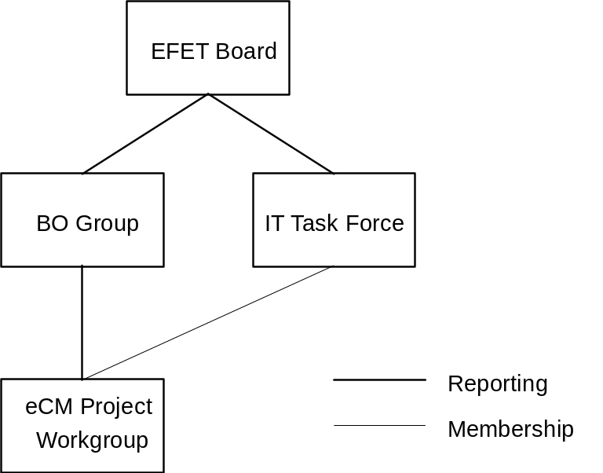

Figure 1 Organisation of the EFET working groups

Version Control
The EFET standards documentation for electronic confirmation matching comprises a single document with chapters and sections.
- The single document shall be a release item under control of the joint EFET back Office Group on behalf of the EFET Board with major versioning i.e. 1.0, 2.0, 3.0…
- Each chapter shall be a configuration item within the single document controlled by either the eCM Project Workgroup and audited via the Revision History between major releases leading to intermediate versioning i.e. 1.1, 1.2, 1.3…(Also release version with change bars)
Note that draft versions are signified by using a letter: 1.1a
The related XML Schemas are expected to be backward compatible within the same version. I.e., an EFET Box+ that is able to process Trade confirmations in version 3, release 3 is also able to process version 3, release 2 and version 3, release 1 – but not, e.g., version 2, release 3.
I.e., extensions to the EFET XML Schema within the same version, can only add optional elements or attributes or reduce the number of values in enumerations. Each EFET Box+ should therefore be able to process earlier releases within the same version.
Should different versions be supported (since individual counterparties may update their systems at different times), dedicated EFET Box+ implementations should handle version-specific eCM protocols.

Current Processes and Business Requirements

Current Business Processes

Description of Current Trade Confirmation Process
The current trade matching processes are generally paper based requiring both parties to produce documents that summarise the transaction. These documents are passed between each party to confirm that the transaction details are accurate and valid.
The main steps in the process are:
- A transaction is agreed between two parties and details of the transactions are entered into each party’s trade management system
- An internal check (usually manual) is normally undertaken by each party to ensure that the transaction details have been accurately entered into the trade management system
- A Trade Confirmation document is then generated by the trade management system. The Trade Confirmation document is checked for accuracy. The trade confirmation might also be signed by the originator (normally the Seller) as an accurate summary of the trade details and then faxed or digitally sent to the recipient party (normally the Buyer) for that transaction
- The recipient party then checks the trade confirmation. (A number of trade management systems will generate a confirmation independently of the fact that the party is the Buyer or the Seller. The Buyer will often use their version of the confirmation to check the details of the Seller’s confirmation). If the recipient party agrees with the details of the transaction, they might sign the trade confirmation to confirm that the details are accurate and valid.
- The recipient party’s signed document might then be faxed back to the originator of the confirmation. This is then a paper affirmation or authentication.
- Each party will enter information into their trade management system to indicate that the transaction has been authenticated.
- The paper work associated with the trade data capture and trade confirmations will, at an appropriate point in time, be archived and retained for a number of years (depending upon local procedures and laws)
- In the event that the transaction details are not agreed as accurate (or the Seller has not raised a confirmation):
- The party finding the mistake first will contact the other party (normally verbally) to indicate the details that are not agreed (or in the case where the Seller did not send a confirmation the Buyer will contact the Seller to indicate that the confirmation has not been received)
- After investigations the transactions details are agreed
- Steps 1 to 8 are repeated such that an accurate and confirmed transaction is recorded in each party’s trade management system.

Many variations of this process exist. Depending on the agreements (Master Agreements like EFET2.1 or industry accepted terms and conditions like NBP97) that exist between the two parties, both the Buyer and the Seller will send a confirmation or only Seller will send a confirmation and the Buyer will affirm or authenticate:
- One of the parties (logically the Seller) has to send the trade confirmation to the other party. The Buyer will then check this confirmation against its own record of the trade. If consistent he will consider the trade confirmed. He might or might not send back by fax an authentication (signed acknowledgement authenticating the confirmation). Certain parties require an authentication of their confirmation to be sent back and will systematically expect one, others will not.
- Both parties send each other the trade confirmation and each will check for itself the validity of the received party’s confirmation against its own trade data. If consistent the trade is then considered “confirmed”. Even in this case one of both parties might still send back an authentication of the received confirmation.
- In the case where a trade is concluded by mediation of an intermediary (either on an e-OTC platform or a voice broker), the intermediary sends a broker “confirmation” of the transaction to both the Buyer and the Seller. It is also customary for a trader to check at the end of the day by phone, the trades concluded via a certain broker. Some e-OTC platforms either list the executed trades or immediately after execution send an email to the trader with the trade details.
Some industry participants refer in the confirmation to an existing Master Agreement in place between both parties. In case no Master is in place, the confirmation might contain certain legal language to ensure legal enforceability of the trade.
The content of the confirmations will also typically vary according to the product (gas, power, oil, …), the transaction type (forward, day ahead, intraday, options, …), the delivery point, Master Agreement and the legal framework.
In case of a dispute, the transaction tapes or the transaction log of an e-OTC platform will always prevail on the written documents (confirmations) irrespective if they are matched or authenticated. Of course, it goes without saying, that if the confirmations match or the confirmation of the Seller is authenticated by the Buyer, it would be highly unlikely for the traders to revert successfully to the transaction tapes and the trade would stand as confirmed.
Important Note: Currently, no unique trade reference for a trading transaction exists between the parties (as is customarily the case for example for the purchase of airline tickets). Each party defines its own unique TradeID.

Issues linked to Current Process
Major issues with the current process are:
- Cost and operational risk linked to manual processing of confirmations
- Archiving cost of paperwork
- Neither the process itself nor the material terms of the trade are standard, introducing complexity in the confirmation matching process and trade follow up
- Risk linked to delay in identifications of trade data capture errors and inconsistencies between parties.

Requirements for Electronic Business Processes
The Goal of the current project is to find a common solution for the automation of the transmission, reception, matching and processing of electronic trade confirmations.
The EFET organisation itself will provide a central EFET directory service and will ensure maintenance of the standard with the publication of new codes etc… See also Section 7.5.

eCM Business Process Scope
The aim of the EFET eCM Project Workgroup is to define a “standard electronic confirmation process” and thus provide a framework enabling parties to:
- Replace the manual transfer of information with the electronic transmission of standard confirmation data between two parties (on a peer-to-peer basis)
- Facilitate the reporting and capture within their trade management systems of electronic data related to the trade confirmation process
- Legal Requirements are covered by the Master Agreement which is refer to by each trade confirmation document.
- Security Requirements are covered by using ebXML as the basic transport protocol for transfer of eCM documents.

Electronic Business Processes – Overview
This section describes the workflow defined for the standard EFET compliant eCM process. For this purpose the actors and their systems are considered to be “black boxes”. EFET has restricted itself to defining the interface requirements for the incoming and outgoing documents.
N.B. for the purpose of defining the role of Buyer and Seller for Financial Transactions where there is no exchange of any physical commodity the following convension is used within the eCM process: the party with the lower identification code value (using alphabetical sorting) shall be deemed the ‘Buyer’ and the counterparty with the higher identification code value (using alphabetical sorting) shall be deemed the ‘Seller’.

Actors and Roles

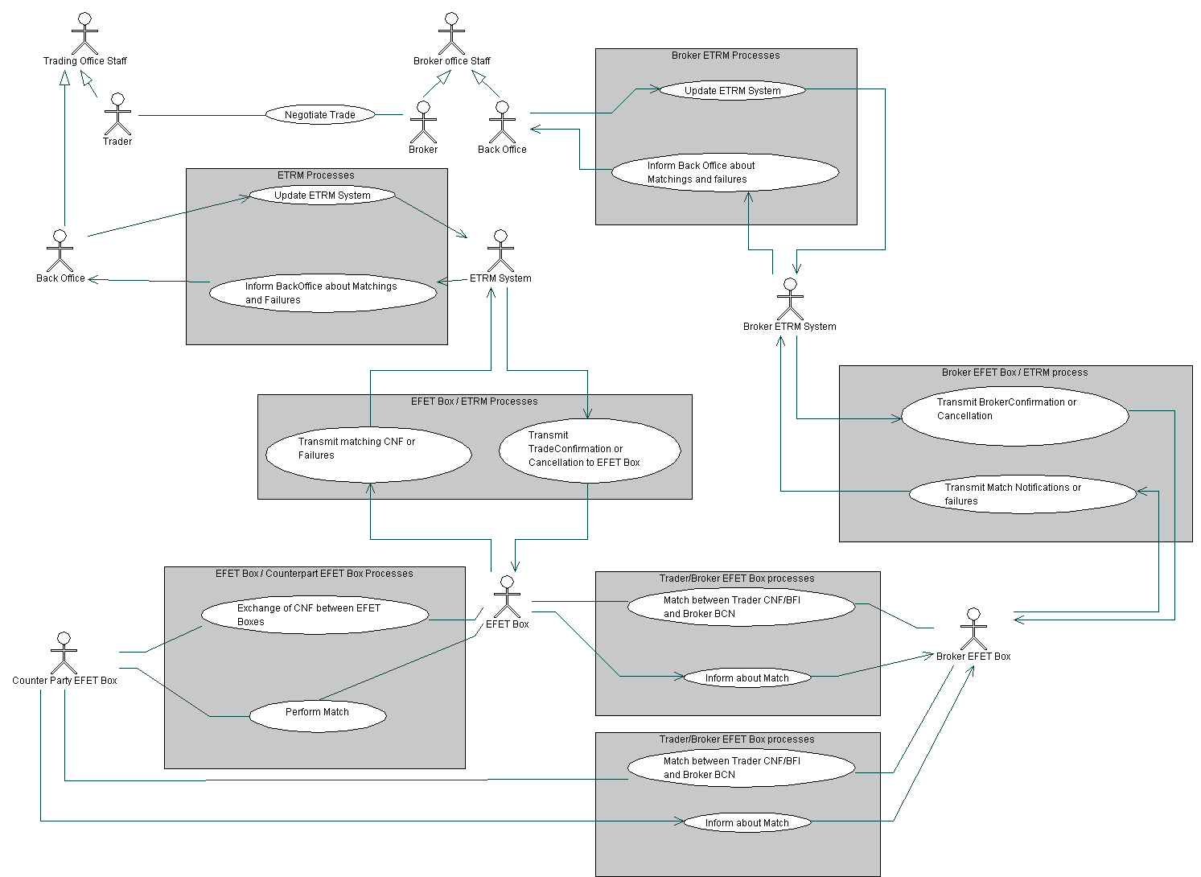

Figure 2 Use Case Diagram for eCM
The use case diagram in figure 2 provides an overview of the validation process. A trade is carried out between traders or through the help of a broker. Once the transaction has terminated, each respective information system is updated with the trade data. Each information system then transmits the trade information to the respective EFET boxes+ which send out relevant documents directly to the other EFET Box+ systems, exceptions are manually resolved.

High Level Business Document Flows

High Level Counterparty Trade Confirmation Dialogue
Both trading parties each send out one Trade Confirmation document to the other trading party and receive one trading confirmation document from the other trading party.
Both parties, through the use of an acknowledgement/rejection document, acknowledge (or eventually reject because of processing errors) the reception of a trade confirmation document.
The Buyer party for this particular trade then tries to find a match between its own Trade Confirmation document sent out to the counterparty and a Trade Confirmation document received from this counterparty.
If a match is found then the Buyer party sends out a ’Match Suggestion’ document to the Seller party.
The Seller party acknowledges the reception of a ’Match Suggestion' document through the use of the acknowledgement document or on rejection a rejection document.
If the Seller party can agree to the match suggestion made by the Buyer party then it sends out a ’Match Suggestion Acceptance’ document to the Buyer party. Otherwise it sends out a ’Match Suggestion Refusal’ document.
The Buyer party acknowledges (or rejects in case of processing errors) the reception of either the ’Match Suggestion Acceptance’ or ’Match Suggestion Refusal’ document through the use of an acknowledgement or rejection document.
If the Seller party sent a match suggestion acceptance message, which is acknowledged by the Buyer party, then an official match between two trade confirmation documents has been found.
In all other cases no match would be found.

High Level Broker Confirmation Dialogue
In the case of a brokered trade each trader optionally enters into a dialogue with the broker. This is independent of whether both counterparties also enter into a dialogue between themselves (as defined previously) or not.
The aim of this dialogue is twofold:
- to independently match some of the information in the Trade Confirmation document held by the trader(s) using third party (Broker) data held within a Broker Confirmation document issued by the broker
- to match data specific to the trader/broker relationship
The broker matching process either proceeds independently of, or may optionally be prioritised to take place before, the counterparty matching process; in either case the result of the counterparty matching process is deemed to take precedence over the broker process since the former relates directly to the confirmation of the underlying trade, whereas the latter simply corroborates the counterparty result. The broker match is therefore considered ‘preliminary’ until the counterparty match is successfully achieved. If the two counterparties do not enter into an eCM dialogue but the trader(s) and broker do, a result from the broker matching process is considered final but is qualified by the absence of a related counterparty matching process.
In their dialogue with the broker the trader, the Buyer and/or Seller, is solely responsible for all matching, the broker conducts no match but receives confirmation of the results of the matching carried out by the trader(s) through receipt of:
- Broker Match Notification document(s) issued to the broker by the trader(s) on successful ‘preliminary’ matching of the Broker Confirmation document, originally sent to the trader(s) by the broker, with data held in the traders Trade Confirmation and Broker Fee Information documents
- Broker Match Notification document(s) issued to the broker by the trader(s) on successful matching of the counterparty Trade Confirmation documents within the counterparty matching process for the same underlying trade which confers a fully matched status on any preliminary results related to the underlying transaction previously communicated by the trader(s) to the broker
- Broker Match Notification document(s) issued to the broker by the trader which reverse the results to the underlying transaction of any preliminary results previously communicated by the trader(s) to the broker(s).
If the Trader and Broker supplied information cannot be matched, manual resolution by the trader and/or broker is required.
Considering the trader/broker interaction only (which is identical for both counterparties: Buyer and Seller) the following dialogue is defined.
The broker sends the Broker Confirmation document to the Trader. This document contains the information that the Broker has about the trade and also information about the brokerage fees. Since the broker will have different and private arrangements with each trader it is necessary for the Broker to create and send different Broker Confirmation documents, one to each Trader involved in a dialogue with the Broker. Each trader responds by issuing to the broker either an acknowledgment or rejection document on receipt of the document.
The trader attempts to match the document received from the Broker, firstly with their own Trade Confirmation document and secondly with a separate Broker Fee Information document which contains the Trader’s view of the brokerage information related to the trade. The Trader uses the same Trade Confirmation document that is used in the Counterparty dialogue (if that dialogue takes place at all) so that only one single instance of the document exists simplifying the audit trail and ensuring that the same document is being matched with the Broker as is being matched with the Counterparty. However since the two Counterparties have different and private broker fee information, this data cannot be included in the Trade Confirmation document but resides in a separate but uniquely related Broker Fee Information document. The Broker Fee Information document on its own does not contain sufficient data to match it to a trade (this is done using the uniquely related Trade Confirmation document), it is in effect an extension to the Trade Confirmation document used solely to validate the broker fee information received from the Broker.
On successful matching of the trade and brokerage information the trader issues a Broker Match Notification document to the broker, which is acknowledged or rejected by the broker.
The broker matching process result is considered ‘preliminary’ until the counterparty matching process has reached the same stage, at which point another Broker Match Notification document is issued by the trader to the broker with the update of the type of the match from ‘preliminary’ to full status. If no counterparty dialogue took place for the underlying trade then the Broker Match Notification is issued as for a full match but with an indication that no counterparty dialogue occurred.
Failures or timeouts that occur during the dialogue require manual intervention by the trader and/or broker.
In all cases the instance of the Broker Confirmation document sent by the broker in this dialogue is a separate and independent document

High Level Counterparty Trade Confirmation Amendment Dialogue
A counterparty to a trade has the possibility to either amend or cancel one of its own trade confirmation documents.
If a Trade Confirmation document is allowed to be amended then the party sends out a new Trade Confirmation document to the counterparty containing the same reference number but a higher version number than the document to be amended.
The receiving party sends an acknowledgement or rejection document. If the new Trade Confirmation document is acknowledged then from this point onwards only the new version of the Trade Confirmation document may be used for further processing.

High Level Broker Confirmation Amendment Dialogue
A broker who has issued a Broker Confirmation document to a trader may amend the document.
If a Broker Confirmation document may be amended (according to the detailed rules of amendment) then the broker sends out a new Broker Confirmation document to the trader containing the same reference number but a higher version number than the document to be amended.
The trader sends an acknowledgement or rejection document. If the new Broker Confirmation document is acknowledged then from this point onwards only the new version of the Broker Confirmation document may be used for further match processing by the trader.
The Trade Confirmation document generated by the trader for the purpose of matching with the Broker Confirmation document may also be amended (subject to the detailed rules of amendment) by superseding the originally generated document with a new instance containing the same reference number but a higher version number than the document to be amended. Note that since the matching process is the sole responsibility of the trader (and not the broker) the document is not issued to the broker.
Amendment of the Trade/Broker Confirmation document will under certain circumstances result in the reversal of a ‘Preliminary Match’ according to the rules of detailed processing.

High Level Broker Fee Information Amendment Dialogue
The broker fee information document generated by the trader for the purpose of matching with the Broker Confirmation document may be amended (subject to the detailed rules of amendment) by superseding the originally generated document with a new instance containing the same reference number but a higher version number than the document to be amended. Note that since the matching process is the sole responsibility of the trader (and not the broker) the document is not issued to the broker.
Amendment of the Broker Fee Information document will under certain circumstances result in the reversal of a ‘Preliminary Match’ according to the rules of detailed processing.

High Level Counterparty Trade Confirmation Cancellation Dialogue
If a Trade Confirmation document can be cancelled then the party sends out a cancellation document to the counterparty containing the reference number of the document to be cancelled.
The receiving party sends an acknowledgement or rejection document. If the cancellation document is acknowledged then from this point onwards the cancelled Trade Confirmation document must not be used for further processing.

High Level Broker Confirmation Cancellation Dialogue
A broker who has issued a Broker Confirmation document to a trader may cancel the document.
If a Broker Confirmation document can be cancelled (subject to the detailed rules of cancellation) then the broker sends out a cancellation document to the trader containing the reference number of the document to be cancelled.
The trader sends an acknowledgement or rejection document. If the cancellation document is acknowledged then from this point onwards the cancelled Trade Confirmation document must not be used for further match processing by the trader.
The Trade Confirmation document generated by the trader for the purpose of matching with the broker supplied document may also be cancelled (subject to the detailed rules of cancellation) through generation of a cancellation document containing the reference number of the document to be cancelled. Note that since the matching process is the sole responsibility of the trader (and not the broker) the document is not issued to the broker but the broker version of the Trade Confirmation document will eventually ‘time out’ according to the appropriate process.
Cancellation of the Trade/Broker Confirmation document will under certain circumstances result in the reversal of a ‘Preliminary Match’ according to the rules of detailed processing.

High Level Broker Fee Information Cancellation Dialogue
A broker fee information document is fundamentally associated with a Trade Confirmation document. When the Trade Confirmation document is cancelled by the Trader then the Broker Fee Information document must not be used for further match processing by the trader.

High Level Acknowledgement/Rejection Dialogue
The recipient of a document will reply with either an Acknowledgement document or a Rejection document. Receipt of an Acknowledgement document will indicate that the counterparty in the dialogue has not only received the previous document issued in the course of this specific dialogue (concurrent dialogues are possible) but that the referenced document is ‘Well Processed’, that is it contains acceptable data that permits the dialogue to continue without intervention. Receipt of a Rejection document conversely will indicate that counterparty cannot proceed with the dialogue due to an exception relating to the data contained in the previous document exchanged within the dialogue to which the Rejection document explicitly refers. In this case intervention is required to resolve the exception. Such intervention may result in a Trade Confirmation Amendment dialogue or Trade Confirmation Cancellation dialogue depending on the status of the Trade Confirmation document at the time of the exception.

High Level Time Out Dialogue
When a Trade Confirmation document is not matched within a specified time period then it times out. This timeout is reported to the ETRM by the EFET eCM box and is intended to raise Back Office attention to an apparent problem with this trade confirmation document. Timed Out trade confirmation documents can be amended to solve the indicated problem.
This applies equally to a Trade/Broker Confirmation document generated by a counterparty, trader (that is a counterparty in the role of a trader in the context of a dialogue with a broker) or broker.
A Broker Fee information document is fundamentally associated with a Trade Confirmation document and does not time out itself. When a timed out Trade Confirmation document is amended the Broker Fee Information document is automatically associated to the latest version of the Trade Confirmation document.
Time Out of the Trade/Broker Confirmation document will under certain circumstances result in the reversal of a ‘Preliminary Match’ according to the rules of detailed processing.
The Time Out must occur not less than 72 business day hours after the time when the initial version of the CNF was set to ‘Pending’ and when local time next reaches 24:00. If a Trade Confirmation document is moved to the ‘Amended’ state then the time out processing will NOT be reset to start again UNLESS the Trade Confirmation document being amended was itself in the Timed Out state at the time of the amendment.

Detailed Business Document Flows

Detailed Counterparty Trade Confirmation Dialogue
The following figure shows the standard eCM message exchange between two trading parties for obtaining a match.
The communication consists of four blocks of messages with two messages in each block.
Within one block the chronological order of the messages is as indicated from top to bottom.
The first and second message block can occur in any chronological order, i.e. one after the other or in parallel.
The third message block always occurs after the first and the second message blocks.
The fourth message block always occurs after the third message block.
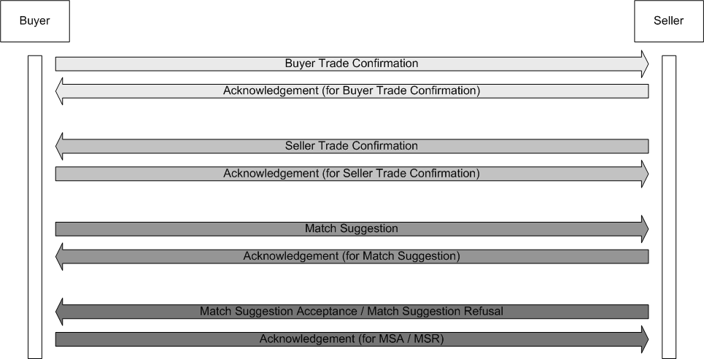

Figure 3 Counterparty Confirmation Matching Process

In the workflow outlined in Figure 3, the Buyer is considered to lead the Trade Confirmation document matching process and the Seller is considered to validate the match, as described in Section 4.2 High Level Business Document Flows. The workflow is as follows:
- Buyer sends a Trade Confirmation document to Seller.
- Seller validates this for conformity with the Trade Confirmation document schema.
- If a Trade Confirmation document is incorrect Seller rejects the trade in question via the transmission of an rejection document
- In the case where the trade is correct Seller informs Buyer of the document’s reception via the transmission of an acknowledgement document.
These first 4 steps are not dependent on the steps that follow.
- Seller sends a Trade Confirmation document to Buyer.
- Buyer validates the content of the document.
- If a trade is incorrect Buyer rejects the trade in question via the transmission of an rejection document.
- In the case where a trade is correct Buyer informs Seller that the document in question has been entered into the matching queue via the transmission of an acknowledgement document.
- Buyer matches the trade with his matching system
- In the case where there is no match, the Trade Confirmation document in both Buyer and Seller matching systems will timeout.
- In the case of a match Buyer informs Seller of the successful match via the transmission of Match Suggestion document.
- Seller acknowledges reception of the Match Suggestion document that he received via the transmission of an acknowledgement document.
- If Seller can validate the suggested match against his own version of the Trade Confirmation documents identified in the Buyer’s Match Suggestion document then he sends a Match Suggestion Acceptance document to the Buyer otherwise he sends a Match Suggestion Rejection document to the Buyer.
- Buyer acknowledges (or rejects in case of an exception) receipt of the Seller document by replying with an Acknowledgement or Rejection document.
- Auditable receipt of the Acknowledgement document from the Buyer by the Seller signals the completion of the dialogue.

Additional rules as defined by EFET:
- The Buyer shall be responsible for the transmission of the Match Suggestion document.
- The Seller shall be responsible for transmission of the Match Suggestion Acceptance or Refusal document.
- EFET requires both parties to send their Trade Confirmation document as soon as possible (best case: end of business day) but latest within the time frame agreed in the corresponding Master Agreement.
- A Match Suggestion document sent by the Buyer forms a proposal that the Seller must either accept or refuse, failure to do so results in an exception (timeout). Acceptance of the proposal by the Seller forms the basis for shared responsibility for the validity of match.

Detailed Brokered Trade Confirmation Dialogue
The following figure shows the standard eCM message exchange between a Trader and a Broker for obtaining a broker match.
The communication consists of four blocks of messages with two messages in each block.
Within one block the chronological order of the messages is as indicated from top to bottom.
The four message blocks occur in the indicated chronological order but depending on the situation it is possible that either only the third block or the second and third block are missing.

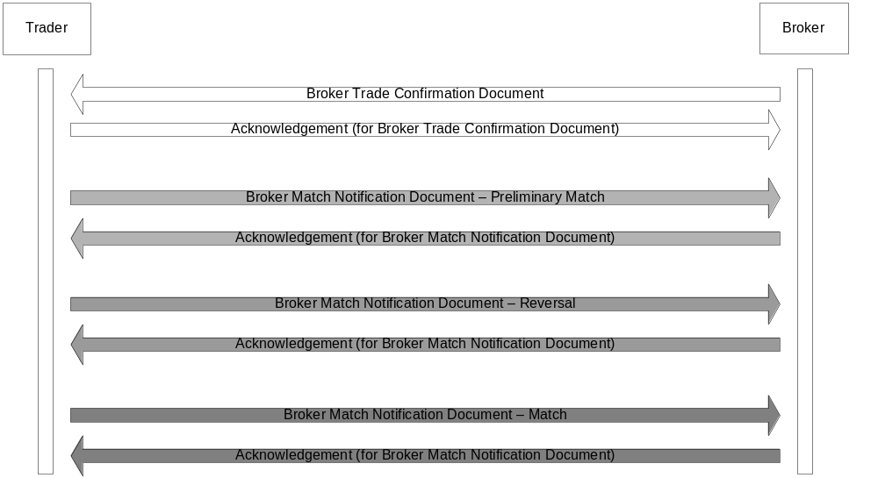

Figure 4 Broker Confirmation Matching Process

In the workflow outlined in Figure 4, the Trader is solely responsible for the matching process and unlike the Counterparty dialogue the other party, the Broker, does not participate in the matching process but is simply informed of the result by the Trader, as described in Section 4.2 High Level Business Document Flows.
Furthermore the Broker may be involved in two such dialogues, one with one counterparty to the underlying trade and one with the other counterparty. The counterparties may themselves be engaged in a Counterparty Trade Confirmation dialogue with one another.
The workflow for the Broker Confirmation process is as follows:
- Broker sends a Broker Confirmation document to Trader.
- Trader validates this for conformity with the Broker Confirmation document schema.
- If a Broker Confirmation document is incorrect Trader rejects the trade in question via the transmission of an rejection document
- In the case where the Broker Confirmation document is correct Trader informs Broker of the document’s reception via the transmission of an acknowledgement document.
The workflow then continues with the matching results qualified by the status of the counterparty dialogue for the same underlying transaction, three possible circumstances are considered:
- The counterparty dialogue has achieved Matched status in which case the results of the broker matching process are final and may not be reversed
- The counterparty dialogue has not yet achieved Matched status in which case the result of the broker matching process are preliminary and may be reversed
- These two counterparties do not support eCM between themselves in which case the results of the broker matching process are final and may not be reversed but the absence of a counterparty dialogue (and therefore match) is recorded and notified to the Broker in the Broker Match Notification document.
- Trader compares the Broker Confirmation document received from the Broker with his own version of the Trade Confirmation document using the mandatory, key trade data fields defined for the Broker Confirmation document (but excluding the fields related to brokerage fees) of which the mandatory, key fields defined in the Trade Confirmation document are a superset.
- In the case of an apparent match being found between two Trade Confirmation and Broker Confirmation documents, based on comparison of the trade data fields, the Trader retrieves the Broker Fee Information document linked to the apparently matched Trade Confirmation document and compares the content of the Broker Fee Information document with the mandatory, key brokerage fee data fields defined in the Broker Confirmation document.
- In the case of a Preliminary Match between two Trade/Broker Confirmation documents and related brokerage fee information the identifiers of the two Trade/Broker Confirmation documents are recorded in the Broker Match Notification document which is then issued by the Trader to the Broker.
- Broker acknowledges reception of the Broker Match Notification document that he received via the transmission of an acknowledgement document and proceeds with the next stage of the matching process.
- Whilst the match remains Preliminary (meaning that a Counterparty dialogue can occur but is yet to achieve a match) the dialogue remains active until such time as the matched status moves from preliminary to final and another Broker Notification document is issued as described in (7) above or other permitted processing occurs which results in the issue of a Broker Notification document which reverses the preliminary match status in accordance with the detailed processing description.
- Auditable receipt of the Acknowledgement document from the Broker by the Trader in response to notification of a full Match (meaning that the counterparty dialogue has achieved Matched status or in the case that there is no counterparty dialogue) signals the completion of the dialogue.
Additional rules as defined by EFET:
- EFET requires Broker to send the Broker Confirmation document before end of business day of the trade date (8pm CET).
- A permitted variation to the process described above allows either or both counterparties to delay transmission of their Trade Confirmation documents to the trading counterparty until after preliminary matching of their own Trade Confirmation document with the Broker Confirmation document has been successfully achieved. In the case of subsequent amendments to the confirmation documents, new versions are released immediately to both the counterparty and broker dialogue. This is to avoid the risk that a broker matched trade Confirmation, released into the counterparty dialogue, is progressed to a Matched state whilst a newly amended version of the document is submitted to the broker dialogue.
N.B. An alternative mechanism would be to Cancel the current version of the Trade Confirmation document (in both dialogues) and resubmit the new version. However this requires a change to the Cancellation processing which breaks backward compatibility and thus may only be considered in a later non-backwardly compatible version of the standard..

Detailed Counterparty Trade Confirmation Amendment Dialogue
A party can always send an amended version of a previously sent trade confirmation, using the same DocumentID and an augmented version number. The amended Trade Confirmation document will supersede the previously sent Trade Confirmation document if this document has not been referenced in a Match Suggestion issued by the Buyer and received by the Seller. Once a Trade Confirmation has been assigned a status other than ‘Pending’, ‘Timed Out’, ‘Not Sent’ or ‘Failed’, for the current or any earlier versions, it cannot be subject to amendment.
N.B. The state of the original Trade Confirmation document will be set to ‘Amended’ in both the Counterparty and Broker Dialogue since the same single document participates in both processes.

Detailed Broker Confirmation Amendment Dialogue
The Broker can always send an amended version of a previously sent Broker Confirmation document, using the same DocumentID and an augmented version number.
Likewise the Trader can also generate an amended local copy of a previously generated Trade Confirmation document (as described above in Section Detailed Counterparty Trade Confirmation Amendment Dialogue), using the same DocumentID and an augmented version number.
An amended Trade/Broker Confirmation document will supersede a previous Trade/Broker Confirmation document. Once a Trade/Broker Confirmation has been assigned a status other than ‘Pending’, ‘Timed Out’, ‘Not Sent’, ‘Preliminary Matched’ or ‘Failed’, for the current or any earlier versions, it cannot be subject to amendment.
If the status of the Trade/Broker Confirmation documents are ‘Preliminary Matched’ then the unamended document’s status is reset to ‘Pending’ and a reversal Broker Notification document is issued to the broker by the Trader.
N.B. The state of the original Trade Confirmation document will be set to ‘Amended’ in both the Counterparty and Broker Dialogue since the same single document participates in both processes.

Detailed Broker Fee Information Amendment Dialogue
The Trader can generate an amended local copy of a previously generated Broker Fee Information document, using the same DocumentID and an augmented version number.
An amended Broker Fee Information document will supersede a previous Broker Fee Information document. Each Broker Fee Information document is linked to a Trade Confirmation document, once the Trade Confirmation document has been assigned a status ‘Matched’ (with a Broker Confirmation Document in the broker dialogue rather than with a counterparty confirmation document in the counterparty dialogue) the Broker Fee Information document cannot be subject to amendment.
If the status of the Trade/Broker Confirmation documents are ‘Preliminary Matched’ then the Trade/Broker Confirmation documents’ status is reset to ‘Pending’ and a reversal Broker Notification document is issued to the broker by the Trader.

Detailed Trade Confirmation Cancellation Dialogue
If a party wants to cancel a Trade Confirmation document, they send a Cancellation document to the other party. The Cancellation document needs to refer to an existing Trade Confirmation document in the system of the receiver. A cancellation of a confirmation is successfully processed when the cancellation could be carried out, i.e. the referenced trade has been taken out of the matching queue and has received the status “cancelled” in the receiving system. The cancellation document will only cancel the Trade Confirmation document if it has the status of ‘Pending’ or ‘Not Sent’. Once a Trade Confirmation has been assigned the status other than ‘Pending’ or ‘Not Sent’ it cannot be cancelled.

Detailed Broker Confirmation Cancellation Dialogue
The Broker can cancel a Broker Confirmation document that has been submitted to the Trader for match processing, by sending to a Cancellation document to the Trader.
Likewise the Trader can also generate a local Cancellation document to cancel a Trade Confirmation document that has previously been submitted for match processing (as described above in Section Detailed Trade Confirmation Cancellation Dialogue).
Once a Trade/Broker Confirmation has been assigned a status other than ‘Pending’, ‘Not Sent’, or ‘Preliminary Matched’ it cannot be subject to Cancellation.
If the status of the Trade/Broker Confirmation documents are ‘Preliminary Matched’ then the uncancelled document’s status is reset to ‘Pending’ and a reversal Broker Notification document is issued to the broker by the Trader.

Detailed Acknowledgement and Rejection Dialogue
The delivery of each document (with the exception of the Acknowledgement or Rejection documents) at each stage of the eCM dialogue is followed by the transmission of an Acknowledgement or Rejection document. Failure to receive either document in response to a transmission will result in an exception on the sender side requiring intervention.

Detailed Time Out Dialogue
No documents are exchanged as a result of a Time Out.

Legal and Confidentiality Issues
For the legal validity of the electronic documents, EFET refers to the Master Agreement in place between participants for the legal issues. The Master Agreement will typically describe the legal specifications of electronic transactions.
Similarly the Master Agreement should contain a confidentiality clause applying to the trade confirmation data sent over to counter parties.

Business Document Processing

‘Suggested Match’ Processing
The Buyer is responsible for identifying Suggested Matches by correlating documents from within the set of Buyer and Seller side Trade Confirmation documents. The process is continuous whilst Trade Confirmation documents with the status of ‘Pending’ exist within the document set.
Note that the mandatory, key fields used in the matching algorithm are defined by this standard as sufficient to adequately distinguish an underlying trade for the purposes of confirmation matching.
The following specific rules define when two documents may be considered identical for business purposes:
- Two Trade Confirmation document field values (XML attributes or elements) are called identical if they consist of the same sequence of characters. Leading and trailing blanks are not accepted within document fields. Should the values be based on a numeric data type, the respective formatting rules apply. I.e., 1.0 matches with 1 or 100 matches 10E2. Equality of values is given if two numeric values are considered equal according to the XML Schema standard (http://www.w3.org/TR/xmlschema-2/).
- Two Trade Confirmation document sections are called identical if the respective values of all key fields are identical. A section is defined as a sequence of XML elements. Such a sequence may either be the header part of a document or a repeatable section. Optional document fields (e.g. "TradeTime") and substructures (e.g. "OptionDetails") count as part of the section.
- Independent of the cardinality of an XML section, a repeatable section may be ordered or unordered. If a repeatable section is ordered, the order of the sections is defined by their sequential appearance.
- Two lists of an ordered repeatable Trade Confirmation document section are called identical if both lists contain the same number of sections and if the n-th section of the one list is identical to the n-th section of the other list where n is between 1 and the length of the sequences.
- Two lists of an unordered repeatable Trade Confirmation document section are called identical if there exists a one-to-one mapping between the sections of the one list and the sections of the other list such that each pair of sections is identical and all sections can be mapped.
- Two different Trade Confirmation documents are considered identical if there exists
  - a one-to-one mapping between all corresponding lists of ordered repeatable sections of the two documents such that each pair of sequences is identical,
  - a one-to-one mapping between all corresponding lists of unordered repeatable sections of the two documents such that each pair of sequences is identical,
  - a one-to-one mapping between the two sets of remaining sections of the two documents such that each pair of sections is identical.

‘Suggested Match Acceptance/Refusal’ Processing
The Seller is responsible for validating Suggested Matches received from the Buyer with the aim of confirming a ‘Match’, as defined by the eCM Standards, between two documents with the set of Buyer and Seller side Trade Confirmation documents.
The Seller shall use information in the Match Suggestion document, received from the Buyer, uniquely identifying two documents. The Seller shall issue a MatchSuggestionAcceptance if the two documents are found to conform to the eCM Standard rules for identification of identical documents, otherwise a MatchSuggestionRefusal shall be issued by the Seller.
If the Seller issued a MatchSuggestionRefusal document, a related ReasonCode must be provided to the Buyer. Any further agreement will have to be done directly between the respective back office staff members.

‘Trade Data’ and Broker ‘Match’ Processing
Within the context of the Broker Confirmation dialogue two phases of match processing occur:
- Trade Data Match processing, which compares trades data information held within the Trade and Broker Confirmation documents takes place first
- Broker Match Processing, which compares the Broker Fee Information document from the Trader with the brokerage fee fields within the Broker Confirmation document and which follows on from the successful pairing of a Trade Confirmation document with a Broker Confirmation document through the Trade Data Match processing
The Trader is responsible for all match processing and for informing the Broker of the results of match processing.
Trade Data Match processing is concerned with correlating Trade/Broker Confirmation documents based of mandatory, key fields that are defined by this standard as sufficient to adequately distinguish an underlying trade for the purposes of confirmation matching, from within the set of Trader and Broker side Confirmation documents. It is only the Trader who can carry out this processing as the Broker does not receive the Trader side documents and therefore does not have a full set of documents to process.
The Trade Data Match process is similar to the ‘Suggested Match’ process but uses a subset of the mandatory, key fields as the broker does not hold all the information that a counterparty to the trade has and match processing is continuous whilst Trade/Broker Confirmation documents with the status of ‘Pending’ exist within the Trader/Broker document set.
Broker Match processing is similar to ‘Suggested Match Acceptance/Refusal’ processing insofar as it is contingent on Trade Data Match processing and uses the unique DocumentID of the Trader Confirmation document output from that process to retrieve the Broker Fee Information document which is then compared with the brokerage fee related data contained within the Broker Confirmation document.

Avoiding Race Conditions between two EFET Boxes+
The state diagram in Error: Reference source not found uses the states “Pending”, “Potential Match”, “MatchSuggested”, and “Matched” to reflect the processing sequence alongside the execution of the eCM protocol as defined in Section 4.3. This approach also avoids race conditions introduced by intermediate amendments that would lead to intermediate version changes and could spoil a match.
Moreover, whenever an Amendment is sent to the counterparty, the full process of this document transfer must be finalised before any later document is transferred that occurs later in the process: If the sending of an Amendment crosses the sending of a MatchSuggestion, the Seller will not respond to the MatchSuggestion unless a response for the Amendment is received. The Buyer, however, will reject this Amendment since the MatchSuggestion was sent before. Therefore, the Match will be processed based on the second-last version of the Seller’s document.

Trade Confirmation document Time Outs
The timeout period starts for the initial version of a Trade Confirmation document when the sender (countrerparty, trader or broker) receives back the eCM Acknowledgement document from the recipient of the Trade Confirmation document.
The timeout period ends on the third business day after its start at 10pm CET. This helps avoiding race conditions between two documents that time out during the office hours with only a short difference in time.
A Business Day is defined as for the EFET Payment Netting standards calendar.
The time-out period is not affected by amendments if the amended document has status “Pending”. A Trade Confirmation document amending a timed out document is also viewed as the initial version of a Trade Confirmation document as far as timeout periods are concerned.
See also EFET Annex to master agreement regarding legal validity of electronic confirmation matching.
Time-outs are primarily processed by the EFET Box+. It is a question of local implementation how this is notified to the ETRM system or the back-office staff.

Matching Process and State Transitions
For one Trade Confirmation document there can exist at most one corresponding trade confirmation from the counterparty. Once a particular Trade Confirmation document is involved in a match suggestion then either this match is accepted or not but in either case the Trade Confirmation document reaches a status which is final, i.e. which does not change ever again (Matched, Time Out/ Amended).

Electronic Business Processes – by Document Types
This section has to be read in conjunction with the appendix Definition of eCM Types and Codes.
Said appendix provides the reference to the list of all the types and codes that are valid within the eCM. Wherever this document is referenced the codes associated with the attribute referenced must be obtained from this source. In particular the code lists contained in the appendix may evolve independently from this section.

Naming and Typing Conventions
Document rules check the validity of data within a given document against the document type definition.
Agreed abbreviations for document types:
- “CNF” for Trade Confirmation
- “REJ” for Rejection
- “MSU” for Match Suggestion
- “MSA” for Match Suggestion Acceptance
- “MSR” for Match Suggestion Refusal
- “CAN” for Cancellation
- “ACK” for Acknowledgement
- “BFI” for Broker Fee Information
- “BMN” for Broker Match Notification
- “BCN” for Broker Confirmation

- Partner Identification
The IDs used in Trade Confirmation, Match Suggestion, Match Suggestion Acceptance, Match Suggestion Refusal, Cancellation, Rejection and Acknowledgement documents will be globally unique IDs (EIC Codes).

- Document IDs
Often, documents are listed in reporting tools, as XSL stylesheets, etc. To provide a common syntax that is comprehensible and maintains uniqueness, a rule for creating unique Document IDs is defined as follows:
A composition of the following components:
- Document type abbreviation (e.g. “CNF” for Trade Confirmation)
- DateCode (8 characters, in yyyymmdd format),
- Locally & daily unique TradeID (min. 10 characters) of the sender side
- “@”
- Sender identification, i.e. domain name or EIC Code of the sender.
Examples:
CNF_20040610_1234567890@electrabel.com
MSA_20040610_1234567890@11XELECTRABEL--Z
This document ID shall correspond with the MessageID of the ebXML Message Service and should be comprehensible for human users.
N.B. This is a convention but it is mandated for compliancy with the eCM Standard and must be used for document types as it is believed that it makes document tracking easier.
- Document Types
There is no DocumentType field any more since document types can be derived from the XML Schema reference in a document instance. Moreover, the root element can be used to derive the document type.

Trade Confirmation

Overview
Each field in a Trade Confirmation document is either a key or an informational field.
- Key fields are those fields that play a role in the definition of a match between two trade confirmation documents.
- Information fields are for information only and not used in matching.
All key fields used in matching are either mandatory or conditional, informational fields are optional
- Mandatory fields must always be included in a compliant document
- Conditional fields are mandatory only under certain circumstances which depend on the values of other data elements within an XML schema. Rules either within the following table or in a separate business rules section after the table are used to express the conditions.

Trade Confirmation – Document Root

Table 1: Specification of Trade Confirmation Elements
Name | Mandatory/ Optional/ Conditional | Type | Key/ Information | Business Rule
Section: Document Header
DocumentID | Mandatory | IdentificationType | Information | The sender generates this ID that must be a unique reference compliant with naming standard defined in 5.1 Naming and Typing Conventions.  When a party receives a trade confirmation with an ID unknown to the receiver then the receiver must treat this document as the initial version of a new trade confirmation document. Otherwise the receiver must treat this document as an amendment of an already sent Trade Confirmation document (see field “Document Version”).
Document Usage | Mandatory | UsageType | Information | “Test” or “Live”
SenderID | Mandatory | PartyType | Information | EIC Code of Sender
ReceiverID | Mandatory | PartyType | Information | EIC Code of Receiver, brokerID in case only Broker is involved.
Receiver Role | Mandatory | RoleType | Information | Trader role applies if the document is being sent to the other party involved in the trade  Agent role applies if the document is in effect a carbon copy of the main confirmation document.
Document Version | Mandatory | VersionType | Information | The version number is always associated the Document ID. It is used to distinguish and order the initial Trade Confirmation document and all its amendments over time. A fixed first version number for the initial Trade Confirmation document is not defined (see field “Document ID”). When a party receives a Trade Confirmation document with an ID already used by the same sender (either a counterparty or its own ETRM) in a previous Trade Confirmation document then the receiver must first check if there exists a Trade Confirmation document from this sender with this ID and a lower version number and in an ‘amendable’ state. If this is not the case then the receiver must send a rejection document. Otherwise the Trade Confirmation document gets the new status “Amended” and the just received Trade Confirmation document gets status “Pending”.  All state processing is described in detail in Chapter 6 State Processing
Market | Conditional | CountryCodeType | Key | If ‘TransactionType’ is a ‘Financial Transaction’  Or if ‘Commodity’ = ‘EUAPhase_1’ or ‘EUAPhase_2’ then this field:  a) must be omitted;  else this field is  b) Mandatory and Key
Commodity | Conditional | EnergyProductType | Key | If ‘TransactionType’ is a ‘Financial Transaction’ then this field:  a) must be omitted;  else this field is  b) Mandatory and Key
Transaction Type | Mandatory | TransactionType | Key
Delivery Point Area | Conditional | AreaType | Key | If ‘TransactionType’ is a ‘Financial Transaction’  Or if ‘Commodity’ = ‘EUAPhase_1’ or ‘EUAPhase_2’ then this field is:  a) must be omitted;  else this field is  b) Mandatory and Key
Buyer Party | Mandatory | PartyType | Key | If ‘TransactionType’ = “FXD_SWP” or “FLT_SWP” then this field:  must be the highest (using alphabetical sorting) EIC code of the two parties to the deal ;  If ‘TransactionType’ = “DAH” or “IND” or “FOR” or “PHYS_INX” then this field:  must be the EIC code of the buyer in the deal  If ‘TransactionType’ = “OPT” or “OPT_PHYS_INX” or “OPT_FIN_INX” or “OPT_FXD_SWP” or “OPT_FLT_SWP” then this field:  must be the EIC code for the Option Holder.  N.B. it is the party identified in this field that initiates the eCM process and issues a Match Suggestion document.
Seller Party | Mandatory | PartyType | Key | If ‘TransactionType’ = “FXD_SWP” or “FLT_SWP” then this field:  must be the lowest (using alphabetical sorting) EIC code of the two parties to the deal ;  If ‘TransactionType’ = “DAH” or “IND” or “FOR” or “PHYS_INX” then this field:  must be the EIC code of the seller in the deal  If ‘TransactionType’ = “OPT” or “OPT_PHYS_INX” or “OPT_FIN_INX” or “OPT_FXD_SWP” or “OPT_FLT_SWP” then this field:  must be the EIC code for the Option Writer.  N.B. it is the party identified in this field that responds to a Match Suggestion document within the eCM process.
Load Type | Conditional | ContractType | Key | See TRC010 below for business rule details.  If ‘TransactionType’ is a ‘Financial Transaction’  Or if ‘Commodity’ = ‘EUAPhase_1’ or ‘EUAPhase_2’ then this field is:  a) must be omitted;  else this field is  b) Mandatory and Key
Agreement | Mandatory | AgreementType | Key | Reference to Master Agreement Model Contract  If ‘TransactionType’ = “FOR”, “IND”, “DAH” or “OPT” then the following validation must be applied:  If ‘Commodity’ = ‘EUAPhase_1’ or ‘EUAPhase__2’ then the following values are valid:  - “ISDA” where the underlying agreement is ISDA;  - “EFET” for EFET agreements,  - “IETA” for IETA trades;  else the following values are valid:  - “GTMA” for the UK electricity market  - “NBP97” for the UK gas market  - “EFET” for EFET agreements (N.B this value is common to EUA certificate and energy commodities)  - “Zebrugge” for deliveries to the Zebrugge hub  - “Other” for trades under other master agreements; this value is NOT validated against any specific market or delivery point.  Else  Any valid value as defined in Appendix A.2 eCM Field Types may be used.
Currency | Mandatory | CurrencyCodeType | Key | With boolean Attribute “UseFractionUnit” to indicate that “Pence” is used instead of “GBP”. This attribute becomes mandatory when issuing CNF documents for the networks that utilize pence. (i.e. UK NBP and Belgium)  If ‘Commodity’ = ‘EUAPhase_1’ or ‘EUAPhase_2’ then the value of this field must be set to the ISO currency code for Euros only.  N.B. For Financial Transactions this is the “Settlement Currency”
Total Volume | Mandatory | QuantityType | Key | If ‘Commodity’ = ‘EUAPhase_1’ or ‘EUAPhase_2’ then the value of this field must be Integer; between 1 and 8 significant figures.  N.B. For Financial Transactions this is the “Total Notional Quantity”  N.B. For Financial Transactions this field shall be rounded to 2 decimal places..
Total Volume Unit | Mandatory | UnitOfMeasureType | Key | If ‘Commodity’ = ‘EUAPhase_1’ or ‘EUAPhase_2’ then the value of this field must be “EUA” thus with “Total Volume” expressing the total number of EUA certificates in the underlying transaction.  N.B. For Financial Transactions this is the “Notional Capacity Unit”
Trade Date | Mandatory | DateType | Key | This date is based on clock time, not a specific time zone.
Trade Time | Optional | TimeType | Information | This time is expressed as clock time.
Trader Name | Optional | NameType | Information
Capacity Unit | Conditional | UnitOfMeasureType | Key | If ‘TransactionType’ is a ‘Financial Transaction’  Or if ‘Commodity’ = ‘EUAPhase_1’ or ‘EUAPhase_2’ then this field is:  a) must be omitted;  else this field is  b) Mandatory and Key
PriceUnit/Currency | Conditional | CurrencyCodeType | Key | The currency unit used to express this price unit must fit to the currency given in field “Currency”.  With Boolean Attribute “UseFractionUnit” = ‘TRUE’ to indicate for example, that “Pence” is used instead of “GBP”. This attribute must be set = “TRUE” when issuing CNF documents for the networks that utilize pence or other fractional usnits. (i.e. UK NBP and Belgium).  If ‘TransactionType’ is a ‘Financial Transaction’  Or if ‘Commodity’ = ‘EUAPhase_1’ or ‘EUAPhase_2’ then this field is:  a) must be omitted;  else this field is  b) Mandatory and Key
PriceUnit/CapacityUnit | Conditional | UnitOfMeasureType | Key | Shall be expressed in units of rate of flow (power) rather than energy, for example, a gas deal on the UK network will be expressed as: p/ThermPerDay; or for a power deal EUR/MW.  If ‘TransactionType’ is a ‘Financial Transaction’  Or if ‘Commodity’ = ‘EUAPhase_1’ or ‘EUAPhase_2’ then this field is:  a) must be omitted;  else this field is  b) Mandatory and Key.
TotalContractValue | Conditional | PriceType | Key | An XML choice below TradeConfirmation.  If ‘TransactionType’ = “DAH”, “IND”, FOR” or “OPT” then this field:  a) is Mandatory and Key  otherwise  b) must be omitted
Rounding | Conditional | RoundingType | Key | If ‘TransactionType’ is a ‘Financial Transaction’ or “PHYS_INX” or “OPT_PHYS_INX” then this field:  a) is Mandatory and Key  otherwise  b) must be omitted
Common Pricing | Conditional | CommonPricingType | key | If ‘TransactionType’ is a ‘Financial Transaction’, or “PHYS_INX” or “OPT_PHYS_INX” then this field:  a) is Mandatory and Key  otherwise  b) must be omitted  If all holiday calendars happen to be the same then Common Pricing must, by default, be set to ‘True’
Order Number | Conditional | IdentificationType | Key | If ‘TransactionType’ is a ‘Financial Transaction’, or “PHYS_INX” or “OPT_PHYS_INX” then this field:  a) is Mandatory and Key if the deal has an Order Number  otherwise  b) must be omitted
Effective Date | Conditional | DateType | Key | If ‘TransactionType’ is a ‘Financial Transaction’ then this field:  a) is Mandatory and Key  otherwise  b) must be omitted  “Effective Date” is ISDA terminology, means Start Date
Termination Date | Conditional | DateType | Key | If ‘TransactionType’ is a ‘Financial Transaction’ then this field:  a) is Mandatory and Key  otherwise  b) must be omitted  “Termination Date” is ISDA terminology, means End Date
Conditional Ordered Repeatable Section below TradeConfirmation: TIME INTERVAL QUANTITIES (1-N)
Ordered by adjacent intervals.
This section must not be used when TransactionType is a ‘Financial Transaction’
This section must not be used when ‘Commodity’ = ‘EUAPhase_1’ or ‘EUAPhase_2’.
DeliveryStartDateAndTime | Mandatory | ClockDateTimeType | Key | Format: As defined in the XML Schema Standard. This date and time are expressed in clock time.  Within this ordered repeatable section this date and time must either be the same as or be after the date and time given in the previous Delivery End Date and Time field (if it exists).
DeliveryEndDateAndTime | Mandatory | ClockDateTimeType | Key | Format: As defined in the XML Schema Standard. This date and time are expressed in clock time.  This point in time is exclusive with respect to the specified delivery period, i.e. this point in time is the first second after the specified delivery period ended. Hence this delivery end date and time must be after the associated delivery start date and time.
Contract capacity | Mandatory | QuantityType | Key | See Section A.1 Core Components
Price | Conditional | PriceType | Key | If the element “TotalContractValue” is used then this field must be present. Otherwise it must not be present.
Conditional Unordered Repeatable Section below as XML choice below TradeConfirmation: PRICING SCHEME = IND (1-N) for each index
As Choice next to TotalContractValue and FloatPriceInformation
This section must not be used. It is retained for reasons of backwards compatibility with earlier version of the version 3 schema set.
PricingSchemeIndex/ ID | Mandatory | IndexIDType | Key | Must occur at most once in this repeatable section.
PricingSchemeIndex/ Name | Mandatory | NameType | Information
PricingSchemeIndex/ Currency | Mandatory | CurrencyCodeType | Key | ISO currency code
PricingSchemeIndex/  Price Unit/Currency | Conditional | CurrencyCodeType | Key | The currency unit used to express this index price unit must fit to the currency given in field “PricingSchemeIndex/ Currency”  If ‘Commodity’ = ‘EUAPhase_1’ or ‘EUAPhase_2’ then this field is:  a) must be omitted;  else this field is  b) Mandatory and Key
PricingSchemeIndex/  Price Unit/Capacity | Conditional | UnitOfMeasureType | Key | If ‘Commodity’ = ‘EUAPhase_1’ or ‘EUAPhase_2’ then this field is:  a) must be omitted;  else this field is  b) Mandatory and Key
PricingSchemeIndex/ Increment | Mandatory | PriceType | Key | Adopts the same currency unit as expressed in “PricingSchemeIndex/  Price Unit/Currency”.
PricingSchemeIndex/ Cap | Optional | PriceType | Key | This field must be present if and only if the specified index has a cap.
PricingSchemeIndex/ Collar | Optional | PriceType | Key | This field must be present if and only if the specified index has a floor.
PricingSchemeIndex/ Basket Ratio | Mandatory | Ratio | Key | All index basket ratios given in this repeatable section (if it is present) must add up to 100.
Conditional Unordered Repeatable Section below TradeConfirmation: Agents (0-N)
For each agent specified in a Trade Confirmation document the following fields must be present.
AgentType | Mandatory | AgentType | Key
Agent Name | Optional | NameType | Information
Details for ‘AgentType’ = “ECVNA” as XML choice below Agent
This agent must appear if and only if the market has been defined as GB and the commodity has been defined as a power commodity
BSC Party ID | Mandatory | BSCPartyIDType | Key
Buyer Energy Account | Mandatory | EnergyAccountType | Key
Seller Energy Account | Mandatory | EnergyAccountType | Key
Buyer ID | Mandatory | BSCPartyIDType | Key
Seller ID | Mandatory | BSCPartyIDType | Key
Details for AgentType = ”Broker”, as XML choice below Agent
Broker ID | Mandatory | BrokerIDType | Key
Conditional Section: HUB CODIFICATION INFORMATION –
This section must be present if and only if the value of field “Commodity” is equal to “Gas” otherwise it must not be present.
Buyer Hub Code | Mandatory | IdentificationType | Key | Identifying the Buyer with the hub network.  For the UK market, this is the “Buyer AT Link Reference”.
Seller Hub Code | Mandatory | IdentificationType | Key | Identifying the Seller with the hub network.  For the UK market, this is the “Seller AT Link Reference”.
Conditional Section below TradeConfirmation: ACCOUNT AND CHARGE INFORMATION
This section must be present if and only if the value of field “Commodity” is equal to “Power” and the market has been defined as GB.
Seller Energy Account Identification | Mandatory | IdentificationType | Key | Consumption or production account.
Buyer Energy Account Identification | Mandatory | IdentificationType | Key | Consumption or production account.
Notification Agent | Optional | PartyType | Key | Party responsible for notifying the transaction to the Energy Contract Volume Aggregation Agent (ECVAA).
Transmission charge Identification | Mandatory | IdentificationType | Key | Indicates how transmission charges are allocated. The requirements are either Schedule 5 on or Schedule 5 off.

Trade Confirmation Section XML Schema
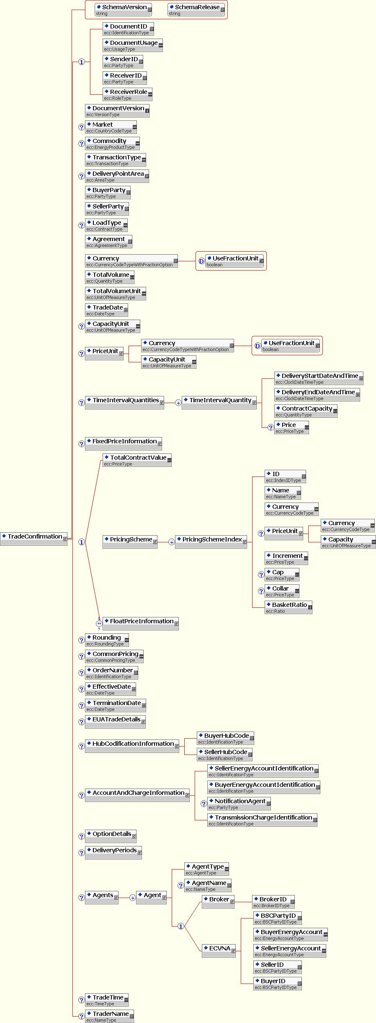

Trade Confirmation – EUA Trade Details

Conditional Section below TradeConfirmation: EUA Trade Details
Only used when ‘Commodity’ = ‘EUAPhase_1’ or ‘EUAPhase_2’.
Price | Conditional | PriceType | Key | If the element “TotalContractValue” is used then this field must be present. Otherwise it must not be present.
Emissions Delivery Date | Mandatory | DateType | Key | e.g. 1st December 2005  This will be the contractual delivery date.  Note that in some cases the contractual delivery date may differ from the actual delivery date due to the contractual delivery date falling on a non business day in one or both registry countries.
Buyer Delivery Account | Optional | EUAAccountCodeType | Infomation

EUA Trade Details Section XML Schema
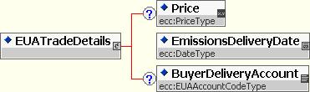

Trade Confirmation – Option Details

Conditional section below TradeConfirmation: OPTION DETAILS
This section must be present if and only if the value of field “Transaction Type” = “OPT” or “OPT_PHYS_INX” or “OPT_FXD_SWP” or “OPT_FLT_SWP” or “OPT_FIN_INX”.
Options Type | Mandatory | OptionType | Key
Option Writer | Mandatory | PartyType | Key | Use EIC Code
Option Holder | Mandatory | PartyType | Key | Use EIC Code
Option Style | Mandatory | OptionStyleType | Key
Strike Price | Conditional | PriceType | Key | See business rules TRC013 and TRC017
IndexStrikePriceStyle | Conditional | IndexStrikePriceStyleType | Key | If ‘TransactionType’ = “OPT_PHYS_INX” or “OPT_FIN_INX” and ‘Strike Price’ = “0” then this field is:  1) is Mandatory and Key  Otherwise  2) it must be omitted  See business rule TRC013
Second Strike Price | Conditional | PriceType | Key | If ‘OptionStyle’ = “Collar” then this field is:  1) is Mandatory and Key  Otherwise  2) it must be omitted  See business rule TRC017
Capped Price | Conditional | PriceType | Key | If ‘OptionType’ = “Capped_Call” then this field is:  1) is Mandatory and Key  Otherwise  2) it must be omitted  See business rule TRC016
Floored Price | Conditional | PriceType | Key | If ‘OptionType’ = “Floored_Put” then this field is:  1) is Mandatory and Key  Otherwise  2) it must be omitted  See business rule TRC016
Option Currency | Conditional | CurrencyCodeType | Key | The currency of the Strike Price, Second Strike Price, Capped Price, and the Floored Price.
Premium Rate | Mandatory | PriceType | Key
Premium Currency | Mandatory | CurrencyCodeType | Key
Premium Unit/Currency | Conditional | CurrencyCodeType | Key | If ‘Commodity’ = ‘EUAPhase_1’ or ‘EUAPhase_2’ then this field is:  a) must be omitted;  else this field is  b) Mandatory and Key
Premium Unit/Capacity | Conditional | UnitOfMeasureType | Key | If ‘Commodity’ = ‘EUAPhase_1’ or ‘EUAPhase_2’ then this field is:  a) must be omitted;  else this field is  b) Mandatory and Key
Total Premium Value | Mandatory | PriceType | Key | Must equal the sum of each of the Premium Values in all the Premium Payments.  N.B. For Financial Transactions this field shall be rounded to 2 decimal places.
Premium Payment Date | Conditional | DateType | Key | If ‘TransactionType is a NOT ‘Financial Transaction’ or “PHYS_INX” or “OPT_PHYS_INX” then this field:  a) is Mandatory and Key  otherwise  b) must be omitted  N.B. Not used for new TransactionTypes introduced in v3.3 where it has been replaced by the repeated section Premium Payments.
Exercise Date Time | Conditional | ClockDateTimeType | Key | If ‘Commodity’ = ‘EUAPhase_1’ or ‘EUAPhase_2’ then this field is:  a)Mandatory and Key;  else this field  b) must be omitted  N.B. this is the opposite of the rule used elsewhere.  N.B. All times must be in CET
Automatic Exercise | Conditional | TrueFalseType | Key | If ‘TransactionType’ is a ‘Financial Transaction’ then this field:  a) is Mandatory and Key  else this field is  b) must be omitted
Early Exercise | Conditional | TrueFalseType | Key | If ‘TransactionType’ is a ‘Financial Transaction’ then this field:  a) is Mandatory and Key  else this field is  b) must be omitted
Written ConfirmationOfExercise | Conditional | TrueFalseType | Key | If ‘TransactionType’ is a ‘Financial Transaction’ then this field:  a) is Mandatory and Key  else this field is  b) must be omitted
Cash Settlement | Conditional | TrueFalseType | Key | If ‘TransactionType’ is a ‘Financial Transaction’ then this field:  a) is Mandatory and Key  else this field is  b) must be omitted
Conditional Ordered Repeatable Section below OptionDetails: Premium Payments (1-N)
Ordered by “Premium payment date”
Must only be used if ‘TransactionType is a ‘Financial Transaction’ or “PHYS_INX” or “OPT_PHYS_INX”.
N.B. Only used for new TransactionTypes introduced in v3.3 where it has replaced the field ‘Premium Payment’.
Premium Payment Date | Mandatory | DateType | Key
Premium Payment Value | Mandatory | PriceType | Key | The sum of the Premium Payment Values must equal the Total Premium Value
Conditional Ordered Repeatable Section below OptionDetails: EXERCISE SCHEDULE (1-N)
This section must not be used when ‘Commodity’ = ‘EUAPhase_1’ or ‘EUAPhase_2’.
Delivery Start Date Time | Conditional | ClockDateTimeType | Key | If ‘TransactionType’ = “OPT” then this field:  a) is mandatory and key,  else this field  b) must be omitted  Time zone of delivery point
Delivery End Date Time | Conditional | ClockDateTimeType | Key | If ‘TransactionType’ = “OPT” then this field:  a) is mandatory and key,  else this field  b) must be omitted  Time zone of delivery point
Exercise Date Time | Conditional | ClockDateTimeType | Key | If ‘TransactionType’ = “OPT” then this field:  a) is mandatory and key,  else this field  b) must be omitted  Time zone of delivery point  This date and time must be after the date and time specified in the previous Exercise Date and Time field.
Exercise/Expiry Date Time | Conditional | ClockDateTimeType | Key | If ‘TransactionType’ = ‘OPT_FXD_SWP’ or ‘OPT_FLT_SWP’ or ‘OPT_FIN_INX’ or ‘OPT_PHYS_INX’ then this field:  a) is mandatory and key, depending on the exercise style of the option as defined in business rule TRC012  else this field  b) must be omitted  Must be expressed in UTC.  Specify each possible exercise date until expiry.  This date and time must be after the date and time specified in the previous Exercise Date and Time field.
Exercise Time Zone | Conditional | TimeZoneOffsetType | Information | If ‘TransactionType’ = ‘OPT_FXD_SWP’ or ‘OPT_FLT_SWP’ or ‘OPT_FIN_INX’ or ‘OPT_PHYS_INX’ then this field:  a) is optional and for information  else this field  b) must be omitted  Must be an offset to UTC

Options Details Section XML Schema
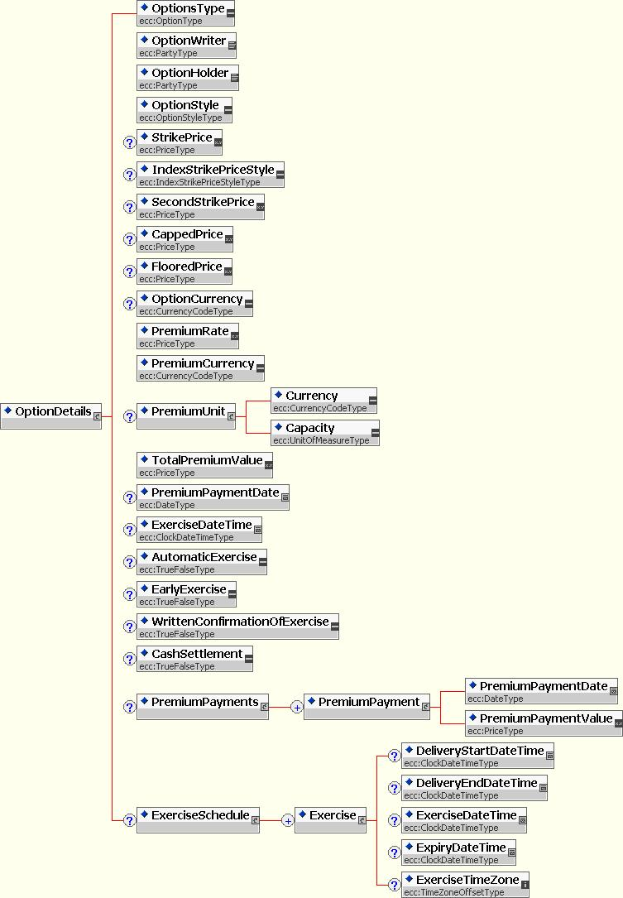

Trade Confirmation – Delivery Periods Details

Conditional Ordered Repeatable Sub-Section below TradeConfirmation: Delivery Periods (0-N)
Must be present if ‘’TransactionType’ is a ‘Financial Transaction’ otherwise must not be present.
Ordered by adjacent intervals
Delivery Period Start Date | Mandatory | DateType | Key | The first start date must be equal to the Effective Date.  Every start date except the first one must be the following date of the preceding (start date = end date + 1).
Delivery Period End Date | Mandatory | DateType | Key | The last end date must be equal to the Termination Date.  This point in time is exclusive with respect to the specified delivery period, i.e. this point in time is the first second after the specified delivery period ended. Hence this delivery period end date and time must be after the associated delivery period start date.
Delivery Period Notional Quantity | Mandatory | QuantityType | Key | All notional quantities must add up to the Total Notional Quantity which is contained in the ‘Total Volume’’ field in the Trade Confirmation section.  This uses the UoM defined for “Notional Capacity Unit” which is contained in the ‘Total Volume Unit’ field in the Trade Confirmation section
Payment Date | Mandatory | DateType | Key | Explicit date.
World Scale Rate | Conditional | PriceType | Key | If ‘TransactionType’ = “FXD_SWP” or “OPT_FXD_SWP” and this is a ‘Freight Swap’ as defined in TRC015 then this field:  1) must be Mandatory and Key  else it  2) must be omitted .
Fixed Price | Conditional | PriceType | Key | If ‘TransactionType’ = “FXD_SWP” or “OPT_FXD_SWP” and this is NOT a ‘Freight Swap’ as defined in TRC015 then this field:  1) must be Mandatory and Key  else it  2) must be omitted

Delivery Periods Section XML Schema

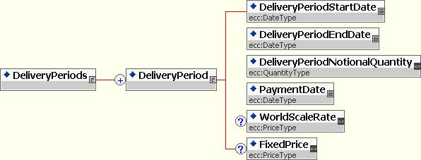

Trade Confirmation – Fixed Price Information

Conditional Section below TradeConfirmation: Fixed Price Information (0-1)
Must be present if Transaction Type = “FXD_SWP” or “OPT_FXD_SWP” otherwise must not be present
Fixed Price Payer | Mandatory | PartyType | Key | EIC Codes. Buyer
FP Currency Unit | Conditional | CurrencyCodeType | Key | If ‘FP Currency Unit’ <> ‘Settlement Currency’ which is contained in the ‘Currency’ field in the Trade Confirmation section then this field:  1) must be Mandatory and Key  Otherwise  2) it must be omitted.
FP Capacity Unit | Conditional | UnitOfMeasureType | Key | If ‘FP Capacity Unit’ <> ’Notional Capacity Unit’ which is contained in the ‘Total Volume Unit’ field in the Trade Confirmation section then this field:  1) must be Mandatory and Key  Otherwise  2) it must be omitted.  Shall be expressed in energy units of the underlying commodity. (Metric tons, gallons).
FP Capacity Conversion Rate | Conditional | QuantityType | Key | If ‘FP Capacity Unit’ is present then this field:  1) must be Mandatory and Key  Otherwise  2) it must be omitted  Conversion rate from the FP Capacity Unit to the Notional Capacity Unit for the deal.
Conditional Section below FixedPriceInformation: FX Information (0-1)
Must be presented if ‘FP Currency Unit’ is present otherwise it must not be present
FX Reference | Conditional | FXReferenceType | Key | Conversion rate from the ‘FP Currency Unit’ to the ‘Settlement Currency’ unit for the deal which is contained in the ‘Currency’ field in the Trade Confirmation section.  Must NOT be present if FX Rate is present
FX Method | Conditional | FXConversionMethodType | key | Must be present if FX Reference is present.
FX Rate | Conditional | QuantityType | Key | Conversion rate from the ‘FP Currency Unit’ to the ‘Settlement Currency’ unit for the deal which is contained in the ‘Currency’ field in the Trade Confirmation section.  Must NOT be present if FX Reference is present

Fixed Price Information Section XML Schema

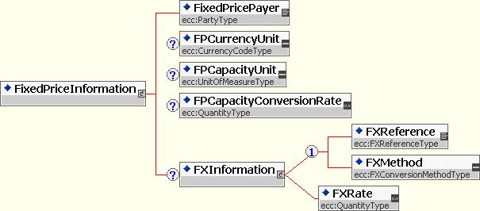

Trade Confirmation – Float Price Information

Ordered Repeatable Section below TradeConfirmation and as Choice next to TotalContractValue: Float Price Information (1-2)
Must be presented if ‘TransactionType’ is a ‘Financial Transaction’ or “PHYS_INX” or “OPT_PHYS_INX” otherwise it must not be present.
If ‘TransactionType’ = “FXD_SWP” or “OPT_FXD_SWP” or “OPT_FIN_INX” or “PHYS_INX” or “OPT_PHYS_INX” only one section must be filled.
If TransactionType = “FLT_SWP” or “OPT_FLT_SWP” two sections must be filled.
Ordered by ascending value of the EIC Code for Float Price Payer
Float Price Payer | Mandatory | PartyType | Key | EIC Codes. Buyer
Formula ID | Conditional | IdentificationType | Key | If this transaction uses a Formula ID then this field:  1) is Mandatory and Key  Otherwise  2) it must be omitted.  Values are defined on a bilateral basis or are taken from Static Data at www.efet.org  Also see Business Rule TRC014.
Conditional Section below Float Price Information: Formula Spread Information (0-1)
Must NOT be present if ‘Formula ID’ is Not present.
If ‘Formula ID’ is present then must be present if the deal carries a spread otherwise it must be omitted.
Spread Payer | Mandatory | PartyType | Key
Spread | Mandatory | PriceType | Key
Spread Currency Unit | Conditional | CurrencyCodeType | Key | If ‘Spread Currency Unit’ <> ‘Settlement Currency’ which is contained in the ‘Currency’ field in the Trade Confirmation section then this field:  1) must be Mandatory and Key  Otherwise  2) it must be omitted.  N.B. The spread must always be in the Notional Capacity Unit
Conditional Section below Formula Spread Information: FX Information (0-1)
Must be present if ‘Spread Currency Unit’ is present otherwise must not be present.
FX Reference | Conditional | FXReferenceType | Key | Conversion rate from the Spread Currency Unit to the Settlement Currency Unit for the deal.  N.B. this is NOT the conversion to the Index Currency Unit for the Commodity Reference but to the Settlement Currency Unit. Must be present if Spread Information FX Rate is NOT present.
FX Method | Conditional | FXConversionMethodType | Key | Must be present if Spread Information FX Reference is present.
FX Rate | Conditional | QuantityType | Key | Conversion rate from the Spread Currency Unit to the Settlement Currency Unit for the deal. Must NOT be present if Spread Information FX Reference is present
Ordered Repeatable Sub-Section below FloatPriceInformation: Commodity References (1-N)
Ordered by ascending value of Commodity Reference Price
Must Not be present if ‘Formula ID’ is present.
Commodity Reference Price | Mandatory | ISDACommodityDefinitionsType | Key | Each value appearing in this section must be unique.  Refer to www.EFET.org Static Data section for a list of valid values.
Index Commodity | Mandatory | IndexCommodityType | Key
Index Currency Unit | Mandatory | CurrencyCodeType | Key
Index Capacity Unit | Optional | UnitOfMeasureType | Key | If present in both CNF documents then it is matched.  N.B. This field is not mandatory because for some basket deals the ‘Index Capacity Unit’ may be different to the ’Notional Capacity Unit’ and yet there is no conversion rate since the price will be used with out conversion, examples of such deals are ‘Dark Spreads’ where an ‘Emissions’ index is combined with a ‘Coal’ index both may use Tonnes or Tons but the Notional Capacity Unit is MWh.
Specified Price | Mandatory | SpecifiedPriceType | Key
Factor | Mandatory | QuantityType | Key
Delivery Date | Mandatory | DeliveryDateType | Key
Multiplier | Conditional | QuantityType | Key | If ‘IndexCommodity’ = “Time_Charter” then this field  1) is Mandatory and Key  Otherwise  2) it must be omitted,
Pricing Date | Conditional | PricingDateType | Key | If ‘TransactionType’ = “PHYS_INX” or “OPT_PHYS_INX” then this field must be omitted and replaced by use of the Physical Index Pricing Dates section.  The date on which a prices are taken for the underlying index.
IndexCap | Optional | PriceType | Key | This field must be present if and only if the specified index has a cap or collar.  If present then it is matched.
IndexFloor | Optional | PriceType | Key | This field must be present if and only if the specified index has a floor or collar.  If present then it is matched.
CR Capacity Conversion Rate | Conditional | QuantityType | Key | If ‘Index Capacity Unit’ is present and <> ’Notional Capacity Unit’ which is contained in the ‘Total Volume Unit’ field in the Trade Confirmation section then this field:  1) must be Mandatory and Key  Otherwise  2) it must be omitted.  Conversion rate from the CR Capacity Unit to the Notional Capacity Unit for the deal.
Optional Section below CommodityReference: FX Information (0-1)
Must be present if ’Index Currency Unit’ in section Commodity Reference <> ’Settlement Currency’ which is contained in the ‘Currency’ field in the Trade Confirmation section otherwise must not be present.
FX Reference | Conditional | FXReferenceType | Key | Conversion rate from the CR Currency Unit to the Settlement Currency Unit for the deal. Must be present if FX Fixed Rate is NOT present.
FX Method | Conditional | FXConversionMethodType | key | Must be present if FX Reference is present.
FX Rate | Conditional | QuantityType | Key | Conversion rate from the CR Currency Unit to the Settlement Currency Unit for the deal.  Must be present if FX Reference is NOT present.
Conditional Repeating Section below CommodityReference: Physical Index Pricing Dates (1-n)
Must be present if TransactionType = “PHYS_INX” ” or “OPT_PHYS_INX” otherwise must not be present.
N.B. If present this section is as the replacement for the ‘Pricing Date’ field for the specified transaction types
PI Pricing Date | Mandatory | DateType | Key | The date on which a specific contract is priced.
Conditional Section below CommodityReference: Spread Information (0-1)
Must be present if this Commodity Reference carries a spread otherwise it must be omitted
Spread Payer | Mandatory | PartyType | Key
Spread | Mandatory | PriceType | Key
Spread Currency Unit | Conditional | CurrencyCodeType | Key | If ‘Spread Currency Unit’ <> ‘Settlement Currency’ which is contained in the ‘Currency’ field in the Trade Confirmation section then this field:  1) must be Mandatory and Key  Otherwise  2) it must be omitted.  N.B. The spread must always be in the Notional Capacity Unit
Optional Section below Spread Information: FX Information (0-1)
Must be present if ‘Spread Currency Unit’ is present otherwise must not be present.
FX Reference | Conditional | FXReferenceType | Key | Conversion rate from the Spread Currency Unit to the Settlement Currency Unit for the deal.  N.B. this is NOT the conversion to the Index Currency Unit for the Commodity Reference but to the Settlement Currency Unit. Must be present if Spread Information FX Rate is NOT present.
FX Method | Conditional | FXConversionMethodType | Key | Must be present if Spread Information FX Reference is present.
FX Rate | Conditional | QuantityType | Key | Conversion rate from the Spread Currency Unit to the Settlement Currency Unit for the deal.Must NOT be present if Spread Information FX Reference is present
Ordered Repeatable Sub-Section: Calculation Periods (1-N)
Ordered by adjacent intervals
StartDate | Mandatory | DateType | Key | Every start date except the first one must be the following date of the preceding end date (start date = end date + 1).
EndDate | Mandatory | DateType | Key | This End Date and time must be after the associated Start Date.
Ordered Repeatable Sub-Section: PricingFXPeriods (1-N).
Ordered by adjacent intervals
StartDate | Mandatory | DateType | Key | Every start date except the first one must be the following date of the preceding end date (start date = end date + 1).
EndDate | Mandatory | DateType | Key | This End Date and time must be after the associated Start Date.

Float Price Section XML Schema

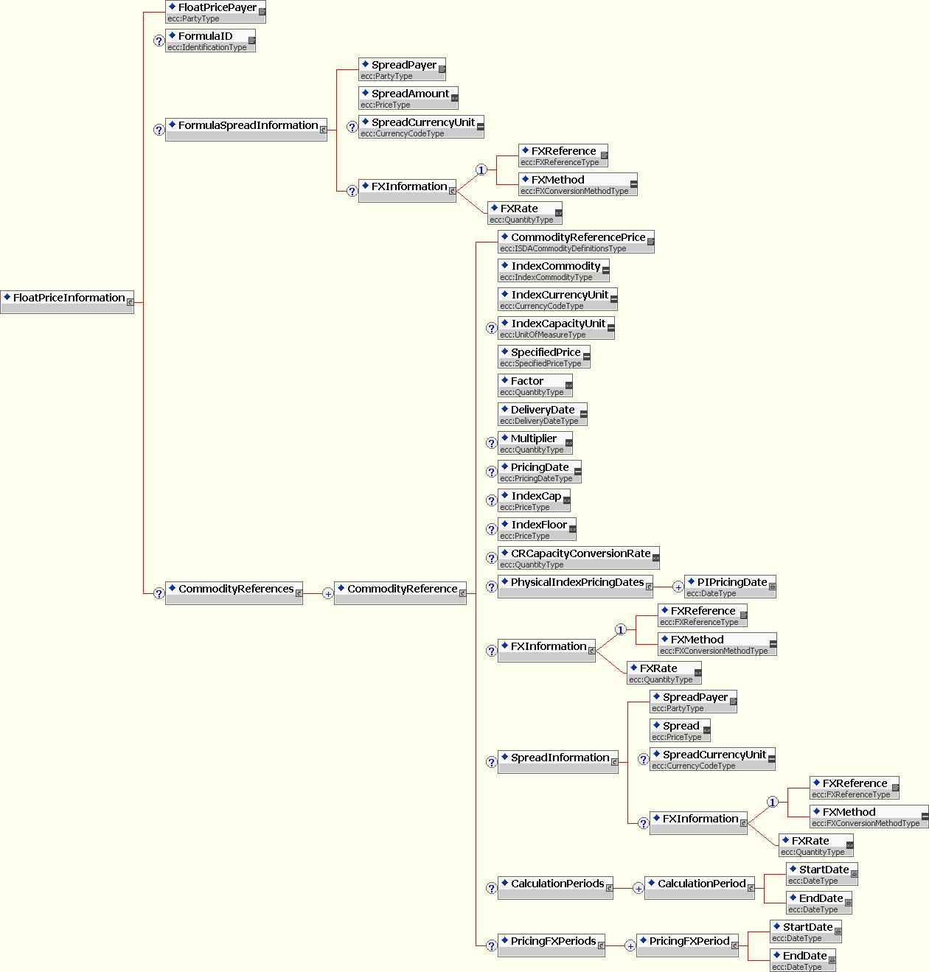

Document specific Business Rules – Trade Confirmation
These business rules apply generally to the document or to specific sections. In addition to the field specific rules defined in the table above these rules provide guidance on the composition and completion of a standard compliant CNF document for the various products and instruments supported.

Table 2: Business Rules for Trade Confirmation Documents
ID | BUSINESS RULE
TRC001 | A Trade Confirmation document is composed of a single trade that the sender wishes to confirm.
TRC002 | Each document has a unique identification. The sender assigns the unique identification to each trade confirmation.  N.B. it is recommended not to use the TradeDate (or any other information that relates to the content of the CNF) as a component of the Document ID, unless the value used can be maintained independently from the Trade Confirmation. This is to ensure that the Document ID is invariant under amendment of the CNF and can be used to identify pervious versions of an amended CNF even if, for example, the Trade Date is amended.
TRC003 | If it is necessary to retransmit the document (i.e. because of a modification to correct something), the document identification shall not be changed. Instead the document version shall be increased by at least 1.
TRC004 | The receiver shall ensure that all document identifications with its associated version number for a given sender shall be unique. A document that is received with the same identification and version number, or the same identification and a version number inferior to the current version, shall be rejected as a duplicate.
TRC005 | If a trade confirmation is to be cancelled a cancellation document shall be used.
TRC006 | A trade confirmation for a physical forward trade (excluding EUA) has as many occurrences of time interval quantities that can cover the whole trade being confirmed.
TRC007 | Negative values are not allowed in the deal confirmation quantities.
TRC008 | The Trade Confirmation document is composed of several structures some mandatory for all uses of the confirmation document and other sections and fields that are optional the use of which depends on the ‘Transaction Type’ and the ‘Commodity’ which are defined terms within this standard:  - Mandatory Sections/Fields are:  - The Document Header providing all the information that is necessary to uniquely identify a trade, along with the identification of involved parties, and the date of the creation of the document.  - The top level Trade Confirmation fields which provides some general information common to all trade confirmations including some information about the Master Agreement under which the trade was enacted.  - Optional sections/fields include:  - Top level Trade Confirmation fields which are relevant to physical forward and physical option deals and include information on commodity and physical delivery.  - EUA Details which is used when the Commodity is EUA certificates unlike continuously delivered energy trades EUA trades have no Time Interval Quantity sub structure. Instead there is a DeliveryDate by which the EUA account transfers must be complete.  - Options Details relevant to options on physical and financial instruments  - Delivery Periods which define the settlement dates and related data  - Fixed Price Information which contains details specific to the fixed leg of a fixed/float swap  - Float Price Information relevant to the floating legs of swaps and index deals and which support baskets of indexes and formula swaps.  - Agents – relating to third parties related in some way to the confirmation process for the deal, these can vary by transaction type, commodity and market, ECVNA data, for instance, being specific to the UK electricity market.  - A block describing hub codification information that is specific to gas trades.  - A block describing account and charge information which is here retained for reasons of backward compatibility, much of the information corresponds with information held in the section Details for AgentType = ECVNA, however the Transmission Charge Identification field which only appears in this section shall have the default value of “Schedule 5 off”.  N.B EUA Trade Confirmation documents do not require sections for Hub based information or for Account and Charge Information
TRC009 | A counterparty is involved, if the receiver of a CNF document is configured as partner. In case the receiver is not known, the CNF is rejected.  A broker is involved additionally to a counterparty, if the broker referenced in the field 'Broker ID' is configured as partner and - additionally - if the CNF matches to the restrictions, which can be defined per broker.  The following criteria should be offered:  Broker, Commodity, Market, Transaction Type and Agreement  e.g.,  Broker BRSPT is applicable for CNFs with Commodity = Power, Market <> UK, Transaction Type = FOR and all Agreements.  A broker is involved without a counterparty, if the receiver of a CNF document is configured as partner and is equal to the 'Broker ID'. If the receiver is not known, the CNF is rejected.
TRC010 | LoadType field is likely to be removed from the matching process in future versions of the standard since the actual profile will be matched at the interval level ensuring that any market based variations of well known products (for instance, Peak) are validated at that level. For this release of the standard the following rules will therefore be applied:  For gas deals the value must be “Base”.  For all other deals the value must be “Custom”, however in future versions of the standard it is the intention either to relax the constraints on this field to allow it to serve as a non-key informational field, thus removing in from the matching algorithm or to remove it from the CNF document entirely.  N.B EUA Trade Confirmation documents do not contain the LoadType field
TRC011 | EUA Trade Confirmation document does not support multiple AgentTypes as the only agent in the trade is the Broker.
TRC012 | For option styles and their exercise dates:  - For European include the Exercise Schedule  - For American include a single final expiry date in the Exercise Schedule  - For Asian include a one exercise date in the Exercise Schedule per delivery period of the underlying transaction as this is taken to be equal to the averaging period  - For Caps, Floors and Collars there will be no Exercise Schedule because they are triggered by price movements rather than a schedule
TRC013 | For options of physical forwards  - The strike price is entered in the Strike Price field of the Option Details section and is the same as the Price of the underlying  For options on a financial index and on physical index deals there are three possibilities depending on the purpose of the option:  - Have a ‘Strike Price’, the strike price may be an absolute value or a fixed differential in the case of an option on a basket index  - Have ‘Strike Price’ = “0” but have ‘Index Strike Price Style’ = “Index_Following”, in which case they are always at the money and can be exercised at the market price if more capacity is required i.e. physical risk management  - Have ‘Strike Price’ = “0” but have ‘Index Strike Price Style’ = “Index_Dated” which means that the strike price of the option is the state of the index on the Trade Date  N.B. In the case of Financial Index Options the settlement terms are defined by the Delivery Periods section.  For fixed/floating swaptions  - The strike price is entered in the Strike Price field of the Option Details section and is the same as the Fixed Price of the underlying swap  For float/float swaptions  - The strike price is entered in the Strike Price field of the Option Details section and is the differential between the two indexes in the underlying swap
TRC014 | If a Formula ID has been agreed between the parties for a certain deal (or type of complex deal) then the Formula ID MUST be filled in by both counterparties and therefore the basket details must be omitted with the exception of the Spread Information. The same Formula can be reused with different spreads without the need to define an additional formula between parties just to account for the new spread.
TRC015 | ‘Freight Swaps’ must be fixed/floating swaps with only one commodity reference in the floating leg, in which case the World Scale Rate value must be included instead of a Fixed. If a Freight Index is part of a basket then the swap will not be considered a ‘Freight Swap’ and none of the Freight Swap validation will be applied i.e.: Fixed Price will be included in the swap (if it is Fixed/Float) and World Scale Rate will be omitted.
TRC016 | An Option Type of ‘Capped_Call’ or ‘Floored_Put’ will comprise a Strike Price and a Cap Price or a Floor Price which must be used to define the upper and lower limit to the pay-off of the option.
TRC017 | An Option Style of :  - ‘Cap’ will comprise a Strike Price only (the option will automatically exercise at the Strike Price)  - ‘Floor’ will comprise a Strike Price only (the option will automatically exercise at the Strike Price)  - ‘Collar’ will comprise a Strike Price which must contain the value of the cap price of the collar and a Second Strike Price which must contain the floor price of the collar.
TRC018 | For the purposes of rounding the fields for ‘Financial Transactions’: “Total Contract Value”, “Total Volume” and “Total Premium Value”, the rounding mechanism to be used must be ‘Rounding to Even’ such that:  - 3.016 rounded to hundredths is 3.02 (because the next digit (6) is 6 or more)  - 3.013 rounded to hundredths is 3.01 (because the next digit (3) is 4 or less)  - 3.015 rounded to hundredths is 3.02 (because the next digit is 5, and the hundredths digit (1) is odd)  - 3.045 rounded to hundredths is 3.04 (because the next digit is 5, and the hundredths digit (4) is even)  - 3.04501 rounded to hundredths is 3.05 (because the next digit is 5, but it is followed by non-zero digits)

Trade Confirmation document Field Specifications
The date and time information is to be stated in clock time (the local time at the Delivery Point Area for the transaction). This means that no compensation needs to be made for daylight saving regimes. For example 13:00 (clock time) on January 1st at the UK NBP would be 13:00 GMT and 13:00 (clock time) on June 1st at the UK NBP would be 14:00 GMT/13:00 BST.

Section Time Interval Quantities

Delivery Start dates are beginning of energy flow
Delivery End Date are the exclusive end of energy flow
One entry is entered for each change in price or capacity during the trade. Missing date and time periods are assumed to be at a 0 capacity rate.

E.g. Baseload for Jan 05 for the German market would be
Start End
2005-01-01T00:00:00 2005-02-01T00:00:00

E.g. Baseload for Jan 05 for the UK market would be
Start End
2004-12-26T23:00:00 2004-01-29T23:00:00

These anomalies are due to the fact that the Monthly calendar follows the EFA rules – as a rule that it means that the month typically starts on the last Sunday in previous month and finishes on the last Sunday in the current month. This repeats throughout the year. Also, the traded day is known as an EFA day and starts at 23:00

Peak Jan 05 for the German market would be
Start End
2005-01-03T08:00:00 2004-01-03T20:00:00
2005-01-04T08:00:00 2004-01-04T20:00:00
2005-01-05T08:00:00 2004-01-05T20:00:00
2005-01-06T08:00:00 2004-01-06T20:00:00
2005-01-07T08:00:00 2004-01-07T20:00:00
2005-01-10T08:00:00 2004-01-10T20:00:00

etc

Calculation and Delivery Periods
The EFET eCM 3.3 Standard extends the scope of the eCM process to incorporate ‘vanilla’ and ‘complex’ swaps. The trade confirmation (CNF) document has therefore been extended to accommodate these new requirements.
The resulting CNF document is capable of expressing both vanilla and complex swaps within the same document structure. To achieve this, a new ‘Delivery Period’ section has been introduced in addition to the familiar ‘Calculation Period’ section which is commonly used in confirmation of vanilla ISDA swaps.
With vanilla swaps the pricing data is collected in the ‘Calculation Period’ which also is the period for which the swap typically settles i.e. the current month.
For complex swaps the pricing data is also collected during the ‘Calculation Period’ but the ‘Calculation Period’ does not need to be the period for which the swap settles – it can be different.
The ‘Delivery Period’ section has therefore been introduced to contain the information used in (typical) monthly settlement, such as the payment date and the notional quantity ‘delivered’ in that period (i.e. month). The range of dates contained in the ‘Calculation Period’ can then be defined separately allowing for pricing data to be collected over other timescales. This is often necessary in complex swaps which may price on, say, an average of prices over the previous 3 month period, but which still settles on a rolling monthly basis.
For vanilla swaps the ‘Delivery Period’ and ‘Calculation Period’ contain the same set of dates but for complex swaps the two sets of dates can be separately specified and confirmed. The introduction of ‘Delivery Period’ therefore allows more complex swaps to be confirmed using the same CNF document as is used for vanilla swaps.

Trade Confirmation document XML Schema
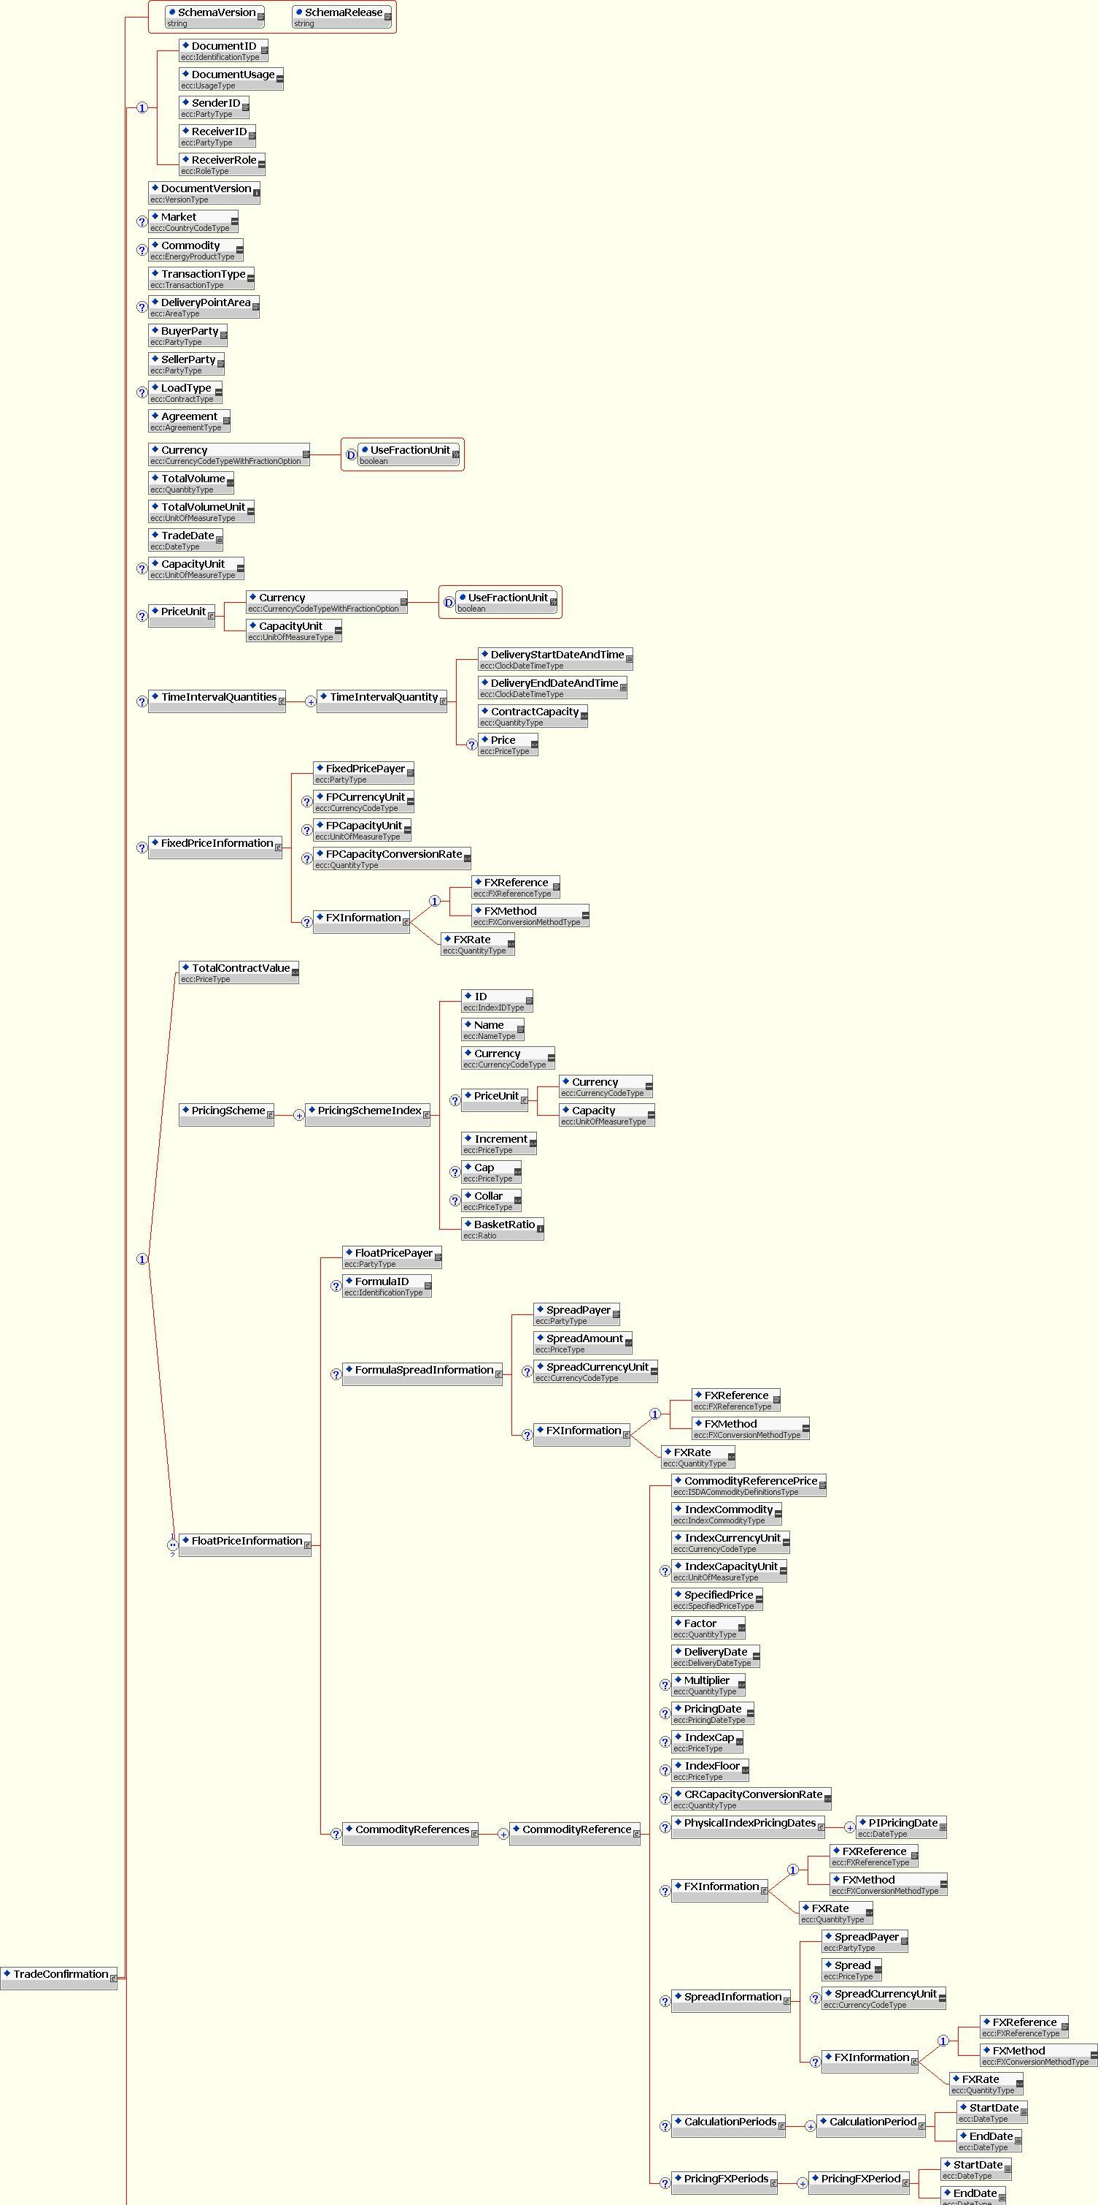
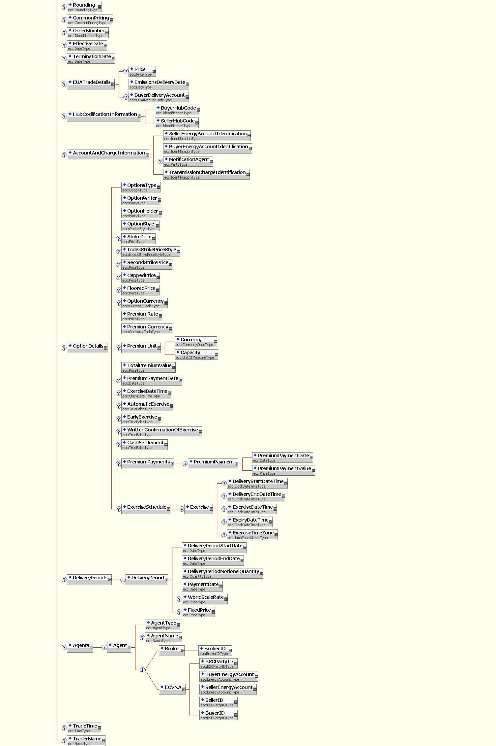

Figure 1: XML Schema for the TradeConfirmation Document

Match Suggestion Document

Overview
The Match Suggestion Document forms a proposal from the Buyer to the Seller as to the similarity between the two Trade Confirmation documents that it references. The similarities between the two documents is based on the Buyer’s belief that all key field values with the two documents are identical and therefore constitute a match under the definition defined with these standards.
The document is signed and therefore provides an auditable record.

Table 3: Element Specification for Match Suggestion
Name | Mandatory/ Optional/ Conditional | Type | Business Rule
Document Header
Document ID | Mandatory | Identification-Type | The sender generates this ID that must be a unique reference compliant with naming standard defined in 5.1 Naming and Typing Conventions.
Document Usage | Mandatory | UsageType
Sender ID | Mandatory | PartyType
Receiver ID | Mandatory | PartyType
Receiver Role | Mandatory | RoleType
Reference Trade Confirmation Identifier
Referenced Buyer Document ID | Mandatory | Identification-Type
Referenced Buyer Document Version | Mandatory | VersionType
Referenced Seller Document ID | Mandatory | Identification-Type
Referenced Seller Document Version | Mandatory | VersionType
A reference to the counterparty ID is not needed since this can be derived from the referenced trade confirmations.

Match Suggestion Document XML Schema
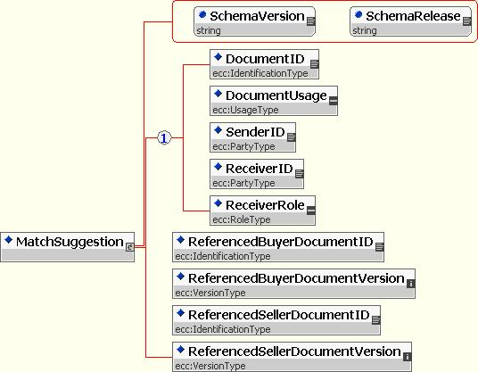

Figure 2: XML Schema for the MatchSuggestion Document

Match Suggestion Acceptance Document
The Match Suggestion Acceptance document forms the acceptance by the Seller of the proposal of a match between two Trade Confirmation documents made by the Buyer through issue to the Seller of the Match Suggestion document.
The document is signed and therefore provides an auditable record.
A DocumentVersion reference is not needed since the referenced document type does not require a version.

Table 4: Element Specification for Match Suggestion Acceptance
Name | Mandatory/ Optional/ Conditional | Type | Description
Document Header
Document ID | Mandatory | Identification-Type | The sender generates this ID that must be a unique reference compliant with naming standard defined in 5.1 Naming and Typing Conventions.
Document Usage | Mandatory | UsageType
Sender ID | Mandatory | PartyType
Receiver ID | Mandatory | PartyType
Receiver Role | Mandatory | RoleType
Reference Match Suggestion Identifier
Match Suggestion Document ID | Mandatory | Identification-Type | The document ID refers to the MatchSuggestion document.

Match Suggestion Acceptance Document XML Schema
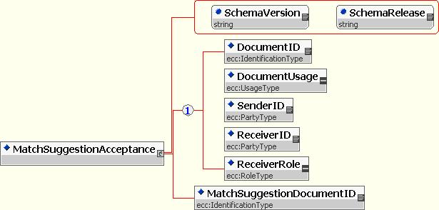

Figure 3: XML Schema for the MatchSuggestionAcceptance Document

Match Suggestion Refusal Document
The Match Suggestion Rejection document forms the rejection by the Seller of the proposal of a match between two Trade Confirmation documents made by the Buyer through issue to the Seller of the Match Suggestion document.
The document is signed and therefore provides an auditable record.
A DocumentVersion reference is not needed since the referenced document type does not require a version.

Table 5: Element Specification for Match Suggestion Refusal
Name | Mandatory/ Optional/ Conditional | Type | Description
Document Header
Document ID | Mandatory | Identification-Type | The sender generates this ID that must be a unique reference compliant with naming standard defined in 5.1 Naming and Typing Conventions.
Document Usage | Mandatory | UsageType
Sender ID | Mandatory | PartyType
Receiver ID | Mandatory | PartyType
Receiver Role | Mandatory | RoleType
Reference Match Suggestion Identifier
Match Suggestion Document ID | Mandatory | Identification-Type | The document ID refers to the MatchSuggestion document.
REASON (1…N)
Reason Code | Mandatory | ReasonCodeType | Code giving the reason for refusal. See details on ReasonCodes further down.
ErrorSource | Optional | String(255)
Originator | Optional | String
Error Text | Optional | ReasonText-Type

Match Suggestion Refusal Document XML Schema
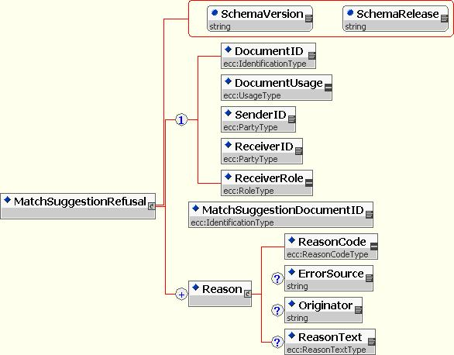

Figure 4: XML Schema for the MatchSuggestionRefusal Document

Cancellation Document
A Cancellation Document refers to a Trade or a Broker Confirmation document and is used to inform the receiver of the sender’s desire to remove the Trade or Broker Confirmation document from their system.

Table 6: Element Specification for Cancellation
Name | Mandatory/ Optional/ Conditional | Type | Description
Document Header
Document ID | Mandatory | IdentificationType | The sender generates this ID that must be a unique reference compliant with naming standard defined in 5.1 Naming and Typing Conventions.
Document Usage | Mandatory | UsageType
Sender ID | Mandatory | PartyType
Receiver ID | Mandatory | PartyType
Receiver Role | Mandatory | RoleType
Reference Trade or Broker Confirmation Identifier
Referenced Document ID | Mandatory | IdentificationType | Document ID of the cancelled trade or broker confirmation
Referenced Document Version | Mandatory | VersionType | Version number of the cancelled trade or broker confirmation

Document specific Business Rules

Business rules AUT001 through AUT012 concern document construction.

Table 7: Business Rules for Cancellation
ID | BUSINESS RULE
CAN001 | A Cancellation document references a single trade or broker confirmation document.
CAN002 | A document that is received with the same identification shall be rejected as a duplicate.
CAN003 | A cancellation document transmission shall always be answered with an acknowledgement/rejection document depending on the status of the original document.

Cancellation Document XML Schema
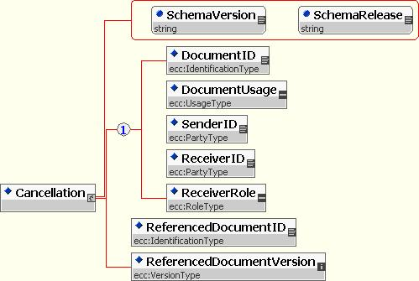

Figure 5: XML Schema for the Cancellation Document

Acknowledgement Document
An Acknowledgement document is sent when an eCM document (except Acknowledgement and Rejection documents) are well-processed.

Table 8: Element Specification for Acknowledgement
Name | Mandatory/ Optional/ Conditional | Type | Description
Document Header
Document ID | Mandatory | IdentificationType | The sender generates this ID that must be a unique reference compliant with naming standard defined in 5.1 Naming and Typing Conventions.
Document Usage | Mandatory | UsageType
Sender ID | Mandatory | PartyType
Receiver ID | Mandatory | PartyType
Receiver Role | Mandatory | RoleType
REFERENCE Document Identifier
ReferencedDocumentType | Mandatory | DocumentType | Used to identify the document type of the referenced document.
Reference Document ID | Mandatory | IdentificationType | The ID of the document that is being acknowledged.
Referenced Document Version | Conditional | VersionType | Only in case of trade confirmations: The version of the trade confirmation that is being rejected. Otherwise, this element is not used.

Acknowledgement Document XML Schema
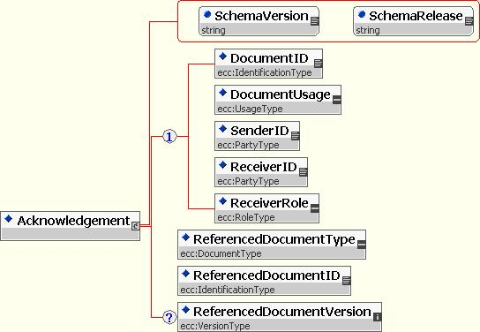

Figure 6: XML Schema for the Acknowledgement Document

Rejection Document
A Rejection document is sent when an eCM document (except Acknowledgement and Rejection documents) could not be well-processed. The reasons for the rejection are listed in the definition of ReasonCodes further down.

Table 9: Element Specification for Rejection
Name | Mandatory/ Optional/ Conditional | Type | Description
Document Header
Document ID | Mandatory | IdentificationType | The sender generates this ID that must be a unique reference compliant with naming standard defined in 5.1 Naming and Typing Conventions.
Document Usage | Mandatory | UsageType
Sender ID | Mandatory | PartyType
Receiver ID | Mandatory | PartyType
Receiver Role | Mandatory | RoleType
REFERENCE Document Identifier
ReferencedDocumentType | Mandatory | DocumentType | Used to identify the document type of the referenced document.
Reference Document ID | Mandatory | IdentificationType | The ID of the document that is being rejected.
Referenced Document Version | Conditional | VersionType | Only in case of trade or broker confirmations: The version of the trade confirmation that is being rejected. Otherwise, this element is not used.
REASON (1…N)
Reason Code | Mandatory | ReasonCodeType | A code indicating the motivation for the rejection. See ReasonCodeType definitions further down in this document.
ErrorSource | Conditional | String(255) | In case of XML error, this element indicates where the error occurred in the document
Originator | Optional | String | Explains which software component raised this error
ReasonText | Optional | ReasonTextType | Additional informal information

Rejection Document XML Schema
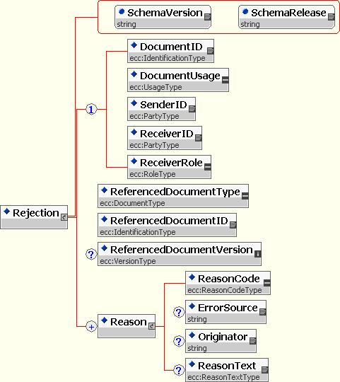

Figure 7: XML Schema for the Rejection Document

Document specific Business Rules for Rejections

Table 10: Business Rules for Rejections
ID | BUSINESS RULE
REJ001 | Each rejection document must provide a supporting reason code and eventual text.

Broker Confirmation

Overview
The Broker Confirmation combines the information of the Trade Confirmation and the Broker Fee Information document. As not all information can be provided by brokers, several fields are defined as optional rather than mandatory, as in the Trade Confirmation Document. Additionally, the Broker Confirmation Document provides broker specific data fields. Each field in a Broker Confirmation document is either a key or an information field.
Key fields are those fields that play a role in the definition of a match between broker confirmation and trade confirmation documents. Key fields are either mandatory or conditional. Information fields are not considered in a match.

Table 11: Specification of Broker Confirmation Elements
Name | Mandatory/ Optional/ Conditional | Type | Key/ Information | Business Rule
Section: Document Header
DocumentID | Mandatory | IdentificationType | Information | The sender generates this ID that must be a unique reference compliant with naming standard defined in 5.1 Naming and Typing Conventions.  When a party receives a broker confirmation with an ID unknown to the receiver then the receiver must treat this document as the initial version of a new broker confirmation document. Otherwise the receiver must treat this document as an amendment of an already sent Broker Confirmation document (see field “Document Version”).
Document Usage | Mandatory | UsageType | Information | “Test” or “Live”
SenderID | Mandatory | PartyType | Information | BrokerID of sender
ReceiverID | Mandatory | PartyType | Information | EIC Code of Receiver.
Receiver Role | Mandatory | RoleType | Information | Trader role applies if the document is being received from a broker of the trade  Agent role applies if the document is in effect a carbon copy of the main confirmation document.
Document Version | Mandatory | VersionType | Information | The version number is always associated the Document ID. It is used to distinguish and order the initial Broker Confirmation document and all its amendments over time. A fixed first version number for the initial Broker Confirmation document is not defined (see field “Document ID”). When a party receives a Broker Confirmation document with an ID already used by the same sender (either a trader or its own Broker Back Office System) in a previous Broker Confirmation document then the receiver must first check if there exists a Broker Confirmation document from this sender with this ID and a lower version number and in an ‘amendable’ state. If this is not the case then the receiver must send a rejection document. Other wise the Broker Confirmation document gets the new status “Amended” and the just received Broker Confirmation document gets status “Pending”.
Market | Conditional | CountryCodeType | Key | If ‘TransactionType’ is a ‘Financial Transaction’  Or if ‘Commodity’ = ‘EUAPhase_1’ or ‘EUAPhase_2’ then this field is:  a) must be omitted;  else this field is  b) Mandatory and Key
Commodity | Conditional | EnergyProductType | Key | If ‘TransactionType’ is a ‘Financial Transaction’ then this field:  a) must be omitted;  else this field is  b) Mandatory and Key
Transaction Type | Mandatory | TransactionType | Key
Delivery Point Area | Conditional | AreaType | Key | If ‘TransactionType’ is a ‘Financial Transaction’  Or if ‘Commodity’ = ‘EUAPhase_1’ or ‘EUAPhase_2’ then this field is:  a) must be omitted;  else this field is  b) Mandatory and Key
Buyer Party | Mandatory | PartyType | Key | If ‘TransactionType’ = “FXD_SWP” or “FLT_SWP” then this field:  must be the highest (using alphabetical sorting) EIC code of the two parties to the deal ;  If ‘TransactionType’ = “DAH” or “IND” or “FOR” or “PHYS_INX” then this field:  must be the EIC code of the buyer in the deal  If ‘TransactionType’ = “OPT” or “OPT_PHYS_INX” or “OPT_FIN_INX” or “OPT_FXD_SWP” or “OPT_FLT_SWP” then this field:  must be the EIC code for the Option Holder.  N.B. it is the party identified in this field that initiates the eCM process and issues a Match Suggestion document.
Seller Party | Mandatory | PartyType | Key | If ‘TransactionType’ = “FXD_SWP” or “FLT_SWP” then this field:  must be the highest (using alphabetical sorting) EIC code of the two parties to the deal ;  If ‘TransactionType’ = “DAH” or “IND” or “FOR” or “PHYS_INX” then this field:  must be the EIC code of the buyer in the deal  If ‘TransactionType’ = “OPT” or “OPT_PHYS_INX” or “OPT_FIN_INX” or “OPT_FXD_SWP” or “OPT_FLT_SWP” then this field:  must be the EIC code for the Option Writer.  N.B. it is the party identified in this field that responds to a Match Suggestion document within the eCM process.
Load Type | Conditional | ContractType | Key | See BCN009 below for business rule details.  If ‘TransactionType’ is a ‘Financial Transaction’  Or if ‘Commodity’ = ‘EUAPhase_1’ or ‘EUAPhase_2’ then this field is:  a) must be omitted;  else this field is  b) Mandatory and Key
Agreement | Optional | AgreementType | Information | Reference to Master Agreement Model Contract  If ‘TransactionType’ = “FOR” or “OPT” then the following validation must be applied:  If ‘Commodity’ = ‘EUAPhase_1’ or ‘EUAPhase_2’ then the following values are valid:  - “ISDA” where the underlying agreement is ISDA;  - “EFET” for EFET agreements,  - “IETA” for IETA trades;  else the following values are valid:  - “GTMA” for the UK electricity market  - “NBP97” for the UK gas market  - “EFET” for EFET agreements (N.B this value is common to EUA certificate and energy commodities)  - “Zebrugge” for deliveries to the Zebrugge hub  - “Other” for trades under other master agreements; this value is NOT validated against any specific market or delivery point.  Else  Any valid value as defined in Appendix A.2 eCM Field Types may be used.
Currency | Mandatory | CurrencyCodeType | Key | With boolean Attribute “UseFractionUnit” to indicate that “Pence” is used instead of “GBP”. This attribute becomes mandatory when issuing CNF documents for the networks that utilize pence. (i.e. UK NBP and Belgium)  If ‘Commodity’ = ‘EUAPhase_1’ or ‘EUAPhase_2’ then the value of this field must be set to the ISO currency symbol for Euros only.  N.B. For Financial Transactions this is the “Settlement Currency”
Total Volume | Mandatory | QuantityType | Key | If ‘Commodity’ = ‘EUAPhase_1’ or ‘EUAPhase_2’ then the value of this field must be Integer; between 1 and 8 significant figures.  N.B. For Financial Transactions this is the “Total Notional Quantity”  N.B. For Financial Transactions this field shall be rounded to 2 decimal places.
Total Volume Unit | Mandatory | UnitOfMeasureType | Key | If ‘Commodity’ = ‘EUAPhase_1’ or ‘EUAPhase_2’ then the value of this field must be “EUA” thus with “Total Volume” expressing the total number of EUA certificates in the underlying transaction.  N.B. For Financial Transactions this is the “Notional Capacity Unit”
Trade Date | Mandatory | DateType | Key | This date is based on clock time, not a specific time zone.
Trade Time | Mandatory | TimeType | Information | This time is expressed as clock time.  This field is Optional in the CNF therefore it is Informational
Trader Name | Mandatory | NameType | Information | This field is Optional in the CNF therefore it is Informational
Capacity Unit | Conditional | UnitOfMeasureType | Key | If ‘TransactionType’ is a ‘Financial Transaction’  Or if ‘Commodity’ = ‘EUAPhase_1’ or ‘EUAPhase_2’ then this field is:  a) must be omitted;  else this field is  b) Mandatory and Key
PriceUnit/Currency | Conditional | CurrencyCodeType | Key | The currency unit used to express this price unit must fit to the currency given in field “Currency”.  With boolean Attribute “UseFractionUnit” to indicate that “Pence” is used instead of “GBP”. This attribute becomes mandatory when issuing CNF documents for the networks that utilize pence. (i.e. UK NBP and Belgium)  If ‘TransactionType’ is a ‘Financial Transaction’  Or if ‘Commodity’ = ‘EUAPhase_1’ or ‘EUAPhase_2’ then this field is:  a) must be omitted;  else this field is  b) Mandatory and Key
PriceUnit/CapacityUnit | Conditional | UnitOfMeasureType | Key | Shall be expressed in units of rate of flow (power) rather than energy, for example, a gas deal on the UK network will be expressed as: p/ Therm; or a for a power deal EUR/MW  If ‘TransactionType’ is a ‘Financial Transaction’  Or if ‘Commodity’ = ‘EUAPhase_1’ or ‘EUAPhase_2’ then this field is:  a) must be omitted;  else this field is  b) Mandatory and Key
TotalContractValue | Conditional | PriceType | Key | An XML choice below TradeConfirmation.  If ‘TransactionType’ = “DAH”, “IND”, FOR” or “OPT” then this field:  a) is Mandatory and Key  otherwise  b) must be omitted
Common Pricing | Conditional | CommonPricingType | key | If ‘TransactionType’ is a ‘Financial Transaction’, or “PHYS_INX” or “OPT_PHYS_INX” then this field:  a) is Mandatory and Key  otherwise  b) must be omitted  If all holiday calendars happen to be the same then Common Pricing must, by default, be set to ‘True’
Effective Date | Conditional | DateType | Key | If ‘TransactionType’ is a ‘Financial Transaction’ then this field:  a) is Mandatory and Key  otherwise  b) must be omitted  “Effective Date” is ISDA terminology, means Start Date
Termination Date | Conditional | DateType | Key | If ‘TransactionType’ is a ‘Financial Transaction’ then this field:  a) is Mandatory and Key  otherwise  b) must be omitted  “Termination Date” is ISDA terminology, means End Date
Conditional Ordered Repeatable Section below TradeConfirmation: TIME INTERVAL QUANTITIES (1-N)
Ordered by adjacent intervals
This section must not be used when TransactionType is a ‘Financial Transaction’
This section must not be used when ‘Commodity’ = ‘EUAPhase_1’ or ‘EUAPhase_2’.
DeliveryStartDateAndTime | Mandatory | ClockDateTimeType | Key | Format: As defined in the XML Schema Standard. This date and time are expressed in clock time.  Within this ordered repeatable section this date and time must either be the same as or be after the date and time given in the previous Delivery End Date and Time field (if it exists).
DeliveryEndDateAndTime | Mandatory | ClockDateTimeType | Key | Format: As defined in the XML Schema Standard. This date and time are expressed in clock time.  This point in time is exclusive with respect to the specified delivery period, i.e. this point in time is the first second after the specified delivery period ended. Hence this delivery end date and time must be after the associated delivery start date and time.
Contract capacity | Mandatory | QuantityType | Key | See Section A.1 Core Components
Price | Conditional | PriceType | Key | If the element “TotalContractValue” is used then this field must be present. Otherwise it must not be present.
Conditional Unordered Repeatable Section below as XML choice below TradeConfirmation: PRICING SCHEME = IND (1-N) for each index
As Choice next to TotalContractValue and FloatPriceInformation
This section must not be used. It is retained for reasons of backwards compatibility with earlier version of the version 3 schema set.
PricingSchemeIndex/ ID | Mandatory | IndexIDType | Key | Must occur at most once in this repeatable section.
PricingSchemeIndex/ Name | Optional | NameType | Information
PricingSchemeIndex/ Currency | Mandatory | CurrencyCodeType | Key | ISO currency code
PricingSchemeIndex/  Price Unit/Currency | Conditional | CurrencyCodeType | Key | The currency unit used to express this index price unit must fit to the currency given in field “PricingSchemeIndex/ Currency”  If ‘Commodity’ = ‘EUAPhase_1’ or ‘EUAPhase_2’ then this field is:  a) must be omitted;  else this field is  b) Mandatory and Key
PricingSchemeIndex/  Price Unit/Capacity | Conditional | UnitOfMeasureType | Key | If ‘Commodity’ = ‘EUAPhase_1’ or ‘EUAPhase_2’ then this field is:  a) must be omitted;  else this field is  b) Mandatory and Key
PricingSchemeIndex/ Increment | Mandatory | PriceType | Key | Adopts the same currency unit as expressed in “PricingSchemeIndex/  Price Unit/Currency”.
PricingSchemeIndex/ Cap | Optional | PriceType | Key | This field must be present if and only if the specified index has a cap.
PricingSchemeIndex/ Collar | Optional | PriceType | Key | This field must be present if and only if the specified index has a floor.
PricingSchemeIndex/ Basket Ratio | Mandatory | Ratio | Key | All index basket ratios given in this repeatable section (if it is present) must add up to 100.
Unordered Repeatable Section: Agents (1-N)
For each agent specified in a Broker Confirmation document the following fields must be present. The Agent Type BROKER must be present once.
AgentType | Mandatory | AgentType | Key
Agent Name | Optional | NameType | Information
Details for ‘AgentType’ = “ECVNA” as XML choice below Agent
This agent must appear if and only if the market has been defined as GB and the commodity has been defined as a power commodity
BSC Party ID | Optional | BSCPartyIDType | Information
Buyer Energy Account | Optional | EnergyAccountType | Information
Seller Energy Account | Optional | EnergyAccountType | Information
Buyer ID | Optional | BSCPartyIDType | Information
Seller ID | Optional | BSCPartyIDType | Information
Details for ‘AgentType’ = “BROKER”
Broker ID | Mandatory | BrokerIDType | Key
Total Fee | Mandatory | Quantity Type | Key | In case the fee amount is 0, this information needs to be provided as well.  This field shall be rounded to 2 decimal places.
Fee Currency | Mandatory | CurrencyCode Type | Key | In case the fee amount is 0, this information needs to be provided as well.
Sleeve | Optional | TrueFalseType | Information
Voice | Optional | TrueFalseType | Information
Initiate | Optional | TrueFalseType | Information
Spread | Optional | TrueFalseType | Information
BrokerSpreadID | Optional | IdentificationType | Information
BrokerTradeID | Optional | IdentificationType | Information
Conditional Section: HUB CODIFICATION INFORMATION – needs to be completed for gas confirms only
This section must be present if and only if the value of field “Commodity” is equal to “Gas”.
Buyer Hub Code | Optional | IdentificationType | Information | Identifying the Buyer with the hub network.  For the UK market, this is the “Buyer AT Link Reference”.
Seller Hub Code | Optional | IdentificationType | Information | Identifying the Seller with the hub network.  For the UK market, this is the “Seller AT Link Reference”.

Broker Confirmation Section XML Schema
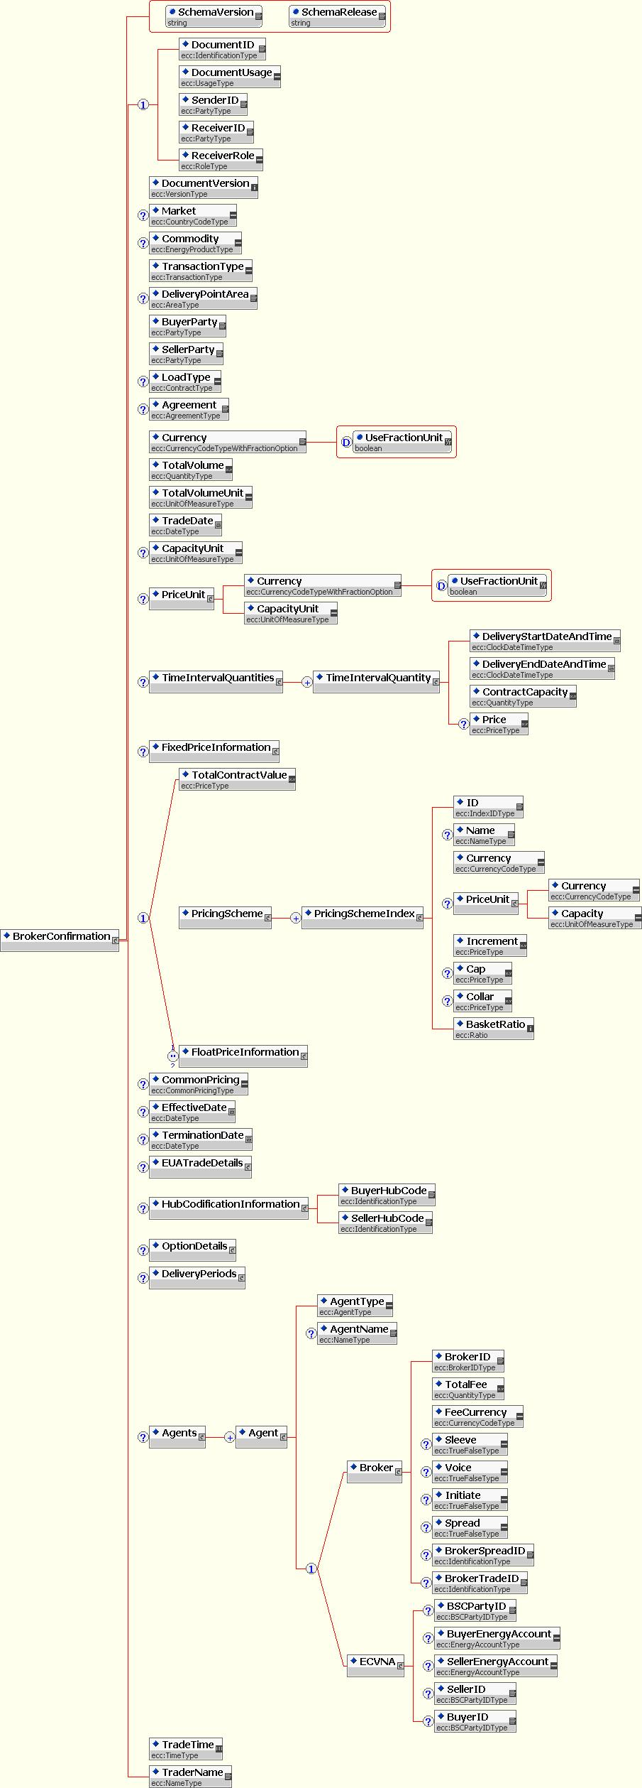

Broker Confirmation – EUA Trade Details

Conditional Section below TradeConfirmation: EUA Trade Details
Only used when ‘Commodity’ = ‘EUAPhase_1’ or ‘EUAPhase_2’.
Price | Conditional | PriceType | Key | If the element “TotalContractValue” is used then this field must be present. Otherwise it must not be present.
Emissions Delivery Date | Mandatory | DateType | Key | e.g. 1st December 2005  This will be the contractual delivery date.  Note that in some cases the contractual delivery date may differ from the actual delivery date due to the contractual delivery date falling on a non business day in one or both registry countries.

EUA Trade Details Section XML Schema

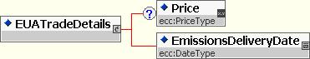

Trade Confirmation – Option Details

Conditional section below TradeConfirmation: OPTION DETAILS
This section must be present if and only if the value of field “Transaction Type” = “OPT” or “OPT_PHYS_INX” or “OPT_FXD_SWP” or “OPT_FLT_SWP” or “OPT_FIN_INX”.
Options Type | Mandatory | OptionType | Key
Option Writer | Mandatory | PartyType | Key | Use EIC Code
Option Holder | Mandatory | PartyType | Key | Use EIC Code
Option Style | Mandatory | OptionStyleType | Key
Strike Price | Conditional | PriceType | Key | See business rules BCN012 and BCN016
IndexStrikePriceStyle | Conditional | IndexStrikePriceStyleType | Key | If ‘TransactionType’ = “OPT_PHYS_INX” or “OPT_FIN_INX” and ‘Strike Price’ = “0” then this field is:  1) is Mandatory and Key  Otherwise  2) it must be omitted  See business rule BCN012
Second Strike Price | Conditional | PriceType | Key | If ‘OptionStyle’ = “Collar” then this field is:  1) is Mandatory and Key  Otherwise  2) it must be omitted  See business rule BCN016
Capped Price | Conditional | PriceType | Key | If ‘OptionType’ = “Capped_Call” then this field is:  1) is Mandatory and Key  Otherwise  2) it must be omitted  See business rule BCN015
Floored Price | Conditional | PriceType | Key | If ‘OptionType’ = “Floored_Put” then this field is:  1) is Mandatory and Key  Otherwise  2) it must be omitted  See business rule BCN015
Option Currency | Conditional | CurrencyCodeType | Key | The currency of the Strike Price, Second Strike Price, Capped Price, and the Floored Price.
Premium Rate | Mandatory | PriceType | Key
Premium Currency | Mandatory | CurrencyCodeType | Key
Premium Unit/Currency | Conditional | CurrencyCodeType | Key | If ‘Commodity’ = ‘EUAPhase_1’ or ‘EUAPhase_2’ then this field is:  a) must be omitted;  else this field is  b) Mandatory and Key
Premium Unit/Capacity | Conditional | UnitOfMeasureType | Key | If ‘Commodity’ = ‘EUAPhase_1’ or ‘EUAPhase_2’ then this field is:  a) must be omitted;  else this field is  b) Mandatory and Key
Total premium value | Mandatory | PriceType | Key | N.B. For Financial Transactions this field shall be rounded to 2 decimal places.
Premium payment date | Conditional | DateType | Information | If ‘TransactionType is a NOT ‘Financial Transaction’ or “PHYS_INX” or “OPT_PHYS_INX” then this field:  a) is Optional and Information  otherwise  b) must be omitted  N.B. Not used for new TransactionTypes introduced in v3.3 where it has been replaced by the repeated section Premium Payments.
Exercise Date Time | Conditional | ClockDateTimeType | Key | If ‘Commodity’ = ‘EUAPhase_1’ or ‘EUAPhase_2’ then this field is:  a)Mandatory and Key;  else this field  b) must be omitted.  N.B. this is the opposite of the rule used elsewhere.  N.B. All times must be in CET
Ordered Repeatable Section: OPTION EXERCISE SCHEDULE (1-N)
This section must not be used when ‘Commodity’ = ‘EUAPhase_1’ or ‘EUAPhase_2’.
Delivery Start Date Time | Conditional | ClockDateTimeType | Key | If ‘TransactionType’ = “OPT” then this field:  a) is mandatory and key,  else this field  b) must be omitted  Time zone of delivery point
Delivery End Date Time | Conditional | ClockDateTimeType | Key | If ‘TransactionType’ = “OPT” then this field:  a) is mandatory and key,  else this field  b) must be omitted  Time zone of delivery point
Exercise Date Time | Conditional | ClockDateTimeType | Key | If ‘TransactionType’ = “OPT” then this field:  a) is Optional and Key and if present it will be matched.  else this field  b) must be omitted  Time zone of delivery point  This date and time must be after the date and time specified in the previous Exercise Date and Time field.
Exercise/Expiry Date Time | Conditional | ClockDateTimeType | Key | If ‘TransactionType’ = ‘OPT_FXD_SWP’ or ‘OPT_FLT_SWP’ or ‘OPT_FIN_INX’ or ‘OPT_PHYS_INX’ then this field:  a) is mandatory and key, depending on the exercise style of the option as defined in business rule BCN011  else this field  b) must be omitted  Must be expressed in UTC.  Specify each possible exercise date until expiry.  This date and time must be after the date and time specified in the previous Exercise Date and Time field.
Exercise Time Zone | Conditional | TimeZoneOffsetType | Information | If ‘TransactionType’ = ‘OPT_FXD_SWP’ or ‘OPT_FLT_SWP’ or ‘OPT_FIN_INX’ or ‘OPT_PHYS_INX’ then this field:  a) is optional and for information  else this field  b) must be omitted  Must be an offset to UTC

Options Details (Broker) Section XML Schema
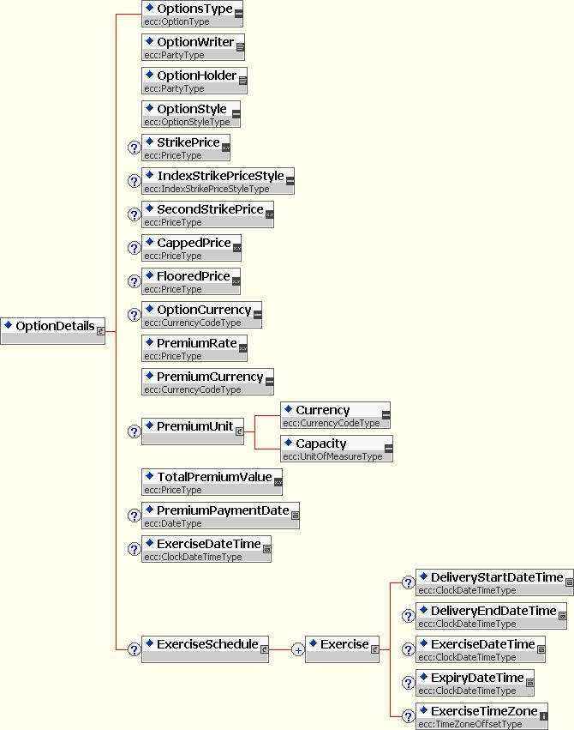

Broker Confirmation – Delivery Periods Details
Conditional Ordered Repeatable Sub-Section below TradeConfirmation: Delivery Periods (0-N)
Must be present if ‘’TransactionType’ is a ‘Financial Transaction’ otherwise must not be present.
Ordered by adjacent intervals
Delivery Period Start Date | Mandatory | DateType | Key | The first start date must be equal to the Effective Date.  Every start date except the first one must be the following date of the preceding end date (start date = end date + 1).
Delivery Period End Date | Mandatory | DateType | Key | The last end date must be equal to the Termination Date.  This point in time is exclusive with respect to the specified delivery period, i.e. this point in time is the first second after the specified delivery period ended. Hence this delivery period end date and time must be after the associated delivery period start date.
Delivery Period Notional Quantity | Mandatory | QuantityType | Key | All notional quantities must add up to the Total Notional Quantity which is contained in the ‘Total Volume’’ field in the Trade Confirmation section.  This uses the UoM defined for “Notional Capacity Unit” which is contained in the ‘Total Volume Unit’ field in the Trade Confirmation section
World Scale Rate | Conditional | PriceType | Key | If ‘TransactionType’ = “FXD_SWP” or “OPT_FXD_SWP” and this is a ‘Freight Swap’ as defined in BCN014 then this field:  1) must be Mandatory and Key  else it  2) must be omitted .
Fixed Price | Conditional | PriceType | Key | If ‘TransactionType’ = “FXD_SWP” or “OPT_FXD_SWP” and this is not a ‘Freight Swap’ as defined in BCN014 then this field:  1) must be Mandatory and Key  else it  2) must be omitted

Delivery Periods (Broker) Section XML Schema

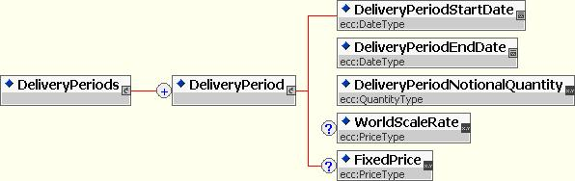

Broker Confirmation – Fixed Price Information

Conditional Section below TradeConfirmation: Fixed Price Information (0-1)
Must be present if Transaction Type = “FXD_SWP” or “OPT_FXD_SWP” otherwise must not be present
Fixed Price Payer | Mandatory | PartyType | Key | EIC Codes. This value identifies the counterparty in the ‘Buyer’ role within the eCM this type of transaction.
FP Currency Unit | Conditional | CurrencyCodeType | Key | If ‘FP Currency Unit’ <> ‘Settlement Currency’ which is contained in the ‘Currency’ field in the Trade Confirmation section then this field:  1) must be Mandatory and Key  Otherwise  2) it must be omitted.
FP Capacity Unit | Conditional | UnitOfMeasureType | Key | If ‘FP Capacity Unit’ <> ’Notional Capacity Unit’ which is contained in the ‘Total Volume Unit’ field in the Trade Confirmation section then this field:  1) must be Mandatory and Key  Otherwise  2) it must be omitted.  Shall be expressed in energy units of the underlying commodity. (Metric tons, gallons).
FP Capacity Conversion Rate | Conditional | QuantityType | Key | If ‘FP Capacity Unit’ is present then this field:  1) must be Mandatory and Key  Otherwise  2) it must be omitted  Conversion rate from the FP Capacity Unit to the Notional Capacity Unit for the deal.
Conditional Section below FixedPriceInformation: FX Information (0-1)
Must be presented if ‘FP Currency Unit’ is present otherwise it must not be present
FX Reference | Conditional | FXReferenceType | Key | Conversion rate from the ‘FP Currency Unit’ to the ‘Settlement Currency’ unit for the deal which is contained in the ‘Currency’ field in the Trade Confirmation section.  Must NOT be present if FX Rate is present
FX Method | Conditional | FXConversionMethodType | key | Must be present if FX Reference is present.
FX Rate | Conditional | QuantityType | Key | Conversion rate from the ‘FP Currency Unit’ to the ‘Settlement Currency’ unit for the deal which is contained in the ‘Currency’ field in the Trade Confirmation section.  Must NOT be present if FX Reference is present

Fixed Price Information (Broker) Section XML Schema

Broker Confirmation – Float Price Information

Ordered Repeatable Section below TradeConfirmation and as Choice next to TotalContractValue: Float Price Information (1-2)
Must be presented if ‘TransactionType’ is a ‘Financial Transaction’ or “PHYS_INX” or “OPT_PHYS_INX” otherwise it must not be present.
If ‘TransactionType’ = “FXD_SWP” or “OPT_FXD_SWP” or “OPT_FIN_INX” or “PHYS_INX” or “OPT_PHYS_INX” only one section must be filled.
If TransactionType = “FLT_SWP” or “OPT_FLT_SWP” two sections must be filled.
Ordered by ascending value of the EIC Code for Float Price Payer
Float Price Payer | Mandatory | PartyType | Key | EIC Code of the Floating Price Payer.
Ordered Repeatable Sub-Section below FloatPriceInformation: Commodity References (1-N)
Ordered by ascending value of Commodity Reference Price
Commodity Reference Price | Mandatory | ISDACommodityDefinitionsType | Key | Each value appearing in this section must be unique.  Refer to www.EFET.org Static Data section for a list of valid values.
Index Commodity | Mandatory | IndexCommodityType | Key
Index Currency Unit | Mandatory | CurrencyCodeType | Key
Index Capacity Unit | Optional | UnitOfMeasureType | Key | If present in the BCN and CNF documents then it is matched  N.B. This field is not mandatory because for some basket deals the ‘Index Capacity Unit’ may be different to the ’Notional Capacity Unit’ and yet there is no conversion rate since the price will be used with out conversion, examples of such deals are ‘Dark Spreads’ where an ‘Emissions’ index is combined with a ‘Coal’ index both may use Tonnes or Tons but the Notional Capacity Unit is MWh.
Factor | Mandatory | QuantityType | Key
Multiplier | Conditional | QuantityType | Key | If ‘IndexCommodity’ = “Time_Charter”  Then this field  1) is Mandatory and Key  Otherwise  2) it must be omitted,
IndexCap | Optional | PriceType | Key | This field must be present if and only if the specified index has a cap or collar.  If present then it is matched.
IndexFloor | Optional | PriceType | Key | This field must be present if and only if the specified index has a floor or collar.  If present then it is matched.
CR Capacity Conversion Rate | Conditional | QuantityType | Key | If is ‘Index Capacity Unit’ is present and <> ’Notional Capacity Unit’ which is contained in the ‘Total Volume Unit’ field in the Trade Confirmation section then this field:  1) must be Mandatory and Key  Otherwise  2) it must be omitted.  Conversion rate from the CR Capacity Unit to the Notional Capacity Unit for the deal.
Conditional Section below CommodityReference: FX Information (0-1)
Must be present if ’Index Currency Unit’ in section Commodity Reference <> ’Settlement Currency’ which is contained in the ‘Currency’ field in the Trade Confirmation section otherwise must not be present.
FX Reference | Conditional | FXReferenceType | Key | Conversion rate from the CR Currency Unit to the Settlement Currency Unit for the deal. Must be present if FX Fixed Rate is NOT present.
FX Method | Conditional | FXConversionMethodType | key | Must be present if FX Reference is present.
FX Rate | Conditional | QuantityType | Key | Conversion rate from the CR Currency Unit to the Settlement Currency Unit for the deal.  Must be present if FX Reference is NOT present.
Optional Section below CommodityReference: Spread Information (0-1)
Must be present if this Commodity Reference carries a spread otherwise it must be omitted
Spread Payer | Mandatory | PartyType | Key
Spread | Mandatory | PriceType | Key
Spread Currency Unit | Conditional | CurrencyCodeType | Key | If ‘Spread Currency Unit’ <> ‘Settlement Currency’ which is contained in the ‘Currency’ field in the Trade Confirmation section then this field:  1) must be Mandatory and Key  Otherwise  2) it must be omitted.  N.B. The spread must always be in the Notional Capacity Unit
Conditional Section below Spread Information: FX Information (0-1)
Must be present if ‘Spread Currency Unit’ is present otherwise must not be present.
FX Reference | Conditional | FXReferenceType | Key | Conversion rate from the Spread Currency Unit to the Settlement Currency Unit for the deal.  N.B. this is NOT the conversion to the Index Currency Unit for the Commodity Reference but to the Settlement Currency Unit. Must be present if Spread Information FX Rate is NOT present.
FX Method | Conditional | FXConversionMethodType | Key | Must be present if Spread Information FX Reference is present.
FX Rate | Conditional | QuantityType | Key | Conversion rate from the Spread Currency Unit to the Settlement Currency Unit for the deal.Must NOT be present if Spread Information FX Reference is present
Ordered Repeatable Sub-Section: Calculation Periods (1-N)
Ordered by adjacent intervals
StartDate | Mandatory | DateType | Key | Every start date except the first one must be the following date of the preceding end date (start date = end date + 1).
EndDate | Mandatory | DateType | Key | This End Date and time must be after the associated Start Date and time.

Float Price Section XML Schema
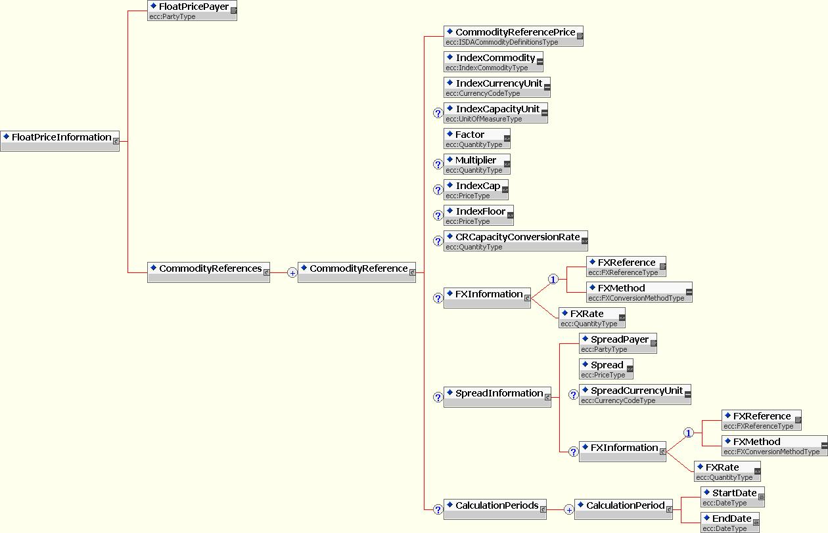

Document specific Business Rules – Broker Confirmation
Business rules BCN001 through BCN007 concern document identification and version numbers, while the business rules BCN008 through BCN013 concern document acceptance and rejection criteria.

Table 12: Business Rules for Broker Confirmation Documents
ID | BUSINESS RULE
BCN001 | A Broker Confirmation document is composed of a single trade that the broker wishes to confirm including the fee-related information. It is always sent from the broker to the trader.
BCN002 | Each document has a unique identification. The sender assigns the unique identification to each broker confirmation.  N.B. it is recommended not to use the TradeDate (or any other information that relates to the content of the BCN) as a component of the Document ID, unless the value used can be maintained independently from the Broker Confirmation. This is to ensure that the Document ID is invariant under amendment of the BCN and can be used to identify pervious versions of an amended BCN even if, for example, the Trade Date is amended.
BCN003 | If it is necessary to retransmit the document (i.e. because of a modification to correct something), the document identification shall not be changed. Instead the document version shall be increased by at least 1.
BCN004 | The receiver shall ensure that all document identifications with its associated version number for a given sender shall be unique. A document that is received with the same identification and version number, or the same identification and a version number inferior to the current version, shall be rejected as a duplicate.
BCN005 | If a Broker Confirmation is to be cancelled an cancellation document shall be used.
BCN006 | A Broker Confirmation for a physical forward trade (excluding EUA) has as many occurrences of time interval quantities that can cover the whole trade being confirmed.
BCN007 | Negative values are not allowed in the deal confirmation quantities.
BCN008 | The Broker Confirmation document is composed of several structures some mandatory for all uses of the confirmation document and other sections and fields that are optional the use of which depends on the ‘Transaction Type’ and the ‘Commodity’ which are defined terms within this standard:  - Mandatory Sections/Fields are:  - The Document Header providing all the information that is necessary to uniquely identify a trade, along with the identification of involved parties, and the date of the creation of the document.  - The top level Broker Confirmation fields which provides some general information common to all trade confirmations including some information about the Master Agreement under which the trade was enacted.  - Optional sections/fields include:  - Top level Broker Confirmation fields which are relevant to physical forward and physical option deals and include information on commodity and physical delivery.  - EUA Details which is used when the Commodity is EUA certificates unlike continuously delivered energy trades EUA trades have no Time Interval Quantity sub structure. Instead there is a DeliveryDate by which the EUA account transfers must be complete.  - Options Details relevant to options on physical and financial instruments  - Delivery Periods which define the settlement dates and related data  - Fixed Price Information which contains details specific to the fixed leg of a fixed/float swap  - Float Price Information relevant to the floating legs of swaps and index deals and which support baskets of indexes and formula swaps.  - Agents – comprising mandatory broker details and option details related to UK power specific details of the third party “ECVNA” who is assigned the responsibility under the deal to notify volume to the market operator.  - A block describing hub codification information that is specific to gas trades.  N.B EUA Trade Confirmation documents do not require sections for Hub based information or for Account and Charge Information
BCN009 | LoadType field is likely to be removed from the matching process in future versions of the standard since the actual profile will be matched at the interval level ensuring that any market based variations of well known products (for instance, Peak) are validated at that level. For this release of the standard the following rules will therefore be applied:  For gas deals the value must be “Base”.  For all other deals the value must be “Custom”, however in future versions of the standard it is the intention either to relax the constraints on this field to allow it to serve as a non-key informational field, thus removing in from the matching algorithm or to remove it from the BCN document entirely.  N.B EUA Broker Confirmation documents do not contain the LoadType field
BCN010 | The EUA Broker Confirmation document does not support multiple AgentTypes as the only agent in the trade is the Broker and ECVNA agents are not relevant in the context of EUA Trades.
BCN011 | For option styles and their exercise dates:  - For European include the Exercise Schedule  - For American include a single final exercise date in the Exercise Schedule  - For Asian include a one exercise date in the Exercise Schedule per delivery period of the underlying transaction as this is taken to be equal to the averaging period  - For Caps Floors and Collars there will be no Exercise Schedule because they are triggered by price movements rather than a schedule
BCN 012 | For options of physical forwards  - The strike price is entered in the Strike Price field of the Option Details section and is the same as the Total Contract Value of the underlying swap  For options on a financial index and on physical index deals there are three possibilities depending on the purpose of the option:  - Have a ‘Strike Price’, the strike price may be an absolute value or a fixed differential in the case of an option on a basket index  - Have ‘Strike Price’ = “0” but have ‘Index Strike Price Style’ = “Index_Following”, in which case they are always at the money and can be exercised at the market price if more for capacity is required i.e. physical risk management  - Have ‘Strike Price’ = “0” but have ‘Index Strike Price Style’ = “Index_Dated” which means that the strike price of the option is the state of the index on the Trade Date  N.B. In the case of Financial Index Options the settlement terms are defined by the Delivery Periods section.  For fixed/floating swaptions  - The strike price is entered in the Strike Price field of the Option Details section and is the same as the Fixed Price of the underlying swap  For float/float swaptions  - The strike price is entered in the Strike Price field of the Option Details section and is the differential between the two indexes in the underlying swap
BCN 013 | If a Formula ID has been agreed between the parties for a certain deal (or type of complex deal) then the Formula ID MUST be filled in by both counterparties and therefore the basket details must be omitted with the exception of the Spread Information. The same Formula can be reused with different spreads without the need to define an additional formula between parties just to account for the new spread.
BCN 014 | ‘Freight Swaps’ must be fixed/floating swaps with only one commodity reference in the floating leg, in which case a single World Scale Rate value (for all Delivery Periods of the deal) must be included (instead of a Fixed Price in each Delivery Period as would be the case in normal fixed/floating swap). If a Freight Index is part of a basket then the swap will not be considered a ‘Freight Swap’ and none of the Freight Swap validation will be applied i.e.: Fixed Price will be included in the swap (if it is Fixed/Float) and World Scale Rate will be omitted.
BCN 015 | An Option Type of ‘Capped_Call’ or ‘Floored_Put’ will comprise a Strike Price and a Cap Price or a Floor Price which must be used to define the upper and lower limit to the pay-off of the option.
BCN 016 | An Option Style of :  - ‘Cap’ will comprise a Strike Price only (the option will automatically exercise at the Strike Price)  - ‘Floor’ will comprise a Strike Price only (the option will automatically exercise at the Strike Price)  - ‘Collar’ will comprise a Strike Price which must contain the value of the cap price of the collar and a Second Strike Price which must contain the floor price of the collar.
BCN 017 | For the purposes of rounding the fields for ‘Financial Transactions’: “Total Contract Value”, “Total Volume” and “Total Premium Value”, the rounding mechanism to be used must be ‘Rounding to Even’ such that:  - 3.016 rounded to hundredths is 3.02 (because the next digit (6) is 6 or more)  - 3.013 rounded to hundredths is 3.01 (because the next digit (3) is 4 or less)  - 3.015 rounded to hundredths is 3.02 (because the next digit is 5, and the hundredths digit (1) is odd)  - 3.045 rounded to hundredths is 3.04 (because the next digit is 5, and the hundredths digit (4) is even)  - 3.04501 rounded to hundredths is 3.05 (because the next digit is 5, but it is followed by non-zero digits)  This rounding mechanism must also be used for “Total Fee” for all transaction types and is therefore a retrospective change affecting eCM v3.1 and v3.2.

Broker Confirmation document Field Specifications
The same document field specification as for the Trade Confirmation document apply. Please refer to section 5.2 Trade Confirmation - Trade Confirmation document Field Specifications.

Broker Confirmation document XML Schema

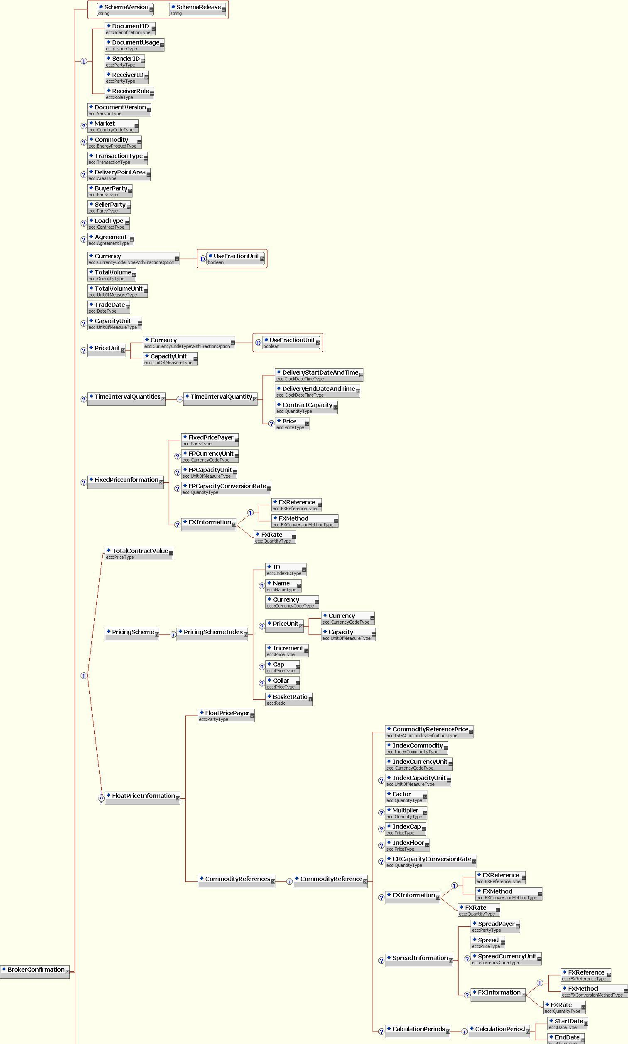
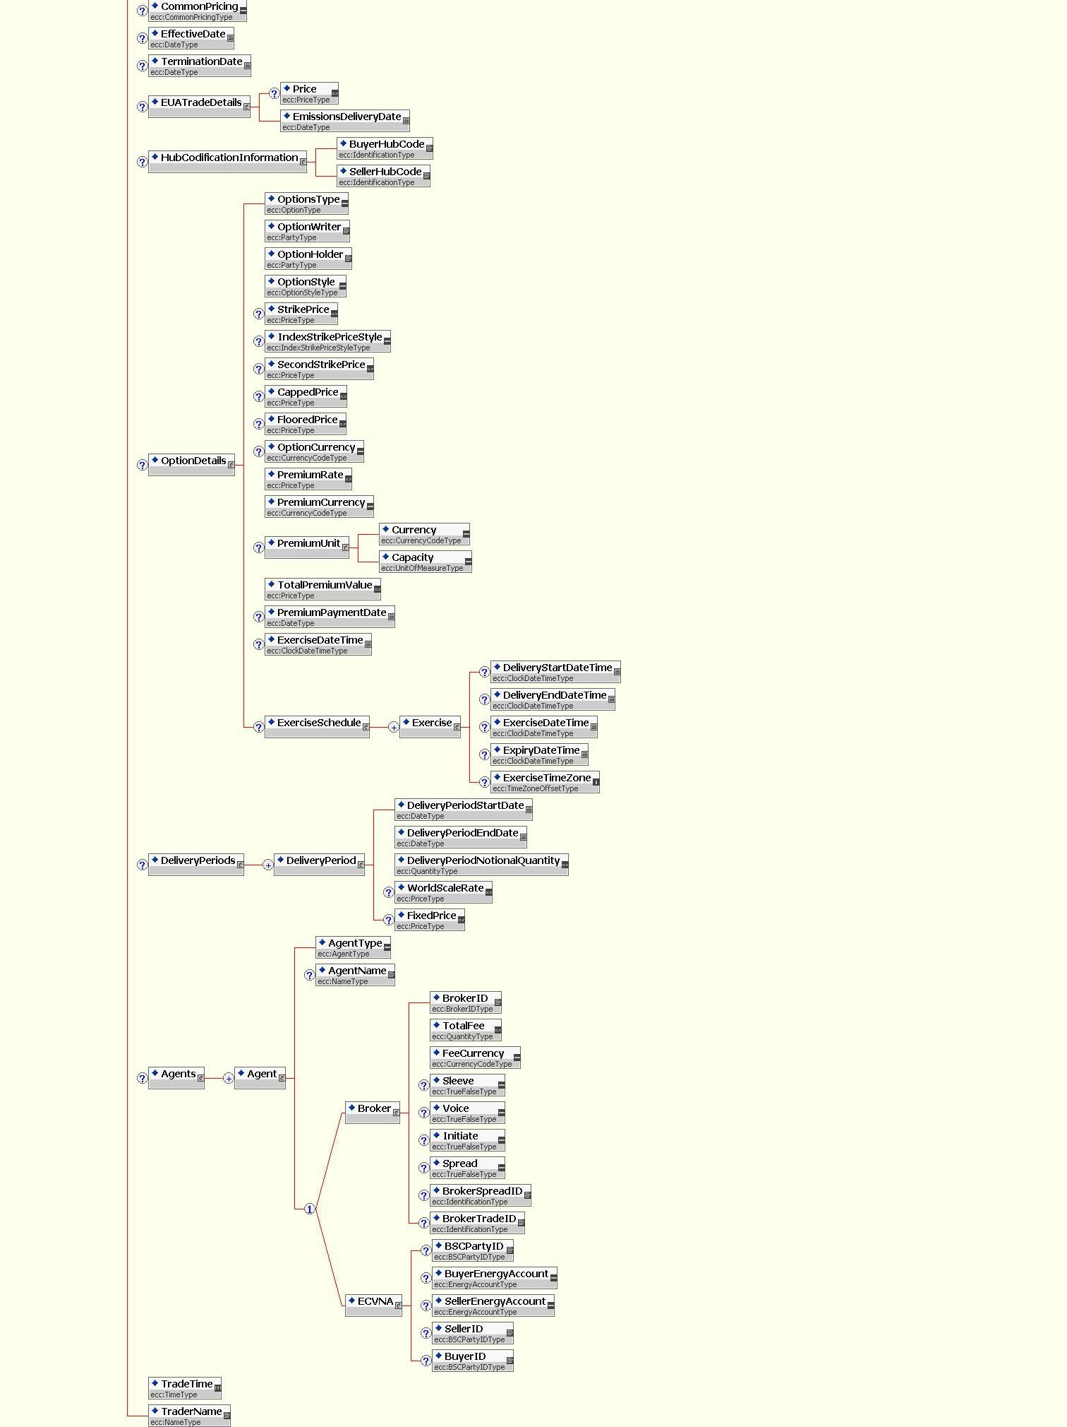

Figure 8: XML Schema for the BrokerConfirmation Document

Broker Fee Information Document
A Broker Fee Information document contains for one deal all fee-related information of the trader which is relevant only for the trader-broker match and which must not be disclosed to the counterparty. Hence a BFI document is not a standalone document but is always linked to a CNF. A BFI document references a DocumentID and is by definition linked to the CNF with this DocumentID and the highest version number. Hence when a BFI is linked to a CNF which is then amended the BFI is automatically linked to the new CNF. On the other hand a BFI document has its own version number so that it can be amended independently from the CNF it is linked to. This makes it possible to amend a BFI even after the linked CNF has been matched with a counterparty trade confirmation document and cannot itself be amended anymore. The fee-related information of the broker is provided in the BCN document.

Table 13: Element Specification for Broker Fee Information
Name | Mandatory/ Optional/ Conditional | Type | Key/ Information | Business Rule
Section: Document Header
DocumentID | Mandatory | IdentificationType | Information | The sender generates this ID that must be a unique reference compliant with naming standard defined in 5.1 Naming and Typing Conventions.  When a party receives a BFI with an ID unknown to the receiver then the receiver must treat this document as the initial version of a new BFI document. Otherwise the receiver must treat this document as an amendment of an already sent BFI document (see field “Document Version”).
Document Usage | Mandatory | UsageType
Document Version | Mandatory | VersionType | Information | The version number is always associated the Document ID. It is used to distinguish and order the initial BFI document and all its amendments over time. A fixed first version number for the initial BFI document is not defined (see field “Document ID”).
LinkedTo | Mandatory | Identification Type | Information | If the BFI is created by a trader it is linked to a trade confirmation document. The DocumentID of the confirmation (representing one deal) to which the included information about broker fees belongs. This information cannot be changed by amendments!  Two different BFI documents from the same sender with different DocumentIDs must not link to the same confirmation DocumentID!  The BFI document is always linked to the confirmation document with the given DocumentID and the highest version number.
SenderID | Mandatory | PartyType | Information | EIC Code of Sender
ReceiverID | Mandatory | PartyType | Information | Broker ID (although the BFI is not sent to the broker)
Receiver Role | Mandatory | RoleType | Information | Broker role applies as the document is being sent by a trader.
Section: Broker Fee Details
Total Fee | Mandatory | Quantity Type | Key | This field shall be rounded to 2 decimal places.
Fee Currency | Mandatory | CurrencyCode Type | Key

Broker Fee Information Document XML Schema
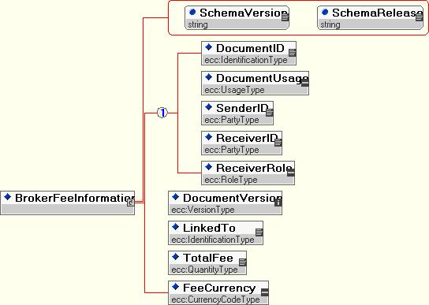

Figure 9: XML Schema for the Broker Fee Information Document

Document specific Business Rules for Broker Fee Information

Table 14: Business Rules for Rejections
ID | BUSINESS RULE
BFI001 | A BFI from a trader is linked to a CNF with the referenced DocumentID and the highest version number.
BFI002 | The referenced DocumentID cannot be changed by amendments.
BFI003 | Two different BFI documents from the same sender with different DocumentIDs must not link to the same confirmation DocumentID!
BFI004 | A BFI does not specify a document usage but inherits the document usage from the CNF it is linked to.
BFI005 | A BFI is rejected in case the defined receiver is not configured as partner.
BFI006 | For the purposes of rounding the field “Total Fee”, the rounding mechanism to be used must be ‘Rounding to Even’ such that:  - 3.016 rounded to hundredths is 3.02 (because the next digit (6) is 6 or more)  - 3.013 rounded to hundredths is 3.01 (because the next digit (3) is 4 or less)  - 3.015 rounded to hundredths is 3.02 (because the next digit is 5, and the hundredths digit (1) is odd)  - 3.045 rounded to hundredths is 3.04 (because the next digit is 5, and the hundredths digit (4) is even)  - 3.04501 rounded to hundredths is 3.05 (because the next digit is 5, but it is followed by non-zero digits)  This rounding mechanism must be applied to “Total Fee” for all transaction types and is therefore a retrospective change affecting eCM v3.1 and v3.2.

Broker Match Notification Document
A Broker Match Notification document is sent from the trader to the broker in order to inform the Broker about a preliminary or final match or a reversal of a preliminary match.

Table 15: Element Specification for Broker Match Notification
Name | Mandatory/ Optional/ Conditional | Type | Business Rule
Document Header
Document ID | Mandatory | Identification-Type | The sender generates this ID that must be a unique reference compliant with naming standard defined in 5.1 Naming and Typing Conventions.
Document Usage | Mandatory | UsageType
Sender ID | Mandatory | PartyType
Receiver ID | Mandatory | PartyType
Receiver Role | Mandatory | RoleType
Notification Type | Mandatory | NotificationFieldType | Identifies, if the match was preliminary, final or reverse.  One of the values: “preliminary”, “final”, “reverse”.
Process Type | Mandatory | ProcessFieldType | Indicates, if the counterparty was involved in the eCM matching at the trader’s side.  One of the values: “withCp” or “withoutCp”.
Reference Trade Confirmation Identifier
Referenced CNF Document ID | Mandatory | Identification-Type
Referenced CNF Document Version | Mandatory | VersionType
Referenced BCN Document ID | Mandatory | Identification-Type
Referenced BCN Document Version | Mandatory | VersionType
Referenced Trader BFI Document ID | Mandatory | Identification-Type
Referenced Trader BFI Document Version | Mandatory | VersionType

Broker Match Notification Document XML Schema
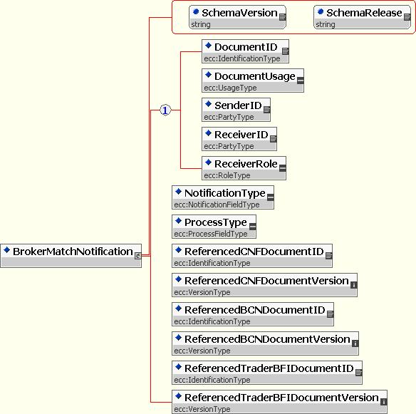

Figure 10: XML Schema for the Broker Match Notification Document

Document specific Business Rules for Broker Match Notification

Table 16: Business Rules for Rejections
ID | BUSINESS RULE
BMN001 | A BMN refers to a match between a (trader’s) CNF and BFI document and a broker’s BCN document.
BMN002 | A BMN of notification type “preliminary” is created, if a match between the trader and the counterparty did not yet occur, but the broker’s document matches with the trader’s document.
BMN003 | A BMN of notification type “final” is created, if the broker’s BCN matches with the trader’s CNF and BFI documents and the trader’s CNF has matched with the counterparty’s CNF or in the case that no counterparty match process exists (see BMN005).
BMN004 | A BMN of notification type “reverse” is created, if a preliminary match notification is reversed due to a trade amendment of the trader’s CNF or BFI / broker’s BCN or a cancellation of the trader’s CNF / broker’s BCN.
BMN005 | A BMN of Process Type “withCp” is sent in case the counterparty is involved in eCM. If the counterparty is not involved, the Process Type “withoutCp” is used.

State Processing
The eCM process comprises two related sub processes or dialogues:
- The Counterparty Dialogue
- The Broker Dialogue
The two dialogues are related through the participation, in both, of the same Trade Confirmation document. State processing is concerned with the progression of the business documents from the initial Pending state through to the Matched state. Within the Counterparty Dialogue the Trade Confirmation document from the Buyer is matched with a Trade Confirmation document from the Seller. In the case of the Broker Dialogue the Trade Confirmation document and Broker Fee Information of the Trader are matched with the Broker Confirmation document from the Broker.
In both cases the process is distributed with an instance of the process operating at each counterparty site and at the broker site. State changes of business documents, defined for each dialogue, must be synchronised between the instances of the process running at different sites to maintain the integrity of the overall process and to come to a consistent result regardless of location. The state processing is therefore presented below at three levels:
- business level – looking at the (unified) state transitions for the matching of the business documents: the Trade Confirmation, the Broker Confirmation and the Broker Fee Information documents
- communication level – looking at the state transitions for the ‘well processed’ processing of all documents including the business documents and the other supporting documents that are exchanged between the distributed instances of the process
- synchronisation level – looking at the state changes for the ‘well received’ processing that is dependent on the exchange of business Acknowledgement or Rejection documents and which synchronises the state changes between distributed instances of the process
Each of the diagrams and the processing they represent conforms to three fundamental premises:
- state changes for documents are at all times synchronised between distributed instances of the process
- all documents must be unique within all states of the current instance of the process
- only one version of a document is permitted to be active within the process at any time.
N.B. multiple versions may be queued until processing of the current version is complete.
N.B. Any messages entering the process that are not in strict compliance with the order of the dialogue or semantically correct according to the business rules defined for the documents must be rejected using a Rejection Document.

Business Document State Processing
The state processing of both the Counterparty and the Broker Dialogues are described below. The Trade Confirmation document participates in both dialogues and therefore has two state diagrams defined for it: one for the state changes defined for it in the Counterparty Dialogue and one for the state changes defined for it in the Broker Dialogue.

State Processing for the Trade Confirmation in the Counterparty Dialogue
Figure 5 Counterparty Process Trade Confirmation Document State Diagram shows the permitted state transitions for the Trade Confirmation document within the Counterparty Dialogue of the eCM Process. The diagram is valid for both the Buyer and Seller instance of the process.
Validated documents entering the business process from the communications process are assigned the Pending state signifying that they are available for matching. In the Buyer instance of the process the matching algorithm is applied as defined in Section 4.4, ‘Suggested Match’ Processing.
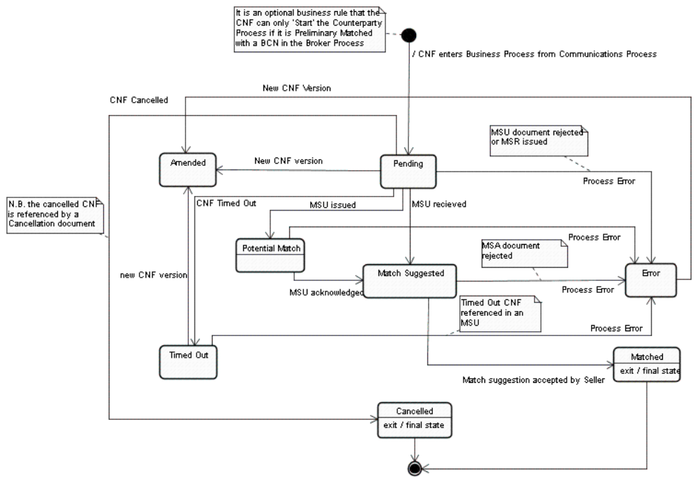Figure 5 Counterparty Process Trade Confirmation Document State Diagram
Once a potential match is detected by the Buyer instance of the process the result is suggested to the Seller instance of the process and the two instances progress to the Match Suggested state via the interim state ‘Potential Match’ in the case of the Buyer instance of the process..
In the Match Suggested state the Seller instance of the process validates the match suggestion made by the Buyer instance using the algorithm defined in Section 4.4, ‘Suggested Match Acceptance/Refusal’ Processing. If a different result is calculated then the Seller cannot accept the suggested match and must refuse; in this case the Trade Confirmation documents in both instances of the process are moved to the Error state. The failure to calculate a common result must be handled outside the process.
If there are problems progressing each instance of the process in a synchronized way then documents in both instances will be assigned to the Error state. Once the processing error has been corrected then the process can be restarted by submitting a new version of the relevant Trade Confirmation documents.
If the match suggestion can be accepted by the Seller instance of the process then the documents are moved to the Matched state and the process in both instances terminates.
Trade Confirmation documents in the Pending state may be assigned to the Amended, Cancelled or Timed Out states based on external events: either the arrival of a higher version of the same Trade Confirmation document identified by the Document ID, the issue of a Cancellation document, or a timer event that measures the ‘life’ of a Trade Confirmation document within the process.
The Matched, Amended and Cancelled states are final states for the Trade Confirmation document.

State Processing for the Trade Confirmation in the Broker Dialogue
Figure 6 Trade Confirmation Document Broker Dialogue State Diagram shows the permitted state transitions for the Trade Confirmation document within the Broker Dialogue of the eCM Process. The diagram is only valid for the local Trade Confirmation document within the Trader instance of the process since the Trade Confirmation document is not issued to the Broker furthermore the matching algorithm is applied only in the Trade instance of the process.
N.B. The counterparty Trade Confirmation document also does not participate in the Broker Dialogue within the ‘local’ instance of the eCM process but may be part of a separate Broker Dialogue within its own ‘local’ instance of the eCM process.

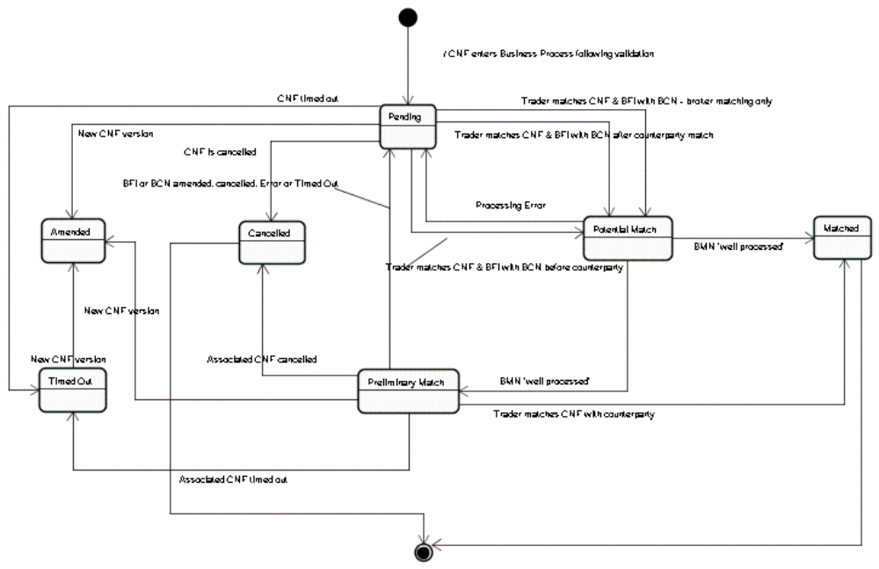Figure 6 Trade Confirmation Document Broker Dialogue State Diagram
The Trade Confirmation document entering the business process, if both counterparties are participating in the Counterparty Dialogue, from the communications process, where it is issued to the counterparty as defined in the Counterparty Dialogue, but not to the Broker, is assigned the Pending state signifying that it is available for matching. In the Trader instance of the process the Trade Data matching algorithm is applied, as defined in Section 4.4, to link the Trade Confirmation with a Broker Confirmation document. Subsequently the Broker Match is performed by the Trader instance of the process to validate the brokerage against the Broker Fee Information document.
The state of the Trade Confirmation is then progressed to the Preliminary Matched or fully Matched state via the interim ‘Potential Match’ state, depending on certain conditions in the related Counterparty Dialogue within the Trader instance of the eCM process.
If the Trade Confirmation document has not entered the Counterparty Dialogue, or is in the Pending, Match Suggested or Error (i.e. non final) state then the Trade Confirmation is progressed to the Preliminary Matched state in the Broker Dialogue on successful delivery of the Broker Match Notification document to the Broker instance of the process.
If the Trade Confirmation document within the Counterparty Dialogue is in the Matched state then the Trade Confirmation is progressed to the Matched state in the Broker Dialogue on successful delivery of the Broker Match Notification document to the Broker instance of the process.
If the Trade Confirmation is not participating in a Counterparty Dialogue then the Trade Confirmation is progressed to the Matched state in the Broker Dialogue on successful delivery of the Broker Match Notification document to the Broker instance of the process.
If the Trade Confirmation document has been moved to the Preliminary Matched state then an amendment to the Trade Confirmation will cause the current version to be set to the final state of Amended.
If the Trade Confirmation document has been moved to the Preliminary Matched state it can be re assigned to the Pending state if either the Broker Fee Information or Broker Confirmation documents are Amended, Cancelled, Timed Out or receive a Rejection Document from the Broker instance of the process when issuing a BMN.
Trade Confirmation documents in the Pending or Preliminary Matched states may be assigned to the Amended, Cancelled or Timed Out states based on external events: either the arrival of a higher version of the same Trade Confirmation document identified by the Document ID, the issue of a Cancellation document, or a timer event that measure the ‘life’ of a Trade Confirmation document within the process.
The Matched, Amended and Cancelled states are final states for the Trade Confirmation document.

State Processing for the Broker Fee Information in the Broker Dialogue
Figure 7 Broker Fee Information Document State Diagram shows the permitted state transitions for the Broker Fee Information document within the Broker Dialogue of the eCM Process. The diagram is only valid for the local Broker Fee Information document within the Trader instance of the process since the Broker Fee Information document is not issued to the Broker (or the Counterparty) furthermore the matching algorithm is applied only in the Trade instance of the process.
The Broker Fee Information document is an associated document of the Trade Confirmation and as such shares the same or similar state processing.
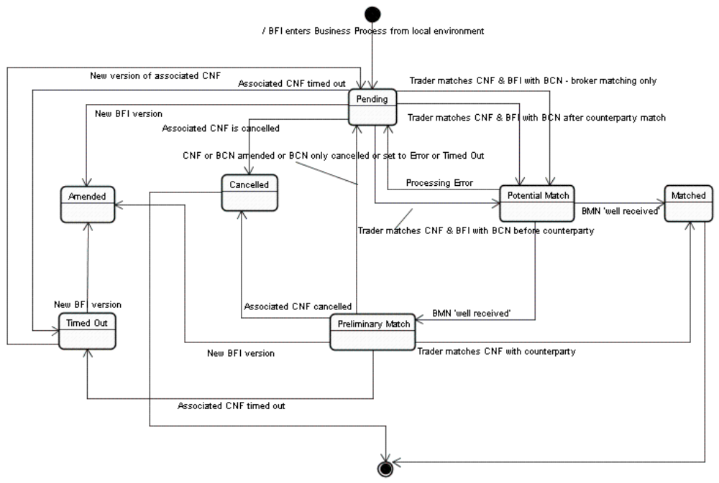Figure 7 Broker Fee Information Document State Diagram
Unlike the Trade Confirmation document the Broker Fee Information document does not participate in the Counterparty Dialogue and so is not subject to any cross dialogue constraints that apply to the Trade Confirmation Document
The Broker Fee Information document entering the business process from the local environment, since it is not issued to the Broker or Counterparty instance of the process, is assigned the Pending state signifying that it is available for matching. In the Trader instance of the process once the Trade Data matching algorithm is applied, as defined in Section 4.4, to link the Trade Confirmation with a Broker Confirmation document the Broker Match is subsequently performed by the Trader instance of the process to validate the brokerage in the Broker Confirmation against the Broker Fee Information document associated with the linked Trade Confirmation document.
The state of the Broker Fee Information is then progressed to the Preliminary Matched or fully Matched state via the interim ‘Potential Match’ state, in line with the state change of the associated Trade Confirmation document and on successful delivery of the Broker Match Notification document to the Broker instance of the process.
If the Broker Fee Information document has been moved to the Preliminary Matched state then an amendment to the Broker Fee Information will cause the current version to be set to the final state of Amended.
If the Broker Fee Information document has been moved to the Preliminary Matched state it must be re assigned to the Pending state if either the Trade Confirmation or Broker Confirmation documents are Amended, or if the Broker Confirmation is Cancelled, set to the Error state or Timed Out.
Broker Fee Information documents in the Pending or Preliminary Matched states may be assigned to the Amended, Cancelled or Timed Out states based on external events: either the arrival of a higher version of the same Broker Fee Information document identified by the Document ID, the issue of a Cancellation document for the associated Trade Confirmation, or when the associated Trade Confirmation document is moved to the Timed Out state.
The Matched, Amended and Cancelled states are final states for the Broker Fee Information document.

State Processing for the Broker Confirmation in the Broker Dialogue
Figure 8 Broker Confirmation State Diagram shows the permitted state transitions for the Broker Confirmation document within the Broker Dialogue of the eCM Process. The diagram is valid for the Broker Confirmation document within the Trader instance of the process and the Broker Confirmation within the Broker instance of the process.
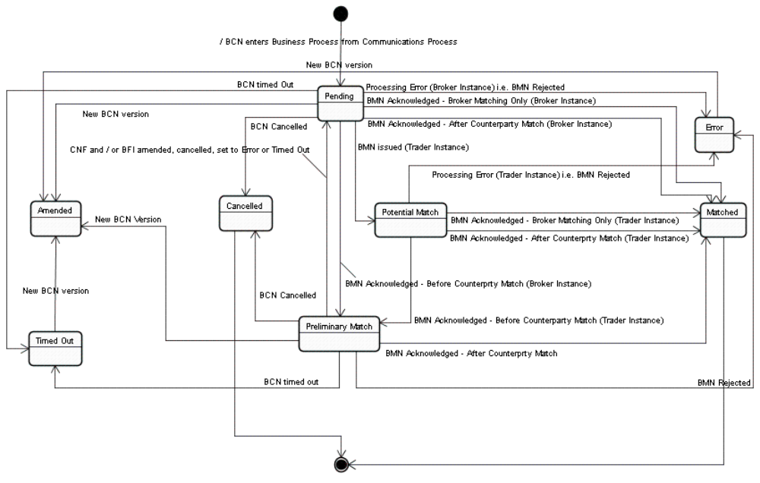Figure 8 Broker Confirmation State Diagram
The Broker Confirmation document entering the business process from the communications process is assigned the Pending state signifying that it is available for matching. In the Trader instance of the process the Trade Data matching algorithm is applied, as defined in Section 4.4, to link the Trade Confirmation with a Broker Confirmation document. Subsequently the Broker Match is performed by the Trader instance of the process to validate the brokerage in the Broker Confirmation against the Broker Fee Information document.
The state of the Broker Confirmation in the Trader instance of the process is then progressed via the interim ‘Potential Match’ state to the Preliminary Matched or fully Matched state depending on certain conditions for the Trade Confirmation document in the related Counterparty Dialogue within the Trader instance of the eCM process. The interim ‘Potential Match’ state is not valid in the Broker instance of the process and the Broker Confirmation document is moved directly to the same ‘Preliminary Matched’ or ‘Match’ state in synchronisation with the Trader instance of the process.
If the Trade Confirmation document within the Confirmation Dialogue is in the Pending, Match Suggested or Error (i.e. non final) state then the Broker Confirmation is progressed to the Preliminary Matched state in the Broker Dialogue
If the Trade Confirmation document within the Confirmation Dialogue is in the Matched state then the Broker Confirmation is progressed to the Matched state in the Broker Dialogue.
If the Trade Confirmation is not participating in a Counterparty Dialogue then the Broker Confirmation is progressed to the Matched state in the Broker Dialogue.
In case there is a processing error when synchronising the state change of the Broker Confirmation document with the Broker Confirmation document in the Broker instance of the process then the Broker Confirmation documents in both instances of the process are assigned the state of Error (or left in the Amended state if it was already there). The error in processing must be resolved outside the scope of the defined dialogue. Once the error is resolved then the Broker Dialogue can be restarted by amendment of the Broker Confirmation document and/or the Broker Fee Information and Trade Confirmation documents.
If the Broker Confirmation document has been moved to the Preliminary Matched state then an amendment to the Broker Confirmation will cause the current version to be set to the final state of Amended.
If the Broker Confirmation document has been moved to the Preliminary Matched state it can be re assigned to the Pending state if either the Trade Confirmation or Broker Fee Information documents are Amended, Cancelled, set to the Error state or Timed Out.
Broker Confirmation documents in the Pending or Preliminary Matched states may be assigned to the Amended, Cancelled or Timed Out states based on external events: either the arrival of a higher version of the same Broker Confirmation document identified by the Document ID, the issue of a Cancellation document for the Broker Confirmation, or a timer event that measure the ‘life’ of a Broker Confirmation document within the process.
The Matched, Amended and Cancelled states are final states for the Broker Confirmation document.

General Document Exchange State Processing

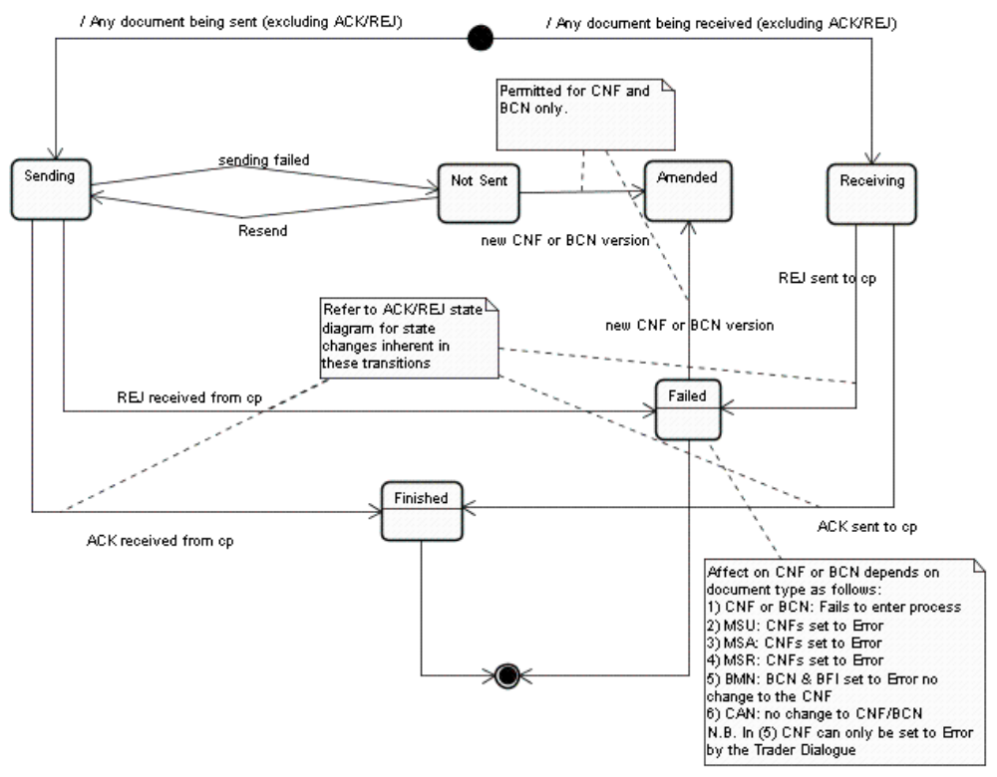

Figure 9 General Document State Processing
Figure 9 General Document State Processing shows the permitted state transitions that apply to all business documents (excluding Acknowledgement and Rejection documents). These state transitions deal specifically with the exchange of documents between the Buyer and Seller and conform to the principles of synchronicity and uniqueness for documents in the process as previously stated.
By definition the state diagram is asymmetric as document exchange is directional i.e. from the sender and to the receiver. A document entering the process will therefore be in either the Sending or Receiving state when it is being transferred from one distributed instance of the process to the other instance.
On entry to the ‘Sending’ state any pre issue validation of business documents must be applied as specified in Section 6.4 Detailed Transition Processing.
A document in the ‘Sending’ state will move to the ‘Not Sent’ state if the delivery cannot be successfully achieved i.e. not ‘well received’. The ‘Not Sent’ state is an exception state and an external trigger is required to return it to the Sending state (i.e. either a timer or manual intervention).
Any validation required when sending the document must be reapplied on re-entry to the Sending state.
A document in the Receiving state will be ‘well received’ but not yet ‘well processed’. Validation against relevant business rules will result in the acceptance or rejection of the document leading to the issue of a business Acknowledgement or Rejection document as appropriate.
If the document was ‘well processed’ then an Acknowledgement Document is issued and it is moved to the ‘Finished’ state and the document exchange process terminates.
If the document is not ‘well processed’ then a Rejection Document is issued and it is moved to the Failed state and the document exchange process terminates. The affect that a business rejection has on the broader eCM process depends on the status of the business documents and is described in later sections.
New versions of business documents (defined as the same Document ID but a higher Version number) entering the process will cause earlier versions in the Not Sent or Failed states to be moved to the Amended state and will then themselves be processed. In the case of business documents in the Finished state new versions will not cause a transition for a previous version to the Amended state. The arrival of a new version of a business document within the Business Process is defined in 6.4 Detailed Transition Processing.
N.B. For the purpose of implementation the ability to raise alerts on ‘Failed’ states in the communications process would be useful in alerting operators to the occurrence of a communications failure.
N.B. in case of race conditions documents will be rejected as a pre-caution in order to avoid state changes becoming unsynchronised or dead-lock situations occur between distributed instances of the process.

Acknowledgement/Rejection Document State Processing

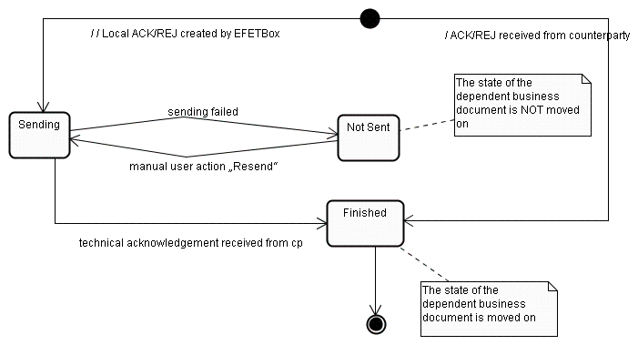

Figure 10 Acknowledgement/Rejection State Processing
Figure 10 Acknowledgement/Rejection State Processing defines the permitted state processing that applies to business Acknowledgement and Rejection documents. These state transitions relate to the synchronisation of state changes between the Buyer and Seller instances of the eCM process.
This process is invoked by the ‘Receiving’ state to communicate whether an exchanged document is ‘well processed’ or not.
The document (Acknowledgement or Rejection) will be assigned the state of ‘Sending’ and will move to the ‘Not Sent’ state if it is not ‘well received’. The ‘Not Sent’ state is an exception state and external intervention is required to return it to the Sending state. In this circumstance the ‘Receiving’ state will persist until the document (Acknowledgement or Rejection) is ‘well received’ and the state moved to ‘Finished’ at which point this instance of the process terminates. Consequently the document in the ‘Received’ state also proceeds to the final state.
Once the document (Acknowledgement or Rejection) is successfully delivered it is also assigned the state ‘Finished’ and the process terminates causing the document that is in the ‘Sending’ state in the remote instance of the document exchange process will progress to the final state so synchronising the two distributed process instances and the state changes of the business documents with both instances of the eCM process.
N.B. The one hour period relating to the transition from ‘Sending to CP’ to ‘Failed’ states in previous versions of the standard are here replaced by the ability to resent the ACK document.

Detailed Transition Processing
Each of the following sections defines the detailed business rules for ‘well processed’ business documents within the Counterparty and the Broker Processes.

Trade Confirmation in the Counterparty Dialogue

Start to Pending
Two Trade Confirmation document may enter an instance of the counterparty dialogue within the eCM process: the local CNF and the remote CNF. Both documents must be ‘well processed’ before they are assigned the Pending status.
A ‘well processed’ Trade Confirmation document:
- may be a new document unknown to the current or a previous process instance
- a higher version of a document with the same Document ID but a higher Version number in which case:
  - the current version of the document must be in the Pending, Timed Out or Error state
  - the current version and any earlier versions of the document must not be in a final state (i.e. Matched or Cancelled)
  - The current version must not be in the Match Suggested state nor be referenced in a Matched Suggestion document that has not yet reached the ‘Finished’ state of the Communication Process
  - Must pass validation as defined in Section 6.4.2.1Start to Pending if participating in the Broker Dialogue
N.B. Should a lower version of a Trade Confirmation document existing in the Business Process progress to a final state then any higher versions of the Trade Confirmation document that might have entered the communications process will be set to Failed.

Pending to Potential Match
The Buyer instance of the process takes the lead and applies the matching algorithm defined. Once a potentially matching document has been identified by the Buyer an MSU document is created.
To avoid race conditions the Buyer instance checks that the state of the specific versions of the Trade Confirmation documents from the Buyer or Seller referenced in the MSU are still in the Pending state. If they are then the MSU is passed to the Communication Process where it is assigned the state ‘Sending’. If not then the MSU is deleted from the process instance and the Buyer instance of the process restarts the matching process.
When the ‘Sending’ state has been assigned to the MSU in the Communications Process the Trade Confirmation documents referenced in the MSU are assigned to the state ‘Potential Match’ and are removed from the matching queue within the Buyer instance of the process.
N.B. The is no transition specified from Potential Match to Amended since a trade Confirmation document in the Potential Match state cannot be amended.

Potential Match to Match Suggested
‘Potential Match’ is an interim state and is unique to the Buyer instance of the process. It lasts until the MSU has reached an end state in the Communication Process: ‘Finished’ or ‘Failed’.
If the MSU is assigned to the ‘Finished’ state in the Communications Process then the referenced Trade Confirmation documents in the Buyer instance of the process will be moved from the ‘Potential Match’ to ‘Match Suggested’ state.

Potential Match to Error
‘Potential Match’ is an interim state and is unique to the Buyer instance of the process. It lasts until the MSU has reached an end state in the Communication Process: ‘Finished’ or ‘Failed’.
If the MSU is assigned to the ‘Failed’ state in the Communications Process then the referenced Trade Confirmation documents in the Buyer instance of the process will be moved from the ‘Potential Match’ to ‘Error’ state.

Pending to Match Suggested
An MSU will be ‘well processed’ by the Seller if the Trade Confirmation documents referenced in the MSU are:
- known to the Seller instance of the process
- in the Pending state.
If the MSU is ‘well processed’ by the Seller instance then the state of the Trade Confirmation documents (in both instances of the process) are synchronised to the new state of ‘Match Suggested’ and the control moves to the Seller instance.
If either of the Trade Confirmation documents referenced in the MSU cannot be identified in the set of CNFs in the ‘Pending’ state, for instance one or both are in the Timed Out state, a then the MSU will not be ‘well processed’ i.e. set to the Failed state in the Communications Process. As defined in Section 6.2 General Document Exchange State Processing, a Rejection document will be issued to the Buyer with a reason explaining the processing error i.e. that a time out had occurred.
Otherwise the Seller instance must independently validate the suggested match received via the MSU document from the Buyer.
If the comparison Seller can agree to the match suggested by the Buyer then a Match Result Acceptance document will be issued by the Seller instance of the process; otherwise a Matching Result Refusal document will be issued.

Pending to Error
A Trade Confirmation document in both the Buyer and Seller instances of the process will be set to the Error state from the Pending state, if it is referenced in a Rejection document (i.e. set to the Failed state in the Communications Process).

Match Suggested to Error
A Trade Confirmation document in both the Buyer and Seller instances of the process will be set to the Error state from the Match Suggested state under the following circumstances:
- If it is referenced in an MSR document that is successfully delivered (i.e. is ‘well processed’)
- If it is referenced in an MSR document that not ‘well processed’ (i.e. set to the Failed state in the Communications Process)
- If it is referenced in an MSA document that not ‘well processed’ (i.e. set to the Failed state in the Communications Process)
MRS and MSA documents will be ‘well processed’ by the Buyer if the Match Suggestion document referenced in the MSR or MSA is known to the Buyer instance of the process and that the Trade Confirmation documents referenced by the MSU can also be identified as belonging to the set of ‘Match Suggested’ documents, otherwise the document will not be ‘well processed’ (i.e. set to the Failed state in the Communications Process).

Match Suggested to Matched
Receipt of a ‘well processed’ Match Suggestion Acceptance document issued to the Buyer by the Seller will result in the transition of the Trade Confirmation documents identified in the MSU referenced by the MSA in both instance of the process from the Match Suggested state to the Matched state in synchronisation.
The MSA will be ‘well processed’ if the relevant Trade Confirmation documents are known to the Buyer instance of the process.
The ‘Matched’ state is a final state for the process and both instances will terminate.

Pending to Amended
If a Trade Confirmation document is in the ‘Pending’ state it may be moved, synchronously within both instances of the process, to the ‘Amended’ state by the assignment of a later and higher version of the same document to the ‘Pending’ state within both instances of the process.
‘Well processed’ processing for the new version of the document is defined previously in 6.4.1.1 Start to Pending.
The ‘Amended’ state is a final state for amended version of the Trade Confirmation document, since it cannot be further processed, but not for the process.

Pending to Timed Out
If a Trade Confirmation document is in the ‘Pending’ state it will be moved, to the ‘Timed Out’ state once the time out period, specified elsewhere, has passed.

Pending to Cancelled
If a Trade Confirmation document is in the ‘Pending’ state it will be moved, to the ‘Cancelled’ state on the entry into the process of a successfully delivered Cancellation document.
The Cancellation document before being issued to the counterparty instance of the process will first be validated against the local instance of the process to verify that it refers to Trade Confirmation documents known to the local Business Process instance that is in the Pending state. If this is not the case then it will be assigned the status of ‘Failed’ within the local instance of the Communications Process.
A Cancellation document will be ‘well processed’ if it refers to a document known to the instance of the process.
The ‘Cancelled’ state is a final state for the process and both instances will terminate.

Timed Out to Amended
If a Trade Confirmation document is in the ‘Timed Out’ state it may be moved, synchronously within both instances of the process, to the ‘Amended’ state by the assignment of a later and higher version of the same document to the ‘Pending’ state within both instances of the process.
‘Well processed’ processing for the new version of the document is defined previously in 6.4.1.1 Start to Pending.
The ‘Amended’ state is a final state for amended version of the Trade Confirmation document, since it cannot be further processed, but not for the process.

Timed Out to Error
A Trade Confirmation document in the Timed Out state in will be set to the Error state, if it is referenced by an MSU document or if it is referenced in a Rejection document.
This might occur when an MSU issued by the Buyer instance of the process references two Trade Confirmation documents which are in the Pending state in the Buyer instance but one or both of which has been assigned to the Timed Out state in the Seller instance of the process. This might be caused by a transition during the delivery or poor synchronisation in time out processing between Buyer and Seller instances due to implementation issues.

Error to Amended
If a Trade Confirmation document is in the ‘Error’ state it may be moved, synchronously within both instances of the process, to the ‘Amended’ state by the assignment of a later and higher version of the same document to the ‘Pending’ state within both instances of the process.
‘Well processed’ processing for the new version of the document is defined previously in 6.4.1.1Start to Pending.
The ‘Amended’ state is a final state for amended version of the Trade Confirmation document, since it cannot be further processed, but not for the process.

Trade Confirmation in the Broker Dialogue

Start to Pending
The trader instance of the broker dialogue of the eCM process accepts and matches a Trade Confirmation document from the trader and a Broker Confirmation document from the broker. The Trade Confirmation from the trader is not issued to the broker instance and so state changes for the Trade Confirmation document do not need to be synchronised between the trader and broker instance.
The Trade Confirmation document can participate in either or both the Counterparty and Broker dialogues of the eCM process. On entry into the business process it is therefore subject to validation in each dialogue to which it is submitted.
A ‘well processed’ Trade Confirmation document:
- may be a new document unknown to the current or a previous process instance (both dialogues)
- a higher version of a document with the same Document ID but a higher Version number in which case:
  - the current version of the document must be in the Pending, Preliminary Matched or Timed Out
  - the current version and any earlier versions of the document must not be in a final state (i.e. Matched or Cancelled)
  - The current version must not be referenced in a Broker Match Notification document with the Notification Type of ‘preliminary’ or ‘final’ that has not yet reached the ‘Finished’ state of the Communication Process
  - must pass validation as defined in Section 6.4.1.1 Start to Pending if participating in the Counterparty Dialogue
N.B. Should a lower version of a Trade Confirmation document existing in the Business Process progress to a final state then any higher versions of the Trade Confirmation document that might have entered the communications process will be set to Failed.
N.B. Unless the Broker dialogue has been specifically prioritised (see Detailed Brokered Trade Confirmation Dialogue) then this transition must always be completed after the transition of the CNF from Start to Pending in the Broker Dialogue as described in 6.4.1.1 Start to Pending. Otherwise if the Broker dialogue has been prioritised and this is the first version of the CNF to enter the process, then CNF must not be issued to the counterparty via the Communications Process until the CNF in the Broker Dialogue has been set to the Preliminary Matched state.

Pending to Potential Match
The trader instance of the process applies the matching algorithm defined. Once a matching Broker Confirmation document has been identified by the trader a BMN document is created.
To avoid race conditions the trader instance checks that the state of the specific versions of the Trade Confirmation document, Broker Confirmation and Broker Fee Information referenced in the BMN are still in the Pending state. If they are then the BMN is passed to the Communication Process where it is assigned the state ‘Sending’. If not then the BMN is deleted from the process instance and the trader instance of the process restarts the matching process.
When the ‘Sending’ state has been assigned to the BMN in the Communications Process the Trade Confirmation document referenced in the BMN is assigned to the state ‘Potential Match’ and is removed from the matching queue within the Trader instance of the process.
N.B. The is no transition specified from Potential Match to Amended since a trade Confirmation document in the Potential Match state cannot be amended.

Potential Match to Preliminary Matched or Matched
‘Potential Match’ is an interim state and is unique to the Trader instance of the process. It lasts until the BMN has reached an end state in the Communication Process: ‘Finished’ or ‘Failed’.
If the BMN is assigned to the ‘Finished’ state in the Communications Process then the referenced Trade Confirmation documents in the Trader instance of the process will be moved from the ‘Potential Match’ to ‘Preliminary Match’ or ‘Matched’ state.
A BMN will be ‘well processed’ by the broker instance if the Broker Confirmation document referenced in the BMN is:
- known to the broker instance of the process
- in the Pending or Preliminary Matched state.
If the BMN is ‘well processed’ by the broker instance then the state of the Trade Confirmation document is set to the new state of:
- Preliminary Matched if the Notification Type in the BMN is ‘preliminary’
- Matched if the Notification Type in the BMN is ‘final’.
‘Matched’ is a terminal state, in which case the dialogue terminates.

Potential Match to Pending
‘Potential Match’ is an interim state and is unique to the Trader instance of the process. It lasts until the BMN has reached an end state in the Communication Process: ‘Finished’ or ‘Failed’.
If the BMN is assigned to the ‘Failed’ state in the Communications Process then the referenced Trade Confirmation document in the Trader instance of the process will be moved from the ‘Potential Match’ to the ‘Pending’ state since the processing error exisits in the Broker instance of the process and can now only be resolved by amendment of the BCN document which has been moved to the ‘Error’ state as specified in 6.4.3.4 Potential Match to Error (Trader instance) and Section 6.4.3.12 Pending to Error.

Preliminary Matched to Matched
This transition is triggered by an external event: the transition to the ‘Matched’ state of the Trade Confirmation document in the Counterparty Dialogue of the eCM process.
To avoid race conditions the trader instance checks that the state of the specific versions of the Trade Confirmation document, Broker Confirmation and Broker Fee Information referenced in the BMN are still in the Pending state. If they are then the BMN is issued to the broker. If not then the BMN is deleted from the process instance and the trader instance of the process restarts the matching process.
A BMN will be ‘well processed’ by the broker instance if the Broker Confirmation document referenced in the BMN is:
- known to the broker instance of the process
- in the Preliminary Matched state.
If the BMN is ‘well processed’ by the broker instance then the state of the Trade Confirmation document is set to the ‘Matched’ state if the Notification Type in the BMN is ‘final’.
‘Matched’ is a terminal state, In which case the dialogue terminates.
If the BMN is not ‘well processed’ then the Trade Confirmation remains in the Preliminary Matched state and is subject to further matching.

Preliminary Matched to Pending
This transition is triggered by the Broker Fee Information document associated with the Trade Confirmation or the Broker Confirmation being assigned to one of the following states:
- Timed Out
- Amended
- Error
- Cancelled
A BMN will be ‘well processed’ by the broker instance if the Broker Confirmation document referenced in the BMN is:
- known to the broker instance of the process
- in the Preliminary Matched state.
If the BMN is ‘well processed’ by the broker instance then the state of the Trade Confirmation document is set to the ‘Pending’ state if the Notification Type in the BMN is ‘reverse’.
If the BMN is not ‘well processed’ then the Trade Confirmation is set to Pending state and is subject to further matching.
Furthermore, if the BMN is assigned to the ‘Failed’ state in the Communications Process then the referenced Trade Confirmation document in the Trader instance of the process will be moved from the ‘Preliminary Match’ to ‘the ‘Pending’ state since the processing error exisits in the Broker instance of the process and can now only be resolved by amendment of the BCN document which has been moved to the ‘Error’ state as specified in 6.4.3.4 Potential Match to Error (Trader instance) and Section 6.4.3.12 Pending to Error.

Pending or Preliminary Matched to Timed Out
If a Trade Confirmation document is in the ‘Pending’ or ‘Preliminary Matched’ state it will be moved, to the ‘Timed Out’ state once the time out period, specified elsewhere, has passed and only if the state of the Trade Confirmation document in the Counterparty Dialogue has not achieved the ‘Matched’ state.

Pending or Preliminary Matched to Amended
If a Trade Confirmation document is in the ‘Pending’ or ‘Preliminary Matched’ state it may be moved, to the ‘Amended’ state by the assignment of a later and higher version of the same document to the ‘Pending’ state within the trader instance of the process.
‘Well processed’ processing for the new version of the document is defined previously in Section 6.4.2.1 Start to Pending.
The ‘Amended’ state is a final state for amended version of the Trade Confirmation document, since it cannot be further processed, but not for the process.

Timed Out to Amended
If a Trade Confirmation document is in the ‘Timed Out’ state it may be moved, to the ‘Amended’ state by the assignment of a later and higher version of the same document to the ‘Pending’ state within both instances of the process.
‘Well processed’ processing for the new version of the document is defined previously in 6.4.2.1 Start to Pending
The ‘Amended’ state is a final state for amended version of the Trade Confirmation document, since it cannot be further processed, but not for the process.

Pending or Preliminary Matched to Cancelled
If a Trade Confirmation document is in the ‘Pending’ or ‘Preliminary Matched’ state it will be moved, to the ‘Cancelled’ state on the entry into the process of a Cancellation document.
The ‘cancelled’ state is a final state for the process and the instance will terminate.

Broker Confirmation in the Broker Dialogue

Start to Pending
Within the Broker Dialogue the Broker Confirmation enters both the trader and broker instance of the eCM process. The state processing of the Broker Confirmation document must therefore be synchronised between the two instances.
A ‘well processed’ Broker Confirmation document:
- may be a new document unknown to the current or a previous process instance
- a higher version of a document with the same Document ID but a higher Version number in which case:
  - the current version of the document must be in the Pending, Preliminary Matched, Timed Out or Error state
  - the current version and any earlier versions of the document must not be in a final state (i.e. Matched or Cancelled)
  - The current version must not be referenced (in the trader instance) in a Broker Match Notification document with the Notification Type of ‘preliminary’ or ‘final’ that has not yet reached the ‘Finished’ state of the Communication Process
N.B. Should a lower version of a Broker Confirmation document existing in the Business Process progress to a final state then any higher versions of the Broker Confirmation document that might have entered the communications process will be set to Failed.

Pending to Potential Match (Trader instance only)

This state transition is valid for the Trader instance of the process only.
When the ‘Sending’ state has been assigned to a BMN in the Communications Process the Broker Confirmation document referenced in the BMN is assigned to the state ‘Potential Match’ and is removed from the matching queue within the Trader instance of the process.

Potential Match to Preliminary Matched or Matched (Trader instance only)
‘Potential Match’ is an interim state and is unique to the Trader instance of the process. It lasts until the BMN has reached an end state in the Communication Process: ‘Finished’ or ‘Failed’.
The state of the Broker Confirmation in trader instance of the process is progressed to the ‘Preliminary Matched’ or ‘Matched’ states from the ‘Potetnial Match’ on the successful issue of a BMN from the trader to the broker instance of the process as described in Section 6.4.2.3 Potential Match to Preliminary Matched or Matched.

Potential Match to Error
‘Potential Match’ is an interim state and is unique to the Trader instance of the process. It lasts until the BMN has reached an end state in the Communication Process: ‘Finished’ or ‘Failed’.
If the BMN is assigned to the ‘Failed’ state in the Communications Process then the referenced Broker Confirmation document in the Trader instance of the process will be moved from the ‘Potential Match’ to the ‘Error’ state in synchronisation with the Broker Confirmation document in the Broker instance of the process ths removing the document instances from further processing.

Pending to Preliminary Matched or Matched (Broker instance only)
The state of the Broker Confirmation in the broker instance of the process is progressed to the ‘Preliminary Matched’ or ‘Matched’ states in a synchronised way with the Broker Confirmation document in the Trader instance of the process on the successful issue (Acknowledgement) of a BMN from the trader to the broker instance of the process as described in Section6.4.2.3 Potential Match to Preliminary Matched or Matched.

Preliminary Matched to Matched
The state of the Broker Confirmation in both the trader and broker instances of the process is progressed to the ‘Matched’ states in a synchronised way on the successful issue of a BMN from the trader to the broker instance of the process as described in Section 6.4.2.3 Potential Match to Preliminary Matched or Matched.

Preliminary Matched to Pending
This transition is triggered by the Broker Fee Information document associated with the Trade Confirmation that has been preliminarily matched with the Broker Confirmation being assigned to one of the following states:
- Timed Out
- Amended
- Error
- Cancelled
Or by the Trade Confirmation being assigned one of the following states:
- Timed Out
- Amended
- Cancelled
The BMN processing as described in Section 6.4.2.6 Preliminary Matched to Pending.

Pending or Preliminary Matched to Timed Out
If a Broker Confirmation document is in the ‘Pending’ or ‘Preliminary Matched’ state it will be moved to the ‘Timed Out’ state once the time out period, specified elsewhere, has passed.

Pending or Preliminary Matched to Amended
If a Broker Confirmation document is in the ‘Pending’ or ‘Preliminary Matched’ state it may be moved, to the ‘Amended’ state by the assignment of a later and higher version of the same document to the ‘Pending’ state within the trader instance of the process.
‘Well processed’ processing for the new version of the document is defined previously in Section 6.4.3.1 Start to Pending.
The ‘Amended’ state is a final state for amended version of the Trade Confirmation document, since it cannot be further processed, but not for the process.

Timed Out to Amended
If a Broker Confirmation document is in the ‘Timed Out’ state it may be moved, to the ‘Amended’ state by the assignment of a later and higher version of the same document to the ‘Pending’ state within both instances of the process.
‘Well processed’ processing for the new version of the document is defined previously in 6.4.3.1 Start to Pending.
The ‘Amended’ state is a final state for amended version of the Trade Confirmation document, since it cannot be further processed, but not for the process.

Pending or Preliminary Matched to Cancelled
If a Broker Confirmation document is in the ‘Pending’ state it will be moved, to the ‘Cancelled’ state on the entry into the process of a successfully delivered Cancellation document.
The Cancellation document before being issued to the trader instance of the process will first be validated against the local instance of the process to verify that it refers to Broker Confirmation documents known to the local Business Process instance that is in the ‘Pending’ or ‘Preliminary Matched’ state. If this is not the case then it will be assigned the status of ‘Failed’ within the local instance of the Communications Process.
A Cancellation document will be ‘well processed’ if it refers to a document known to the instance of the process.
The ‘Cancelled’ state is a final state for the process and both instances will terminate.

Pending to Error
A Broker Confirmation document in both the Broker and Trader instance of the process will be set to the ‘Error’ state from the Pending state, if it is referenced by an BMN document that is not ‘well processed’ (i.e. set to the Failed state in the Communications Process)
N.B. This processing applies only to a Broker Confirmation document that is currently in the Pending state if it is in another state then it will remain in that state unless otherwise specified elsewhere.

Preliminary Matched to Error
A Broker Confirmation document in both the Broker and Trader instances of the process will be set to the Error state from the Preliminary Matched state, if it is referenced by an BMN document that is not ‘well processed’ (i.e. set to the Failed state in the Communications Process)
N.B. This processing applies only to a Broker Confirmation document that is currently in the Preliminary Matched state if it is in another state then it will remain in that state unless otherwise specified elsewhere.

Error to Amended
If a Broker Confirmation document is in the ‘Error’ state it may be moved, synchronously within both instances of the process, to the ‘Amended’ state by the assignment of a later and higher version of the same document to the ‘Pending’ state within both instances of the process.
‘Well processed’ processing for the new version of the document is defined previously in 6.4.3.1 Start to Pending
The ‘Amended’ state is a final state for amended version of the Broker Confirmation document, since it cannot be further processed, but not for the process.

Broker Fee Information in the Broker Dialogue
As with the Trade Confirmation document the Broker Fee Information document from the trader is not issued to the broker instance and so state changes for the Broker Fee Information document do not need to be synchronised between the trader and broker instance.
The Broker Fee Information document is associated with a Trade Confirmation document and inherits it states from the state of the Trade Confirmation. The only Broker Fee Information explicit processing is described in the following sections.

Start to Pending
On entry into the business process the Broker Fee Information document is subject to the following validation.
A ‘well processed’ Broker Fee Information document:
- may be a new document unknown to the current or a previous process instance
- a higher version of a document with the same Document ID but a higher Version number in which case:
  - the current version of the document must be in the Pending, Preliminary Matched, Timed Out or Error state
  - the current version and any earlier versions of the document must not be in a final state (i.e. Matched or Cancelled)
  - The current version must not be referenced (in the trader instance) in a Broker Match Notification document with the Notification Type of ‘preliminary’ or ‘final’ that has not yet reached the ‘Finished’ state of the Communication Process
N.B. Should a lower version of a Broker Fee Information document existing in the Business Process progress to a final state then any higher versions of the Broker Fee Information document that might have entered the communications process will be set to Failed.

Pending to Potential Match
The Broker Fee Information document is set to this state if the associated Trade Confirmation document is set to this state.

Potential Match to Preliminary Matched or Matched
The Broker Fee Information document is set to this state if the associated Trade Confirmation document is set to this state.

Preliminary Matched to Matched
The Broker Fee Information document is set to this state if the associated Trade Confirmation document is set to this state.

Preliminary Matched to Pending
The Broker Fee Information document is set to this state if the associated Trade Confirmation document is set to this state.

Pending or Preliminary Matched to Timed Out
The Broker Fee Information document is set to this state if the associated Trade Confirmation document is set to this state.

Pending or Preliminary Matched to Amended
If a Broker Fee Information document is in the ‘Pending’ or ‘Preliminary Matched’ state it may be moved, to the ‘Amended’ state by the assignment of a later and higher version of the same document to the ‘Pending’ state within the trader instance of the process.
‘Well processed’ processing for the new version of the document is defined previously in Section 6.4.4.1 Start to Pending.
The ‘Amended’ state is a final state for amended version of the Trade Confirmation document, since it cannot be further processed, but not for the process.

Timed Out to Amended
If a Broker Fee Information document is in the ‘Timed Out’ state it may be moved, to the ‘Amended’ state by the assignment of a later and higher version of the same document to the ‘Pending’ state within the trader instance of the process.
‘Well processed’ processing for the new version of the document is defined previously in Section 6.4.4.1 Start to Pending.
The ‘Amended’ state is a final state for amended version of the Broker Fee Information document, since it cannot be further processed, but not for the process.

Timed Out to Pending
If a Broker Fee Information document is in the ‘Timed Out’ state it may be moved, to the ‘Pending’ state if the associated CNF is amended.

Communication Protocol and Interfaces
This chapter presents the communication protocol used to transport all EFET eCM messages.
The communication protocol is valid for not only the communication of EFET eCM messages but also of other types of messages for which standard definitions can be agreed on in the future.

Technical Requirements for Communication Protocol
The ebXML transport mechanism described in the next subsection helps securing the end-to-end delivery of EFET documents. Therefore several security requirements will be addressed:
- Authentication (verification of identity)
- Confidentiality (encryption)
- Data Integrity (message signing)
- Non-repudiation
Authentication ensures that message originators are whom they purport to be, and that intended recipients receive the messages.
Confidentiality ensures that messages can be read only by authorized entities.
Data integrity ensures that messages are unchanged from their source and have not been accidentally or maliciously altered.
Non-repudiation ensures that strong and substantial evidence is available that a messages has really been sent.

Standards and References Used
Most Internet protocols (such as https) only support encryption/authentication via one single IP connection, not end-to-end from application to application. To bridge the path from application to application via the internet, DMZs and firewalls of the involved organisations, EbXML shall be adopted by EFET for the purpose of data exchange. EbXML is in use as an existing standard and is already widely accepted by different industries and implements the required security related functions. EFET XML message and confirmation process shall be supported by ebXML as illustrated by the following figure, which describe the logical structure of an ebXML message.
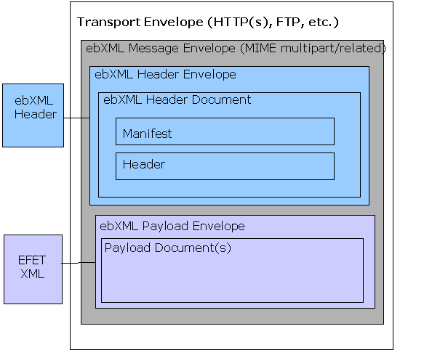

Figure 11: Logical structure of an ebXML message.
Further information on the ebXML standard can be found on the website : http://www.ebxml.org. References are being made in the following to the ebXML Messaging Service standard version 2.0 (ebXML MS 2.0).

Well Received
ebXML allows for the creation of signed acknowledgements to confirm that an EFET business document was received. Such a confirmation implies non-repudiation of reception and that the document was stored on stable storage (e.g. put into an inbox on the receiver side).
“Well Received” does not imply that the receiver understood, accepted or processed the document entirely in his application software system, apart from syntactical checking.

Well Processed
Each EFET document type will be confirmed with an Acknowledgement document (except Acknowledgement or Rejection documents themselves). This indicates that the original document was not only received but also processed at the application level (e.g. fed into the matching queue). The Acknowledgement document also guarantees that there are no syntactic errors within the original document and that all relevant document references are valid.
While “Well received” is the final status of an ebXML document transfer, “Well Processed” is the result of an EFET Box+ processing (application level). “Well processed” is signalled via business documents (Rejections or Acknowledgement).

ebXML Architecture – Communicating with Outside Partners
It is mandated to follow the ebXML Message Service Specification v2.0 (http://www.ebxml.org/specs/ebMS2.pdf). Any further information may be obtained from the ebXML standards Web site (www.ebxml.org).

eCM Standard ebXML Profile
The ebXML profile defined here seeks to support the business requirement for flexibility within the standard. As well as allowing for diversity in B2B communication between different organisations, this requirement also relates to broader application of the standard to support other processes, message sets and potentially communication with (and within) other segments of the energy market. It is accepted that such flexibility in the standard means more complexity in implementation of eCM, however this consideration is outweighed by the the requirement for the standard to provide a solid foundation for broad based B2B interoperation, as well as to support diversity in B2B communication for eCM and beyond.

Transport Protocols and Related Issues
Specifically for the transport aspect of the ebXML profile three protocol configurations are defined for: https, http and for smtp. The following sections define the settings for each, the minimal compliancy requirements and circumstances under which each might be used.
An implementation of the eCM Standards used by one or more organisations (i.e. a bespoke build or 3rd party software product) MUST be (at least minimally) compliant with the requirements defined in this section. An installation (i.e. a site specific configuration of an implementation), whilst constrained by the scope of the implementation, will only be required to comply with the eCM Standards for those transport protocols that it is configured to support. Any transport protocol that an installation supports in a compliant way, can be used to communicate bilaterally if that partner agrees.
Where the EFET Settings in the following tables are set to ‘Individual’ the actual values can be agreed bilaterally between installations using compliant implementations of the standards that support such flexibility. For example: the number of retries, the retry interval, and therefore the “TimeToLive” value may be set bilaterally by the partners, depending on network latency and business requirements.
Using the above recommended values, this leads to a “TimeToLive” interval of 4 minutes for http and 40 minutes for smtp.
N.B. The ‘Default Values and Minimal Compliancy Requirements’ defined in the following tables are not intended to restrict the ‘EFET Settings’ with respect to the business benefit they provide through support for flexibility and/or the selection of settings on a bilateral basis. Implementations which meet all the requirements of the EFET Settings shall be considered fully compliant; whereas implementations that meet the minimal compliancy requirements shall be considered compliant for those aspects of the eCM Standards that they implement in a compliant way. In this way variations in compliant implementations are both permitted and transparently declared.

- HTTPS
All implementations compliant with the eCM Standards MUST as a minimum condition be capable of supporting this protocol although it is not a requirement of the standard that all compliant installations must use this protocol. Installations wishing to support this protocol MUST be fully compliant with the profile settings.

The following ebXML profile settings are defined
EbXML Profile Element | EFET Settings | Default values and minimal compliancy requirements
XML Signature for envelope and payload | On | Minimal compliancy requirement is ‘ON’
SyncReply | On | Minimal compliancy requirement is ‘ON’
DuplicateElimination | On | Minimal compliancy requirement is ‘ON’
Use EbXML Acknowledgement | On | Minimal compliancy requirement is ‘ON’
Signing of Acknowledgements | On (using XML Signature) | Minimal compliancy requirement is ‘ON’
Number of Retries | Individual | Default value of 3
Retry Interval | Individual | Default value of 1 minute
Transport Protocol | HTTPS
HTTPS supports secure communication with use of certificates at the session level. Envelope and payload signing is implemented (encrypting the message) and the additional encryption at the session level adds a further layer of security. The ability to support this protocol is a minimum requirement of the standard as it is considered that https represents the most likely ‘common denominator’ for B2B communication amongst the EFET community.

- HTTP
All implementations compliant with the eCM Standards MAY support this protocol. Installations wishing to support this protocol MUST be fully compliant with the profile settings.

The following ebXML profile settings are defined
EbXML Profile Element | EFET Settings | Default values and minimal compliancy requirements
XML Signature for envelope and payload | On | Minimal compliancy requirement is ‘ON’
SyncReply | On | Minimal compliancy requirement is ‘ON’
DuplicateElimination | On | Minimal compliancy requirement is ‘ON’
Use EbXML Acknowledgement | On | Minimal compliancy requirement is ‘ON’
Signing of Acknowledgements | On (using XML Signature) | Minimal compliancy requirement is ‘ON’
Number of Retries | Individual | Default value of 3
Retry Interval | Individual | Default value of 1 minute
Transport Protocol | HTTP

Envelope and payload signing is implemented (encrypting the message) but there is no additional encryption at the session level. It does not require the use of session level certificates or the associated over head of configuration and operation. This protocol is supported by the requirement to allow for diversity in security and communication architectures amongst organisations who may wish to implement the eCM Standard. Furthermore it may be more applicable for high performance/throughput architectures.

- SMTP
All implementations compliant with the eCM Standards MAY support this protocol. Installations wishing to support this protocol MUST be fully compliant with the profile settings.

The following ebXML profile settings are defined
EbXML Profile Element | EFET Settings | Default values and minimal compliancy requirements
XML Signature for envelope and payload | On | Minimal compliancy requirement is ‘ON’
SyncReply | Off | Minimal compliancy requirement is ‘OFF’
DuplicateElimination | On | Minimal compliancy requirement is ‘ON’
Use EbXML Acknowledgement | On | Minimal compliancy requirement is ‘ON’
Signing of Acknowledgements | On (using XML Signature) | Minimal compliancy requirement is ‘ON’
Number of Retries | Individual | Default value of 3
Retry Interval | Individual | Default value of 10 minute
Transport Protocol | SMTP with SMIME encryption | SMIME is preferred but not mandated for minimal compliancy
The use of SMIME must be agreed bilaterally at the installation level. If it is implemented by an installation then that installation shall be required to be compliant.
Envelope and payload signing is implemented (encrypting the message). It is an asynchronous protocol and therefore does not establish a session as is the case for http or secure that session like https. Since no session is established smtp does not require any firewall configuration over and above the normal configuration an organisations has for its e-mail traffic. Because of this protocol is supported by the requirement to allow for diversity in communication and security architectures amongst organisations who may wish to implement the eCM Standard. Furthermore, due to it not requiring any special firewall reconfiguration, it may be useful in establishing initial connectivity, acting as a fall back communication channel and/or for light implementations of the standards.

Payload and Related Issues
As far as the payload is concerned, the following application-level setting MUST be used:

EFET Profile Element | EFET Setting
Encryption of payload | On, encoded as "CMS/PKCS #7 enveloped data" content encryption algorithm is “Three Key Triple-DES in Cypher-Block-Chaining mode” the key is encrypted with RSA algorithm.
Compression of payload | Compression methodology is gzip compliant (“GNU zip”)
Persistent signing of payload | On, encoded as "PKCS#7 signed data” signing algorithm is “SHA1 with RSA”
Compression | ON, algorithm is: “gzip”
XML Validation | On

Only if required by the local policy of the partners, these functions MAY be switched off.
EFET Acknowledgements are regular business documents and should also be signed using a CMS/PKCS#7 object in a separate MIME attachment.
An outbound payload document MUST be processed in the following order:
- Signing
- Compression
- Encryption
Signature attachments MUST be encoded as CMS/PKCS#7 “signed-data” object - without embedded content. Signatures are based on the transmitted (decrypted, uncompressed) XML Business Document.
Signature attachments are NOT to be compressed. The signed-data object may include any certificates although this is not mandatory since
- this is already included within the XML Signature in the ebXML envelope (as required by the XML Signature standard)
- attached certificate chains have no value since they may be faked by the sending party. Instead it is expected that the receiving party obtains the required certificates via a trusted path from the issuing certificate authority.
It is recommended to install the ebXML Message Service in the secure zone of the intranet and a dedicated http/s Listener in the DMZ.
A transfer is considered as successful only if a signed acknowledgement was received from the receiver without an error code in the ebXML Acknowledgement (see section on “well received”).
The wire format MUST be BASE64-encoded in case of SMTP to avoid any interoperability issues, for http transmissions this is not required but allowed.

Mandated ebXML Envelope settings:
At the current time the EFET standard does not declare a namespace. The rationale for this decision is due to the complexity that namespaces add to the message and there is no compelling reason to define a namespace. The EFET Work Group continually monitors this issue and if a compelling reason to include namespace is uncovered this decision will be reconsidered.
A generalized example of a well-formed EFET message is presented further down. The items that are italicized are the items that would vary based upon the message being communicated.
In line 1 the required XML element with attributes for version and encoding is shown.
In line 3 the required reference to the version of the XML Schema Instance standard that is being used.
In line 4 the required reference to the schema for the message is communicated. The example points to the efet.org domain for the schema as a naming convention.
Example: Referencing a schema file that is remotely stored. This would be the most common approach for inter-business communication.

<?xml version = "1.0" encoding = "UTF-8" standalone=”yes”?>
<EFETMessageRootElement
xmlns:xsi = “http://www.w3.org/2001/XMLSchema-instance”
xsi:noNamespaceSchemaLocation = “http://www.efet.org/schemas/V3R3/<Schema_file_name>.xsd

AttributesForEFETMessage = "valid option">
…Content of EFET Message refer to the doc. for the particular message type
</EFETMessageRootElement>

SOAP Packaging Specification
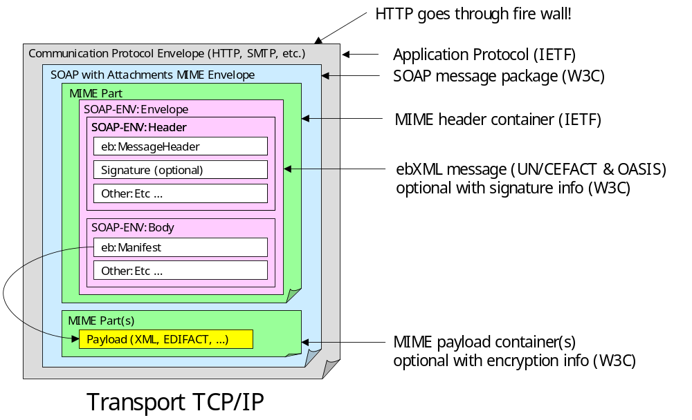

Figure 12: ebXML Standard Message Header Format
The general structure and composition of a SOAP - ebXML message is illustrated in Figure 13. A complete discussion of this information can be found in the ebXML Message Service 2.0 documentation (on www.ebxml.org). We’ll provide some background to this specification so that you can follow the EFET interpretation. We’ll discuss the Header and Payload Container in this section and the Message Package in the following sections. In XML, SOAP-ENV would be written as soap:Envelope. This means, “the envelope as described in the soap namespace”. This envelope is comprised of header and body elements (designated as SOAP-ENV:Header and SOAP-ENV:Body in the graphic).
In the above graphic soap:Header is comprised of MessageHeader and Error elements both in the ebXML namespace (designated as “eb”). The Error element is optional and in the EFET Box+ implementation would not be necessary. Other elements may also be referenced in the soap:Header.
The graphic indicates that soap:Body contains eb:Manifest. The Manifest element contains information describing the message payload. Notice that there may be multiple payloads each identified as a separate MIME part. This approach serves to isolate the message payload from the routing information, supporting payload encryption, attachments, and other functions.

MIME and its extensions (S/MIME and S/MIME Certificates)
MIME (Multipurpose Internet Mail Extension4) is a standard system for identifying the type of data contained in a file based on its extension. MIME is an Internet standard format that permits binary files to be packaged and sent across the Internet. These files include graphics, photos, etc, as well as formatted text documents. MIME covers many different operating systems and types of software.
The original MIME standard has been extended to include security and certificate functionality (S/MIME and S/MIME Certificates). Various issues are discussed in the documents referenced in the Technical References section with appropriate solutions. MIME has been implemented for decades and issues associated with its adoption have passed.

SOAP and SOAP with Attachments
SOAP is a lightweight XML format for the exchange of information in a decentralized, distributed environment. It is an XML based protocol that consists of three parts: an envelope that defines a framework for describing what is in a message and how to process it, a set of encoding rules for expressing instances of application-defined data-types, and a convention for representing remote procedure calls and responses. SOAP can be used in combination with a variety of other protocols.
SOAP is general enough that most implementations will have no problem implementing it. An ebXML compliant Message Service uses a SOAP with Attachments MIME envelope with S/MIME extensions permitted to provide security.

ebXML extensions to SOAP
The ebXML Message Service standard suggests several extensions to the SOAP standard to provide needed functionality. This document discusses these extensions.

Compression
EFET provides a compression choice within its ProcessingDirective extensions to ebXML. Regardless of the manner used to communicate the compression approach this standard requires use of a compression methodology that is gzip compliant (“GNU zip”).

Reliable Messaging
ebXML Reliable messaging defines a process that two Message Service Handlers can use to reliably exchange messages, using acknowledgment, retry and duplicate detection and elimination mechanisms, resulting in the ToParty receiving the message Once-And-Only-Once. The process is flexible, allowing for both store-and-forward and end-to-end reliable messaging.
Reliability is achieved by a Receiving Message Service Handler responding to a message with an Acknowledgment Message. An Acknowledgment Message is any ebXML message containing an Acknowledgment element. Failure to receive an Acknowledgment Message by a Sending Message Service Handler may trigger successive retries until such time as an Acknowledgment Message is received or the predetermined number of retries has been exceeded at which time the FromParty must be notified of the probable delivery failure.
Whenever an identical message may be received more than once, some method of duplicate detection and elimination is appropriate, usually through the mechanism of a persistent storage mechanism. This functionality while desirable in a message service is not necessary for interoperability.
Reliable messaging through ebXML containing an Acknowledgement element is the EFET Standard approach, duplicate detection and removal is therefore required to comply with the Standard.

SOAP – ebXML Envelope Documentation
What follows is the EFET interpretation of the SOAP – ebXML envelope specification (we will refer to this as the “EFET-SOAP-ebXML envelope”). It is EFET’s goal to be as consistent as possible with the official documentation (refer to the Technical Reference section). The next several sections describe the EFET-SOAP-ebXML envelope standard. The discussion is organized in the following way:
All digital signature information described in this standard should be considered, at this time, to refer to the XML Digital Signature Specification (see www.w3.org). Participants in the eCM messaging process are encouraged to use this specification as quickly as possible.
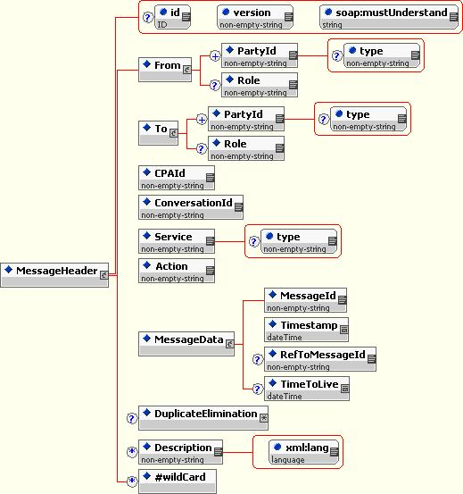

Figure 13: Schema for ebXML MessageHeader Format
In the following the EFET-specific settings for the ebXML envelope will be defined in further detail:
- ConversationID
The required ConversationId element is a string identifying the set of related messages that make up a conversation between two parties. The party initiating a conversation determines the value of the ConversationId element that shall be reflected in all messages pertaining to that conversation. The ConversationId remains constant for all messages within a conversation. The value used for a ConversationId is implementation dependent.
Within EFET, an individual conversation is used for each trade confirmation. In the following matching conversation, the Buyer’s ConversationId is used to identify the ongoing session. Cancellations will use the same ConversationId as the to-be-cancelled document.
The value used for the ConversationID should be equal to the MessageID used for the initial TradeConfirmation. As soon as the match process is initiated by the Buyer, the Buyer’s CNF ConversationID will be used for the remaining process by all parties.

CPAId
The required CPAId element is a string that identifies the parameters governing the exchange of messages between the parties. Within EFET, a dummy value (“http://www.efet.org/cpa/dummy.xml”) will be used since the ebXML CPPA standard is not implemented.
- Duplicate Elimination
This is used in order to avoid multiply sent messages to be forwarded to the receiver’s ETRM system
- From/PartyId, To/PartyId
The PartyId element is the identifier for the party that originated the message (in the case of From/PartyId) or the receiver of the message (in the case of To/PartyId). In the context of message communication from the writer of the message to the reader of the message the PartyId mechanism may need to be robust enough to communicate the endpoints of the message service as well as the final, intended recipient of the communication.
Within EFET, this PartyId is the EIC code used for the sending party, using the type attribute PartyId eb:type="EIC".
- MessageId
The required element MessageId is a globally unique identifier for each message. It is generated by the sending EFET Box+. The participants should use a combination of a locally unique ID (e.g., the trade ID) in connection with the participant identifier, e.g. by using the EIC code (“…@11XRWETRADING—0“) or the internet domain (“…@rwe.com”).
- Service
A Service is a collection of Actions that is implemented by a service provider (i.e., an eCM service). The required Service element identifies the service and it is specified by the designer of the service. The designer of the service may be a standards organization, or an individual or enterprise.
- Within EFET, all Messages (trade confirmation, match suggestion, match suggestion acceptance, cancellation, acknowledgement, rejection etc.) share the same Service ID which is defined as “ECM-3.3”, using the type attribute Service eb:type="EFET".
- The value of this Service ID always corresponds to the latest EFET eCM version that the transmitting EFET box supports. The syntax rule for this service string uses the prefix “ECM-“ followed by the version number of the EFET eCM Standards
- Action
The required Action element identifies a process within a Service that processes the message. Action should be unique within the Service in which it is defined. The value of the Action element is specified by the designer of the service.
Within EFET, the value of the Action element corresponds to the Schema Root
Element of the document type that corresponds to the transaction, e.g., 'TradeConfirmation'.
- TimeToLive
If the TimeToLive element is present, it must be used to indicate the time, expressed as UTC, by which a message should be delivered to the To Party Message Service Handler.
Within EFET, this information MUST be provided with a value agreed bilaterally with the counterparty.
In case of HTTP or its derivates it is recommended to use 3 re-tries with 1 minute interval each, giving a total TimeToLive of 4 minutes. (To be precise, the time 4 minutes ahead of message transfer time is used as the value in ISO date/time format). Any final failure of transmission has to be handled locally at the application level by the sender’s EFET Box+.
Two counterparties may bilaterally agree on a deviating TimeToLive pattern.

- Manifest
The Manifest contains a list of references to the MIME attachments of the message. The first reference points to the payload attachment which holds the EFET document. Exactly one EFET document is transferred per ebXML message.
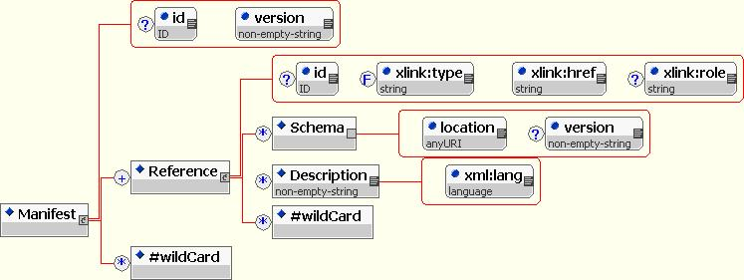

Figure 14: ebXML Schema for Manifest Format
The Schema location attribute corresponds to the schema URI, e.g. http://www.efet.org/Schemas/V3R3/EFET-Rej-V3R3.xsd. The URI format is used within ebXML to uniquely identify the schema. The eCM application obtains the schema document from a local Schema repository by using the URI as an access code.
The following role attributes are to be used in order to identify attachments:
- Xlink:role = “http://www.efet.org/ebXMLAttachment/Roles/BusinessDocument”, then the attachment is to be processed as a business document.
- Xlink:role = “http://www.efet.org/ebXMLAttachment/Roles/BusinessDocumentSignature”, then the attachment is to be processed as a signature.
The first reference to the payload attachment is mandatory, the second to the payload signature is optional and only to be used if the signature is attached.
The <Description> element is not interpreted and optional.

SyncReply
The optional SyncReply element may be present on any outbound message sent using synchronous communication protocol. The SyncReply element may be present as a direct child descendant of the SOAP Header element. It contains the following attributes:
- soap:actor, required with the value of "http://schemas.xmlsoap.org/soap/actor/next"
- soap:mustUnderstand - with a value of "1"
If present, this element indicates to the receiving SOAP or ebXML Message Service Handler node the connection over which the message was received should be kept open in expectation of a response message to be returned via the same connection.
Within EFET, all HTTP/S calls will require a SychReply in order to allow for a immediate processing the ebXML acknowledgement transmission within the pending http request. Should SMTP be used, SyncReply cannot be used.
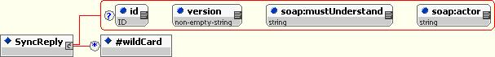

Figure 15: ebXML Schema for SyncReply Format

Example for an EFET ebXML Envelope

<?xml version="1.0" encoding="UTF-8" ?>
<soap-env:Envelope xmlns:soap env="http://schemas.xmlsoap.org/soap/envelope/">

<soap-env:Header>
<eb:MessageHeader xmlns:eb="http://www.oasis-open.org/committees/ebxml-msg/schema/msg-header-2_0.xsd" soap-env:mustUnderstand="1" eb:version="2.0">

<eb:From>
<eb:PartyId eb:type="EIC">11XRWETRADING--0</eb:PartyId>

</eb:From>
<eb:To>

<eb:PartyId eb:type="EIC">11XELECTRABEL--Z</eb:PartyId>
</eb:To>

<eb:CPAId>http://www.efet.org/cpa/dummy.xml</eb:CPAId>
<eb:ConversationId> MID-1079985404061@RWE.com</eb:ConversationId>
<eb:Service eb:type="EFET">ECM-3.3</eb:Service>
<eb:Action>TradeConfirmation</eb:Action>
- <eb:MessageData>

<eb:MessageId>MID-1079985404061@RWE.com</eb:MessageId>
<eb:Timestamp>2004-03-22T19:56:44</eb:Timestamp>

<eb:TimeToLive>2004-03-22T19:58:24</eb:TimeToLive>
</eb:MessageData>

<eb:DuplicateElimination />
</eb:MessageHeader>
<eb:SyncReply xmlns:eb="http://www.oasis-open.org/committees/ebxml-msg/schema/msg-header-2_0.xsd" soap-env:mustUnderstand="1" eb:version="2.0" soap-env:actor="http://schemas.xmlsoap.org/soap/actor/next" />
<eb:AckRequested xmlns:eb="http://www.oasis-open.org/committees/ebxml-msg/schema/msg-header-2_0.xsd" soap-env:mustUnderstand="1" eb:version="2.0" eb:signed="true" />

</soap-env:Header>
- <soap-env:Body>
- <eb:Manifest xmlns:eb="http://www.oasis-open.org/committees/ebxml-msg/schema/msg-header-2_0.xsd" eb:version="2.0">
- <eb:Reference xmlns:xlink="http://www.w3.org/1999/xlink" xlink:href="cid:MID-1079985404061@RWE.com.xml" xlink:role="http://www.efet.org/ebXMLAttachment/Roles/BusinessDocument">
<eb:Schema eb:location="http://www.efet.org/Schemas/V3R3/EFET-CNF-V3R3.xsd" eb:version="3.30" />

<eb:Description xml:lang="en">EFET Payload</eb:Description>
</eb:Reference>
- <eb:Reference xmlns:xlink="http://www.w3.org/1999/xlink" xlink:href="cid:MID-1079985404061@RWE.com.sig" xlink:role="http://www.efet.org/ebXMLAttachment/Roles/BusinessDocumentSignature">

<eb:Description xml:lang="en">Signature</eb:Description>
</eb:Reference>

</eb:Manifest>
</soap-env:Body>
</soap-env:Envelope>

ebXML Architecture – Integration into Enterprise Architecture
This section is not normative.

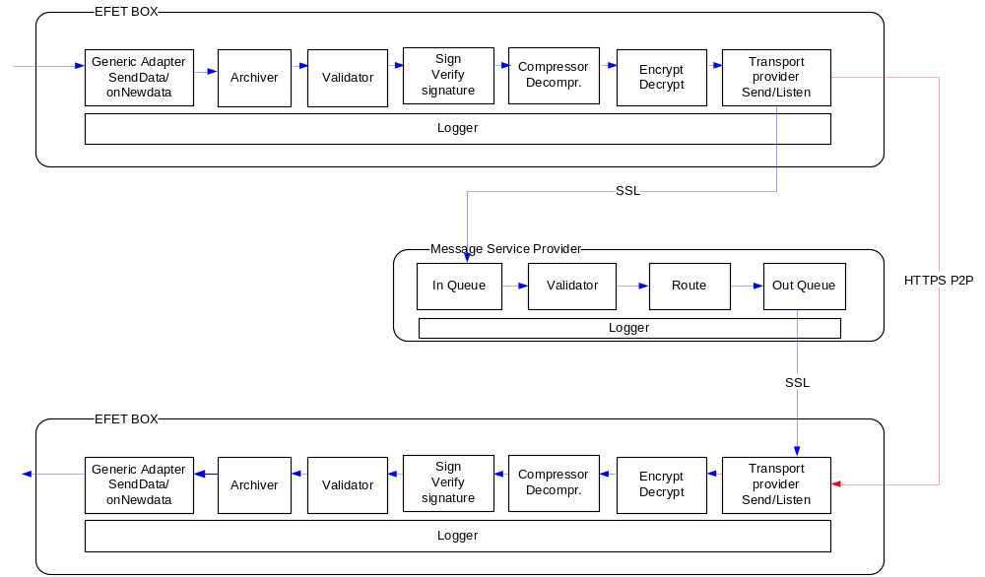
ETRM
Matching
ETRM
Matching

Figure 16: Flow of business messages

- Generic adapter sends or receives messages. (Can be integrated with ETRM systems)
- Archiver is responsible for storing all messages passing through the EFET Box+.
- Validator checks the format of incoming/outgoing messages against the relevant schema.
- Sign/Verify signature Messages are signed with the private key of the sender. On incoming messages the signature validity is checked against the revocation list.
- Compressor reduces the size of outgoing messages or expands incoming messages.
- Encrypt/Decrypt Encrypts outgoing messages with the recipient’s public key or decrypts incoming messages with the own private key.
- Transport provider Sends the message to the message service provider using the standard EFET transport layer or if bilateral agreed otherwise sends the message directly to the counter part. All transport providers need to implement the same interface.
- Message Service Provider In Queue. The message arrives in the in queue
- Message Service Provider Validator checks the header format of the message and routes to message to the correct out queue.
- Message Service Provider Out Queue delivers the message to the recipient’s listener.
- Trade confirmations status changes are integrated with the ETRM system.

Central Registry Service
This section is not normative.
Usage of a central profile registry is OPTIONAL, as an alternative, profile information may be exchanged manually or created locally for the involved ebXML Message Service. Standards such as ebXML Registry and CPPA are not included within the EFET eCM specification. For this reason, each vendor may use an own implementation / representation of the profiles and registries.
Profile information shall be maintained by efetNet BV. It shall be an XML document that is accessible via the standard WebDAV protocol. The document shall be accessible only by the EFET community. Administrators may selectively update individual entries after downloading the profile. WebDAV is the protocol for upload/download and for maintaining the profile information.
Each participant has access to exactly one folder which has as name the PartyID of the participant. Both the partner profile and the EFET Box+ configuration will be stored here.
The Profile Format is as follows:
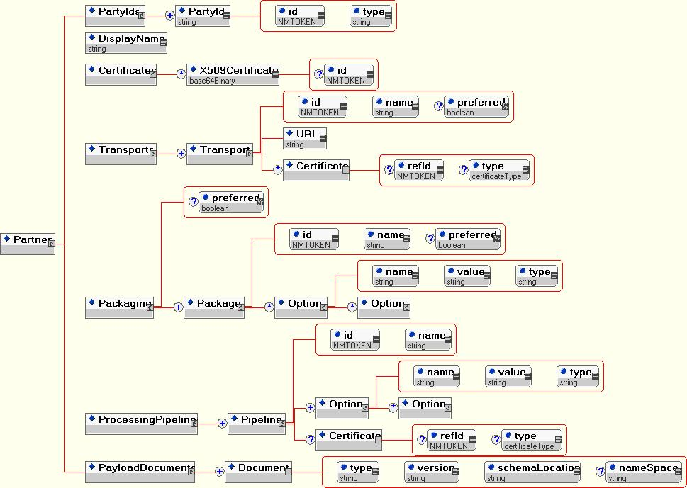

Figure 17: Partner Profile Structure

PKI and Certificate Management
This section is not normative.
Certificates of any available CAs shall be used to verify signatures and to access public keys of receivers for document encryption. As a default solution, certificates MAY be issued and maintained by the technical support of EFETnet.

- Definition of eCM Types and Codes
This appendix describes code conventions and best practices for the technical implementation of eCM and other EFET compliant interfaces. It is not limited to the use within the eCM process but should be used and extended to support other implementations related to other processes.
The actual implementation of this standard within the eCM processes and the description of the EFET eCM standards interface is the subject of the relevant sections describing the individual messages.
  - Core Components
The core components respect the basic principles defined by ebXML.
Core components are the basic building blocks of the message interchange system.
The ebXML definition of a core component is “a building block for the creation of a semantically correct and meaningful information exchange ‘parcel’. It contains only the information pieces necessary to describe a specific concept”.
There are two kinds of core component:
- Basic core components that are context independent and may be used in their native mode or in a context specific mode through the addition of a prefix name that qualifies its use within the defined context.
- Context specific “core components” that are used within a specific message context. These components will automatically inherit all the attributes of the basic core component but will have a specific definition to clearly explain its use.
Each of the context specific core components will be assigned a name such as “Buyer Party” and Seller Party”. The words “Buyer” and “Seller” identify the function of a party within the context in which the basic core component is used.
  - eCM Field Types

Table 17: eCM Field Types
TypeName  Order by | DEFINITION | XML Base Type. | Size
AgentType | Values: “Broker” or “ECVNA” | NMTOKEN
AgreementType | The set of valid values are specified on: http://www.efet.org in the Static Data section. | string | 35
AreaType | A domain covering a number of related objects, such as balance area, grid area, country, etc. EIC Types are used here. | string | 16
BrokerIDType | Identifies a broker for a trade. The set of valid values are specified on: http://www.efet.org in the member’s section. | string | 5
BSCPartyIDType | Identifies a BSC Party for a trade. The set of valid values are maintained at http://www.elexon.co.uk/participating/BSCSignatoriesAgents/bscSignatories.aspx | String | 255
ClockDateTimeType | This corresponds to dateTime, but without the time zone extension. The type is derived from dateTime with the following pattern restriction: "20..-..-..T..:..:..". | dateTime | 19
CommonPricingType | This refers to the whether there has been an agreement to use ’Common Pricing’ when calculating settlements.  Permitted values are:  “True”: yes, holidays observed by an index will be applied ‘commonly’ to all indexes when collecting settlement prices  “False”: no, holidays observed by an index will not be applied ‘commonly’ to all indexes. | NMTOKEN
ContractType | The load type defines the conditions under which energy is purchased, allocated and handled. EG:  In the case of TSO communications it represents: daily auction, weekly auction, monthly auction, yearly auction, etc.  In the case of Trader to Trader communications it represents: Base load, peak load, etc…  The significance of this type is dependent on area specific coded working methods.  Values: "Base", "Peak", "OffPeak", "Custom" | NMTOKEN | 10
CountryCodeType | The identification of the market where the commodity is traded.  In this context it uses ISO 3166-1 2 alpha codes is used for their identification. | NMTOKEN
CurrencyCodeType | The specification of a currency unit respecting ISO 4217 3 alpha codes. | NMTOKEN
DateType | Identification of a particular calendar day by its calendar year, its calendar month and its ordinal number within its calendar month. The date shall respect ISO 8601 formatting extended format YYYY-MM-DD. Leading zeros shall be used. | date | 10
DeliveryDateType | Delivery Date" means, in respect of a Transaction and a Commodity Reference Price, the relevant date or month for delivery of the underlying Commodity (which must be a date or month reported or capable of being determined from information reported in or by the relevant Price Source Valid values are:“Spot”: The spot contract  “First_Nearby”: The month of expiration of the first Futures Contract to expire following that Pricing Date  “Second_Nearby”: The month of expiration of the second Futures Contract to expire following that Pricing Date  “Sixth_Nearby”: The month of expiration of the sixth Futures Contract to expire following that Pricing Date  “Calculation_Period”: The period specified in by the Calculation Period of the deal | NMTOKEN
EnergyAccountType | Definitions within the Balancing & Settlement Code for the UK electricity market.  Values: ”Production”,  ”, ”& “Consumption” | NMTOKEN
EnergyProductType | The identification of the nature of an energy product such as Power, gas, oil, active power, reactive power, etc.  Values: “Gas”, “Power”, “Oil”, ReactivePower”  The identification of the nature of an EUA vintages defined by the European Directive:  Values: “EUAPhase_1”, “EUAPhase_2” | NMTOKEN
EUAAccountCodeType | EUA account codes must conform to the following format:  CC-nnn-nnn-0  CC-nnn-nnnn  CC-nnn-nnn  Where CC is the Country Code as defined ISO 3166-1 2 alpha codes ; and  n represents any single digit integer  0 is the character for zero | string | 12
FXReferenceType | This is a reference to a spot price. All references shall be encoded as EFET Static Data on www.efet.org | String | 255
FXConversionMethodType | The method for calculating currency conversion from a referenced spot rate.  Values are:  'Daily', 'Monthly', 'Mixed' where:  ‘Daily’ = Daily index rate * daily exchange rate  ‘Monthly’ = Monthly average index * monthly average exchange rate  ‘Mixed’ = monthly average index * daily exchange rate  N.B. These definitions use PricingDateType to identify valid days upon which prices can be collected i.e. rates will only be collected for valid Pricing Dates | NMTOKEN
IdentificationType | A code to uniquely distinguish one occurrence of an entity from another. | string | 255
IndexCommodityType | The following values have been added for use with Financial Transactions:  “Benzene”  “Coal”  “Diesel_Fuel”  “Electricity”  “Fuel_Oil”  “Gas_Oil”  “Gasoline”  “Heating_Oil”  “Jet_Fuel”  “Methanol”  “Naphtha”  “Nat_Gas”  “NGL”  “Oil”  “Freight”  “Time_Charter”  “Emissions” | NMTOKEN
IndexIDType | A code that identifies a reference index and for the index how it is used as a basis for calculation in relation to the trade.  Set of values to be defined.  Types of Averaging Method to be referenced within name:  - Arithmetic Average identified by inclusion of “AA” within index name. | string | 35
IndexStrikePriceStyleType | Defines how the index is used in determining the strike price of an option on an index, permitted values are:  - “Index_Following”, which means that the strike price of the option is the current state of the index at the present time, meaning that the option is always at the money  - “Index_Dated”, which means that the strike price for the option is the state of the index on the trade date, meaning that the option can vary in and out of the money based on the relative performance of the index compared with the historic value on the trade date. | NMTOKEN
ISDACommodityDefinitionsType | All values defined in Sub-Annex A to the 2005 ISDA Commodity Definitions  plus  other explicitly defined indices published on www.efet.org Static Data page, including but not limited to the value: “Formula” | string | 255
NameType | A word or combination of words constituting the individual designation by which a person, animal, place, or thing is known. | string | 35
NotificationFieldType | Values: “preliminary”, “final”, “reverse”. | NMTOKEN
OptionStyleType | Values: “American”, “European”, “Asian”, “Cap”, “Floor”, “Collar”  N.B. “Cap”, “Floor” and “Collar” refer to an exercise style which can be equated to a strip of automatically exercised optlets with a strike price equal to the ‘Cap Price’/’Floor Price’. | NMTOKEN
OptionType | The type of option contract:  Values: “Put”, “Call”, “Capped_Call”, “Floored_Put”  N.B. ‘Capped’ calls and “Floored” puts contain a cap/floor on the upside/downside which effectively limits the explicit value of an in the money option. | NMTOKEN
PartyType | The identification of an actor in the Energy market. Uses EIC codes. EIC company codes for brokers and trading parties will be issued by EFET. For Party EIC codes issued by ETSO see:  http://www.etso-net.org/activities/edi/_library/index.asp See definition for EIC code format further down. | string | 16
PricingDateType | The date upon which the Specified Price is recorded for settlement purposes.  Values:  “CBD”: Each commodity business day  “Monday”: Each Monday if it is a commodity business day  “Tuesday”: Each Tuesday if it is a commodity business day  “Wednesday”: Each Wednesday if it is a commodity business day  “Thursday”: Each Thursday if it is a commodity business day  “Friday”: Each Friday if it is a commodity business day  “Saturday”: Each Saturday if it is a commodity business day  “Sunday”: Each Sunday if it is a commodity business day  “Monthly”: On the same day each month - the actual day is not defined but is considered to be known to the counterparties and broker | NMTOKEN
PriceType | The price in some currency. Positive quantities shall not have a sign. A price may be expressed up to 9 decimal places, dot-separated and with leading zeros suppressed. | decimal | 25
ProcessFieldType | Values: “withCp” or “withoutCp”. | NMTOKEN
QuantityType | The number of occurrences of an object. Positive quantities shall not have a sign. A quantity may be expressed up to 8 decimal places, dot-separated and with leading zeros suppressed.  The number of EUA Certificates. Positive quantities shall not have a sign. A quantity shall always be expressed as a whole number (integer) up to 8 figures in length, with leading zeros suppressed e.g. 1 to 99.999.999 | decimal | 30
Ratio | A percentage must be <= 100 | integer | 3
ReasonCodeType | A code defining a known technical or business processing error. Will relate to situations when a document is NOT ‘Well Received’ or when a document is NOT ‘Well Processed’  A complete list of reason codes is described further down. | NMTOKEN | See valid values
ReasonTextType | The textual explanation of an act. | string | 512
RoleType | One of the values: “Trader”, “Broker”, “ClearingHouse”, “ECVNA” | NMTOKEN
RoundingType | Indicates the number of decimal places to round to, valid values are:  - “0”: meaning precisely nil d.p.  - “1”: meaning precisely one d.p.  - “2”: meaning precisely two d.p.  - “3”: meaning precisely three d.p.  - “4”: meaning precisely four d.p.  - “5”: meaning precisely five d.p.  - “6”: meaning precisely six d.p.  - “7”: meaning precisely seven d.p.  - “8”: meaning precisely eight d.p.  - “9”: meaning precisely nine d.p.  - “N_A”: meaning that there is no greement to the number of d.p. | NMTOKEN
SpecifiedPriceType | In respect of a Transaction and a Commodity Reference Price, any of the following prices (which must be a price reported in or by, or capable of being determined from information reported in or by, the relevant Price Source), as specified in the relevant Confirmation (and, if applicable, as of the time so specified) Values are:  “High”: (A) the high price;  “Low”: (B) the low price;  “Average”: (C) the average of the high price and the low price;  “Closing”: (D) the closing price;  “Opening”: (E) the opening price;  “Bid”: (F) the bid price;  “Ask”: (G) the asked price;  “Ave_Bid_Ask”: (H) the average of the bid price and the asked price;  “Settlement”: (I) the settlement price;  “Off_Settlement”: (J) the official settlement price;  “Official”: (K) the official price;  “Morning”: (L) the morning fixing;  “Afternoon”: (M) the afternoon fixing;  “Spot”: (N) the spot price;  “Other”: (O) any other price specified in the relevant Confirmation | NMTOKEN
TimeType | A point within a unit of time of 24 hours. The time shall respect ISO 8601 formatting extended format HH:MM:SS(Z). | time | 8
TimeZoneOffsetType | This is the time zone offset from UTC.  Valid values are integers from 0 to 24. Must be signed if negative. | Integer | 3
TransactionType | Need to extend this type to include:  “DAH”: Day Ahead  “IND”: Intraday  “FOR”: Physical Forward that settles against a fixed price  “OPT”: Option on a physical forward  “PHYS_INX”: Physical forward that settles against an index  “OPT_PHYS_INX”: Option on a physical forward that settles against an index  N.B. “PHYS_INX” and “OPT_PHYS_INX” must be used for version 3.3 and above only  The following transaction types are collectively termed ‘Financial Transactions’  “FXD_SWP”: Fixed/float swap  “FLT_SWP”: Float/float swap  “OPT_FXD_SWP”: Fixed/float swaption  “OPT_FLT_SWP”: Float/float swaption  “OPT_FIN_INX”: Option on an index | NMTOKEN
TrueFalseType | Data type used to indicate if a condition is true or false.  Values: “true”, “false”. | Boolean
UnitOfMeasureType | The unit of measure that is applied to a quantity.  Valid energy (work) units are as follows:  Therm  KWh  MWh  GWh  MJ  100MJ  MMJ  GJ  BBL  MT  GAL  Valid power (work rate) units are as follows:  ThermPerDay  KWhPerDay  GWhPerdDay  MJPerDay  100MJPerDay  MMJPerDay  MW  KW  GW  GJPerDay  Day (for Time Charter Swaps)  Valid value for EUA Trade Confirmation documents is “EUA”  N.B. 1 EUA = 1 tinne of CO2. | NMTOKEN
UsageType | Indicates Test or Live message.The coded type of a document. The document type describes the principal characteristic of a document.  Values: “Test” or “Live” | NMTOKEN
VersionType | A code that distinguishes one evolution of an identified object from another. Information about a specific object may be sent several times, each transmission being identified by a different version number. | integer | 3

  - Reason Code Types
Naming conventions: Naming domain codes are used as a prefix to qualify error codes and originators:
- “xml”
- “efet”
- “ebxml”
- Vendor-specific, e.g. “ponton” etc.

Minimal required reason codes:
- ebXML Error Codes: See ebXML MS2.0 Spec. (ValueNotRecognized, NotSupported, Inconsistent, OtherXml, DeliveryFailure, TimeToLiveExpired, SecurityFailure, MimeProblem, Unknown)
- EFET Error Codes: TimeOut, TCAlreadyMatched, NoMatch, InvalidData
- Vendor-specific Error codes (non): See vendor-specific documentation

Table 18: List of Error Codes
Domain | Error Code | Comment
XML | ValidationFailure | An XML element/attribute could not be validated against the Schema
ebxml | ValueNotRecognized | XML enumeration not defined in Schema
ebxml | NotSupported | An ebXML feature that is not supported, e.g. multi-hop communication
ebxml | Inconsistent | In valid XML document
ebxml | OtherXML | Error explained in more detail in ReasonText
ebxml | DeliveryFaliure | Error explained in more detail in ReasonText
ebxml | TimeToLiveExpired
ebxml | SecurityFailure | Error explained in more detail in ReasonText
ebxml | MimeProblem | Error explained in more detail in ReasonText
ebxml | Unknown | Error explained in more detail in ReasonText
efet | InvalidData | One or more data fields are invalid (yet XML Schema compliant).
efet | TimeOut | The trade confirmation timed out on the sender side of the document.
efet | InvalidMatchAttempt | The trade confirmation is generally in a document state that does not allows for matching (e.g. Amended, Failed, Matched etc.)
efet | AmendmentError | The amendment has a wrong version number
efet | IDNotFound | An externally defined ID (e.g. EIC Code) could not be verified
efet | UniquenessViolation | ID used in a trade confirmation is already in use
efet | NoMatch | The sender could not match the two trade confirmations referenced by the Match Suggestion
efet | ReferencedDocNotExists | The referenced Document does not exist in the Counterparts System.
efet | RefDocInvalidState | The referenced Document is not in a valid state for further processing. (e.g. state ACKNOWLEDGED was expected but it is in state PENDING )
efet | MinorVersionInInvalidState | The currently processed Trade Confirmation has minor versions in a state that does not allows amendments. (e.g. state is FAILED)

Example 1:
<Reason>
<ReasonCode>ebXML:Validation</ReasonCode>
<ErrorSource>/TradeConfirmationDocument/DocumentCreation/DateTime </ErrorSource>
<Originator>ponton:PontonXP</Originator>
<ReasonText>Element Value could not be validated against dateTime type</ReasonText>
</Reason>

Example 2:
<Reason>
<ReasonCode>efet:timeout</ReasonCode>
<Originator>efet:efetbox</Originator>
<ReasonText>trade confirmation timed out at 2004-30-08T21:30:00Z UTC</ReasonText>
</Reason>

  - Use of Code Standards

Table 19: Used Code Standards
Component | Coding Scheme or Format | Comment
Character set | UTF-8 | Used as the character encoding schema
Currency codes | ISO 4217 3 alpha codes | See annex for list of frequently used codes
Date time | ISO 8601 YYYY-MM-DDTHH:MM:SSZ.  Shall be expressed in UTC.  Midnight is 00:00.  For Date values: ISO 8601 format - YYYY-MM-DD.  For Time values: ISO 8601 format - HH:MM:SSZ. | Note: Z refers to Zulu time, being a synonym to Coordinated Universal Time or UTC (formerly known as Greenwich Mean Time or GMT). The delivery periods (start and end date and times shall always be expressed in local time.
Delivery areas | EIC codes | For the physical delivery areas, EIC codes issued by ETSO will be used see:  http://www.etso-net.org/activities/edi/_library/index.asp Additional EIC codes will be issued and maintained by EFET for virtual trading hubs.  See annex for list of ETSO EIC codes for physical delivery areas.
Market | The ISO 3166-1 2 alpha codes are used for the markets that correspond to a country.  Special codes are added to the sub-country markets within the U.K. | This EFET coding scheme partly exists of the ISO controlled standard country, extended with EFET controlled codes to identify the markets within the U.K.
Measurement units | UN/ECE Recommendation 20. | See annex for list of frequently used codes
Numeric values | Standard numeric format is UK/American but without comma separation for orders of 10³: “nnnnnnn.nn”. Always cut leading zeros.
Party | EIC code | EIC company codes for brokers and trading parties will be issued by EFET.  For Party EIC codes issued by ETSO see:  http://www.etso-net.org/activities/edi/_library/index.asp  It is still under discussion whether the EFET standard will allow the parallel use of EAN codes. In any case, the EIC code will get strong preference above EAN code.

  - EFET Coding Scheme
The EFET coding scheme is made up of a number of code lists. All the code lists in question may be found on the EFET website www.efet.org. These lists will be constantly kept up to date and therefore they should be queried occasionally in order to determine if there are any new codes of interest.

Note:
EIC codes (ETSO Identification Codes) are issued anytime by EFET and have the following form: NNxABCDEFGHIJKLc:
- NN : Issuing office
- x : digit indicates the type of EIC code, e.g. ‘X’ indicates a party identification code
- AB..L : A 12 digit identification code
- c : Check digit

EFET Standards regarding delivery points and areas are not issued by EFET but by other Local Issuing Offices within the EIC community. These codes take the same form but with the following exceptions:
- x: indicating the type of EIC code is set to ‘Y’ for Areas and represent network areas in which capacity constraints are typically managed by a Transmission System Operator
- x: indicating the type of EIC code is set to ‘Z’ for Measurement Points where a commodity is considered to be traded and exchanged; the pipe line operators are identified in the case of interconnections between gas pipe lines.

In all cases codes used in the eCM process will be ‘International’ EIC codes and so will be posted on the ETSO EIC code site at: www.edi.etso-net.org

- Glossary of Data Elements and Terms
  - Context Specific Data Elements in Alphabetic Order

Table 20: Context-specific Data Elements in alphabetic Order
ELEMENT NAME | DEFINITION | Based on type | Context employed
Agent Name | Name of the service provider | NameType | Trade/Broker Confirmation
Agent Type | The role of the service provider | AgentType | Trade/Broker Confirmation
Agreement | The Master Agreement underwhich the transaction was conducted | AgreementType | Trade/Broker Confirmation
Automatic Exercise | Flag indicating if an option will automatically exercise | TrueFalseType | Trade/Broker Confirmation
Broker ID | The Broker code | BrokerIDType | Trade/Broker Confirmation
BrokerSpreadID | The identifier given by the broker to that particular type of spread transaction | IdentificationType | Broker Confirmation
BrokerTradeID | Identifier issues by broker and unique to that specific broker | IdentificationType | Broker Confirmation
BSC Party ID | Identifies a party to the UK Electricity market Balancing and Settlement Code (BSC) | BSCPartyIDType | Trade Confirmation
Buyer Delivery Account | The account code for the Buyer of an EUA to which the delivery of certificate must be made. | EUAAccountCodeType | Trade Confirmation
Buyer Energy Account | Consumption or production account (GB market only) | EnergyAccountType | Trade/Broker Confirmation
Buyer Energy Account Identification | The account to which the Buyer of a power trade in the UK market will allocate the volume of the trade. | IdentificationType | Trade Confirmation
Buyer Hub Code | The shipper code of the Buyer at the hub where the trade will deliver and the capacity is needed. | IdentificationType | Trade/Broker Confirmation
Buyer ID | Party ID as defined in the Interface Definition Documents (IDD) on www.elexon.co.uk | BSCPartyIDType | Trade/Broker Confirmation
Buyer Party | The party that is purchasing the commodity. | PartyType | Trade/Broker Confirmation
CalculationPeriodEndDate | End date of a period during which price data is collected and subsequently used in calculating the settlement of a financial trade. | DateType | Trade/Broker Confirmation
CalculationPeriodStartDate | Start date of a period during which price data is collected and subsequently used in calculating the settlement of a financial trade | DateType | Trade/Broker Confirmation
Capacity unit | The unit of measurement in which the contract capacity quantity is expressed | UnitOfMeasureType | Trade/Broker Confirmation
Capped Price | The price at which the up side of a call option is stops paying out. | PartyType | Trade/Broker Confirmation
Cash Settlement | Flag indicating if the option is cash settled or not | TrueFalseType | Trade/Broker Confirmation
Commodity | Defines which energy product is traded | EnergyProductType | Trade/Broker Confirmation
Commodity Reference Price | A commodity reference price/index. | ISDACommodityDefinitionsType | Trade/Broker Confirmation
Common Pricing | ‘Common Pricing’ refers to the treatment of holiday schedules observed by underlying indices. Holidays affect the collection of prices since there will be no prices published for an index on a holiday. | TrueFalseType | Trade/Broker Confirmation
Contract Capacity | The contract capacity of the commodity that has been negotiated. | QuantityType | Trade/Broker Confirmation
CR Capacity Conversion Rate | The conversion factor that must be used in converting a unit of measure in which a commodity reference is quoted to the settlement unit of measure for the deal. | QuantityType | Trade/Broker Confirmation
Currency | ISO currency code. In some cases, the currency element is extended by an optional attribute: “UseFractionUnit”. This indicates that, e.g., “pence” is used instead of “GBP” | CurrencyCodeType | Trade/Broker Confirmation
Delivery Period Start Date | The start date of a delivery period for a financial trade. Delivery periods define the settlement regime. | DateType | Trade/Broker Confirmation
Delivery Date | For a given commodity reference this identifies which underlying delivery contract is used for pricing i.e. month ahead. | DeliveryDateType | Trade/Broker Confirmation
Delivery Period End Date | The end date of a delivery period for a financial trade. Delivery periods define the settlement regime. | DateType | Trade/Broker Confirmation
Delivery Period Notional Quantity | The notional volume in a delivery period for a financial trade. Used in calculating the settlement in that Delivery Period. | QuantityType | Trade/Broker Confirmation
Delivery Point Area | The area where the commodity is being delivered.  In general this refers to the hub on which the commodity is delivered. | AreaType | Trade/Broker Confirmation
DeliveryEnd DateAndTime | The end date and time of the time interval for a period. The resulting duration is expressed in minutes for a single quantity period.  The time interval shall always be expressed in the time zone of the commodity delivery area. | ClockDateTimeType | Trade/Broker Confirmation
DeliveryStartDateAndTime | The start date and time of the time interval for a period. The resulting duration is expressed in minutes for a single quantity period.  The time interval shall always be expressed in the time zone of the commodity delivery area. | ClockDateTimeType | Trade/Broker Confirmation
Document ID | The unique identification of a document compliant with naming standard defined in 5.1 Naming and Typing Conventions. | IdentificationType | Trade/Broker Confirmation, Suggested Match, Suggested Match Acceptance, Suggested Match Refusal, Cancellation,  Acknowledgement/ Rejection
Document Version | Version of the document being sent. An entire document may be sent several times with the same identification. The version is used to distinguish one instance of the same document from another with the same identification. | VersionType | Trade/Broker Confirmation, Suggested MatchSuggestionMatch, Suggested Match Acceptance, Suggested Match Refusal, Cancellation,  Acknowledgement/ Rejection
DocumentUsage | Indicates whether it is a test message or a live message | UsageType | Trade/Broker Confirmation
Early Exercise | Flag indicating if an option is subject to early exercise. | TrueFalseType | Trade/Broker Confirmation
Effective Date | The start date of the first Delivery Period. ISDA term identifying the start swap. | DateType | Trade/Broker Confirmation
Emissions Delivery Date | Contractual date that the emissions certificates are due for transfer from the Sellers account to the Buyers account. | DateType | Trade/Broker Confirmation
ErrorSource | Location of the Error (e.g. Xpath of an XML element | String (255) | Match Suggestion Refusal,  Rejection
Exercise Date Time | Date and Time at which the option has to be exercised for the bounded delivery period | ClockDateTimeType | Trade/Broker Confirmation
Exercise Time Zone | Offset relative to UTC used to record the local counterparty time zone when the exercise date and time is in UTC. | TimeZoneOffsetType | Trade/Broker Confirmation
Exercise/Expiry Date Time | The dates of the exercise schedule in UTC of European and Asian options and in the case of an American option the expiry date. | ClockDateTimeType | Trade/Broker Confirmation
Factor | Percentage contribution of a specific Commodity Reference to a basket. | QuantityType | Trade/Broker Confirmation
Fee Currency | Currency in which brokerage has been agreed | CurrencyCode Type | Broker Confirmation
Fixed Price | The price in a Delivery Period of the fixed side of a swap. | PriceType | Trade/Broker Confirmation
Fixed Price Buyer | Identifies the counterparty paying the fixed price in a swap | PartyType | Trade/Broker Confirmation
Float Price Buyer | Identifies the counterparty(ies) paying the floating price(s) in a swap | PartyType | Trade/Broker Confirmation
Floored Price | The price at which the down side of a put option is stops paying out. | PriceType | Trade/Broker Confirmation
Formula ID | An identifier of a complex formula the details of which are agreed outside the scope of this standard but which can be referenced by both parties in order to confirm deals of this type. | IdentificationType | Trade/Broker Confirmation
FP Capacity Conversion Rate | The conversion factor that must be used in converting a unit of measure in which a fixed price leg of a swap is quoted to the settlement unit of measure for the deal. | QuantityType | Trade/Broker Confirmation
FP Capacity Unit | Unit of measure of the fixed price leg of a swap | UnitOfMeasureType | Trade/Broker Confirmation
FX Method | The method used to calculate the agreed FX rate from the FX reference | FXConversionMethodType | Trade/Broker Confirmation
FXPeriodEndDate | End date of a period during which FX data is collected and subsequently used in calculating the FX rate as part of settlement of a financial trade. | DateType | Trade/Broker Confirmation
FXPeriodStartDate | Start date of a period during which FX data is collected and subsequently used in calculating the FX rate as part of settlement of a financial trade. | DateType | Trade/Broker Confirmation
FX Rate | This is an actual FX rate agreed at the time of the trade. | QuantityType | Trade/Broker Confirmation
FX Reference | A reference to an agreed spot price where FX information will be collected for using converting between currencies during the calculation of the settlement of a transaction. | FXReferenceType | Trade/Broker Confirmation
Index Capacity Unit | The unit of measure of a Commodity Reference | UnitOfMeasureType | Trade/Broker Confirmation
Index Commodity | The commodity of a Commodity Reference | IndexCommodityType | Trade/Broker Confirmation
Index Currency Unit | The unit of currency of a Commodity Reference | CurrencyCodeType | Trade/Broker Confirmation
IndexCap | The cap applied to a Commodity Reference. | PriceType | Trade/Broker Confirmation
IndexFloor | The floor applied to a Commodity Reference. | PriceType | Trade/Broker Confirmation
IndexStrikePriceStyle | Defines what the strike price is for an option on an index: either the current price of the commodity reference on the date of settlement or the price on the day of the trade. | IndexStrikePriceStyleType | Trade/Broker Confirmation
Initiate | Did the broker initiate the deal? | TrueFalseType | Broker Confirmation
LinkedTo | Cross reference between a Broker Fee Information document and a Trade Confirmation document. | IdentificationType | Broker Fee Information
Load Type | Conditions under which energy is purchased | ContractType | Trade/Broker Confirmation
Market |  | CountryCodeType | Trade/Broker Confirmation
Match Suggestion Document ID | Reference to the Match Suggestion document which is accepted or refused. | IdentificationType | Match Suggestion Acceptance, MatchSuggestion Refusal
Multiplier | A factor used in Time Charter deals | QuantityType | Trade/Broker Confirmation
Notification Agent | Third party used in the UK electricity market to notify the volumes under a deal to the central market. | PartyType | Trade/Broker Confirmation
Option Currency | Currency of the prices referenced in the option. | CurrencyCodeType | Trade/Broker Confirmation
Option Holder | The party with the write of exercise over the option | PartyType | Trade/Broker Confirmation
Option Style | A code specifying the exercise type  “E” : European : option can only be exercised on the exercise date itself  ”A” : American : option can be exercised on any date, starting from the exercise date until the latest exercise date. | OptionStyleType | Trade/Broker Confirmation
Option Writer | Identity of the party who writes the option | PartyType | Trade/Broker Confirmation
Options Type | A code specifying if the option is a “call” or a “put” option | OptionType | Trade/Broker Confirmation
Order Number | A code that identifies a derivative contract between two legal entities typically for regulatory compliance. | IdentificationType | Trade Confirmation
Originator | Software component that raised the error | string | Match Suggestion Refusal,  Rejection
Payment Date | One of a series of explicit dates identifying when payments are made during settlement of a financial trade. | IdentificationType | Trade/Broker Confirmation
PI Pricing Date | One of a series of explicit dates upon which an index deal will be physically settled | DateType | Trade/Broker Confirmation
Premium Currency | Currency of the premium | CurrencyCodeType | Trade/Broker Confirmation
Premium Payment Date | Date when payment of premium is due | DateType | Confirmation
Premium Payment Value | Value of the premium payment in the specified currency in the specified period. | PriceType | Trade/Broker Confirmation
Premium Rate | Amount per Premium Unit. If empty, the option has an absolute premium. | PriceType | Trade/Broker Confirmation
Premium Unit/Capacity | Capacity unit in which Premium is expressed | UnitOfMeasureType | Trade/Broker Confirmation
Premium Unit/Currency | Currency unit in which Premium is expressed | CurrencyCodeType | Trade/Broker Confirmation
Premium Value | Value of the premium in the specified currency in the specified period. | PriceType | Trade/Broker Confirmation
Price | The price per TimeInterval | PriceType | Trade/Broker Confirmation
Price Unit/Capacity | Capacity unit in which Price is expressed | UnitOfMeasureType | Trade/Broker Confirmation
PriceUnit/Currency | Currency unit in which Price is expressed | CurrencyCodeType | Trade/Broker Confirmation
Pricing Date | Code identifying when prices that are used during settlement of a financial trade must be collected. | PricingDateType | Trade/Broker Confirmation
PricingSchemeIndex /ID | EAN Number for Price Index | IndexIDType | Trade/Broker Confirmation
PricingSchemeIndex Index/Name | Name of Price Index | NameType | Trade/Broker Confirmation
PricingSchemeIndex/ Basket Ratio | %age of the Index Basket which should be priced using this index. Total of %ages should always add to 100. | Ratio | Trade/Broker Confirmation
PricingSchemeIndex/ Currency | Currency for the Price Index | CurrencyCodeType | Trade/Broker Confirmation
PricingSchemeIndex/ Increment | Absolute offset from the Index Price – stated in the Index Price Unit. Eg –2p/therm to represent bid side of the spread | PriceType | Trade/Broker Confirmation
PricingSchemeIndex/  Price Unit/Capacity | Capacity unit in which pricing scheme is expressed | UnitOfMeasureType | Trade/Broker Confirmation
PricingSchemeIndex/  Price Unit/Currency | Currency unit in which pricing scheme is expressed | CurrencyCodeType | Trade/Broker Confirmation
PricingSchemeIndex/ Cap | Cap for the Index in the Index Price Unit | PriceType | Trade/Broker Confirmation
PricingSchemeIndex/ Collar | Collar for the Index in the Index Price Unit | PriceType | Trade/Broker Confirmation
Reason Text | Text describing the reason for rejection | ReasonText | Match Suggestion Refusal,  Rejection
Receiver ID | Identification of the party who is receiving the document. | PartyType | Trade/Broker Confirmation, Suggested Match, Suggested Match Acceptance, Suggested Match Refusal, Cancellation,  Acknowledgement/ Rejection
Receiver role | Either “trader” (=principal) or “broker”, “ECVNA” or “clearinghouseClearingHouse”. | RoleType | Trade/Broker Confirmation, Suggested Match, Suggested Match Acceptance, Suggested Match Refusal, Cancellation,  Acknowledgement/ Rejection
Referenced Broker BFI Document ID | Document ID of the Broker Fee Information document that was successfully matched | Identification-Type | Match Notification
Referenced Broker BFI Document Version | Version of the Broker Fee Information document that was successfully matched | VersionType | Match Notification
Referenced Broker CNF Document ID | Document ID of the Trade Confirmation document document that was successfully matched | Identification-Type | Match Notification
Referenced Broker CNF Document Version | Version of the Trade Confirmation document that was successfully matched | VersionType | Match Notification
Referenced Buyer Document ID | Reference to the Buyer Trade Confirmation document ID which is part of the suggested match. | IdentificationType | Match Suggestion
Referenced Buyer Document Version | Reference to the Buyer Trade Confirmation document version which is part of the suggested match. | VersionType | Match Suggestion
Referenced Document ID | Reference to the Trade Confirmation document ID which is cancelled. | IdentificationType | Cancellation, Rejection
Referenced Document Version | Reference to the Trade Confirmation document version which is cancelled. | VersionType | Cancellation, Rejection
Referenced Seller Document ID | Reference to the Seller Trade Confirmation document ID which is part of the suggested match. | IdentificationType | Match Suggestion
Referenced Seller Document Version | Reference to the Seller Trade Confirmation document version which is part of the suggested match. | VersionType | Match Suggestion
ReferencedDocumentType | Indicates the document type of the referenced document | DocumentType | Acknowledgement, Rejection
Rounding | The number of decimal places to which numbers used in calculation of a financial trade must be rounded.  This specifically applies to the rounding of the of the averaged value of the index(es) which is based on published (unrounded) prices | RoundingType | Trade/Broker Confirmation
SchemaRelease | Indicates the release of the EFET set of Schemas the documents conforms to | String | All document types
SchemaVersion | Indicates the version of the EFET set of Schemas the documents conforms to | String | All document types
Second Strike Price | The floor price in a collar option | PriceType | Trade/Broker Confirmation
Seller Energy Account | Consumption or production account (GB market only) | Energy AccountType | Trade/Broker Confirmation
Seller Energy Account Identification | The account to which the Seller of a power trade in the UK market will allocate the volume of the trade. | IdentificationType | Trade Confirmation
Seller Hub Code | The shipper code of the Seller at the hub where the trade will deliver and the capacity is needed. | IdentificationType | Trade/Broker Confirmation
Seller ID | Party ID as defined in the Interface Definition Documents (IDD) on www.elexon.co.uk | BSCPartyIDType | Trade/Broker Confirmation
SellerParty | The party that is selling the product | PartyType | Trade/Broker Confirmation
Sender ID | Identification of the party who is sending the document. | PartyType | Trade/Broker Confirmation, Suggested Match, Suggested Match Acceptance, Suggested Match Refusal, Cancellation,  Acknowledgement/ Rejection
Sleeve | Was the deal sleeved by the broker? | TrueFalseType | Broker Confirmation
Specified Price | Identifies which price for a Commodity Reference must be used in settlement of a financial trade. | SpecifiedPriceType | Trade/Broker Confirmation
Spread | Was the deal a spread | TrueFalseType | Broker Confirmation
Spread Amount | Monetary value of the spread on an index deal | PriceType | Trade/Broker Confirmation
Spread Currency Unit | Currency unit of the spread used in a swap or index deal | CurrencyCodeType | Trade/Broker Confirmation
Spread Buyer | Identifies which counterparty to the deal will pay the spread. | PartyType | Trade/Broker Confirmation
Strike Price | Strike price of the option contract | PriceType | Trade/Broker Confirmation
Termination Date | The end date of the last Delivery Period. ISDA term identifying the start swap. | DateType | Trade/Broker Confirmation
Total Contract Value | Mandatory for fixed price contracts.  Total financial value of the transaction in the specified currency. If ‘Currency’ utilises the attribute ‘UseFractionUnit’ the TotalContractValue must also be expressed in pence. | PriceType | Trade/Broker Confirmation
Total Fee | Brokerage fee | Quantity Type | Broker Confirmation
Total Premium Value | Total financial value of the premium in the specified currency. | PriceType | Trade/Broker Confirmation
Total Volume | The total volume of a commodity that has been negotiated in a transaction.  Equal to capacity*number of time units of delivery | QuantityType | Trade/Broker Confirmation
Total Volume Unit | Unit in which the total volume is expressed. (Typically mwh) | UnitUnitOfMeasureType | Trade/Broker Confirmation
Trade date | The date that a transaction was concluded. Must be expressed in local clock time. | DateType | Trade/Broker Confirmation
Trade Time | The time of day that a transaction was concluded. Must be expressed in local time. | TimeType | Trade/Broker Confirmation
Trader Name | The specific name of the person that concluded a transaction | NameType | Trade/Broker Confirmation
TransactionType |  | TransactionType | Trade/Broker Confirmation
Transmission charge Identification | Term used in the UK electricity market to determine which counterparty will pay the transmission charges. | IdentificationType | Trade/Broker Confirmation
Voice | True/false flag recording whether the deal was voice brokered or executed on an electronic broker platform. | TrueFalseType | Broker Confirmation
World Scale Rate | Rate related to fright deals | PriceType | Trade/Broker Confirmation
Written ConfirmationOfExercise | Flag indicating if an option requires a written confirmation of exercise. | TrueFalseType | Trade/Broker Confirmation

  - Glossary of Terms

Table 21: Glossary of Terms
3rd party acknowledgement | A broker acting as an intermediary or third party between Buyer and Seller can report the trade to both parties. He then sends out a 3rd party acknowledgement.
ASP | Application Service Provider
Central Directory & Standardisation Service | Service delivered by EFET.org.  The Central Directory Service centralises, maintains and publishes information concerning:  - The EFET approved EFET Box+ installations and their communication interfaces,  - Parties being registered with those EFET Boxes+,  - Parties able to send & receive EFET eCM compliant trade confirmation messages.  The Central Standardisation Service centralises, maintains and publishes new releases of the EFET standard and the EFET eCM standard:  - list of valid EFET codes,  - EFET eCM interface standard,  - best practices and other guideline documents
Confirmation Reconciled | The fact that a counter party confirmation has been received that contains material terms similar to the own trade (or confirmation) content and thus is acceptable.
Confirmation Statuses | A trade confirmation can have different statuses:  - Pending  - MatchSuggested  - MatchSuggestionAccepted  - MatchSuggestionRefused  - Matched  - TimedOut  - Cancelled  - Rejected
EAN Code | “EAN international” managed codes - see www.ean-int.org  The EAN·UCC identification number can comprise 8, 13, 14, 8 digits and is accordingly defined as EAN-UCC-8,-13, -14.
eCM | Electronic Confirmation and/or Matching
EDI | Electronic Data Interchange – the transfer of structured data, by agreed message standards, from one computer application to another by electronic means and with a minimum of human intervention
EFET | European Federation of Energy Traders
EFET Box+ | An application consisting on one hand of the EFET XML handler and on the other hand of different business modules (e.g. eCM, scheduling, …) delivering extra functionalities.  eCM-related functionalities might typically be confirmation reconciliation and subsequent generation of authentications, reporting functionalities, etc.  Future modules can be added to the EFET Box+ once common EFET standards and processes have been defined on the corresponding functionality.  This application will be of particular interest to parties not registered to any central service provider.  Business and technical requirements concerning this EFET Box+ are no part of the EFET eCM standard.  Nevertheless, a spontaneous grouping of interested parties can jointly decide to share part of the development cost of this EFET Box+.
EFET Codes | Acceptable values (formats) for specific attributes of an object (e.g. counter party, currency code, product code, delivery date…) published by EFET as part of its EFET standard.
EFET eCM Standard | The EFET eCM standard refers to the EFET standard and describes in more detail the exact message flow, message content and message structure for messages exchanged during an eCM process (either bi-lateral or via a central service provider). An interface behaving according to the EFET eCM standard is said to be EFET eCM compliant. Two EFET compliant interfaces can thus talk to each other and understand each other even if developed by different software providers.  The EFET eCM standard thus includes details about the business logic/rules (what message to expect/send and when), the structure of these messages…  In summary: this is with the EFET standard the only document needed to build e.g. your own EFET Box+, or an EFET eCM compliant ETRM system.
EFET IT TF | EFET IT Task Force – the original one
EFET IT TF – Business Workgroup | - The EFET IT TF subgroup responsible for defining the business processes and business requirements for the eCM process.
EFET IT TF – Technical Workgroup | - The EFET IT TF subgroup responsible for defining the XML schemas and technical communication protocols for the EFET eCM standard.
EFET Standard | The EFET standard would describe the EFET code tables and the structure of a trade or any other object on which information is exchanged between members of EFET and between these and other external market players.  For example a trade would be found in the interface definition of the broker software to enable a company to upload directly its trades into its trade capture system but also in the interface definition of the eCM software to enable different companies to exchange trade confirmation messages.  This EFET standard is needed to lower the cost of interfacing different systems. Nowadays each solution provider or software developer defines a trade slightly differently and uses different codes for the same value, forcing the development of different interfaces and the use of different code matching tables.
EIC Codes | ETSO Identification Code
Electronic Authentication | An electronic trade confirmation sent by one party having been given the “countersigned” status (and having thus been digitally countersigned and approved) by the other party.
Electronic Match | The fact that an EFET Box+ has, according to the rules described in Chapter 4, identified two confirmations coming from two parties as being a match.  Both confirmations will be reported to each party by the EFET Box+ as having status “matched”.
Electronic Trade Confirmation | The electronic version of a trade confirmation.
End of Business Day | 8 pm CET
ETRM System | Energy Trading and Risk Management System
ETSO | European Transmission System Operators
FTP | File Transfer Protocol
HTML | Hyper Text Markup Language
HTTP | Hyper Text Transfer Protocol. Standard protocol used over the Internet
ICE | InterContinental Exchange – a service provider offering brokering services.
ISO Code | Codes published by the International Organization for Standardization
Key Field | The EFET eCM standards shall include the definition of Key Fields. The introduction of the concept of key and informational fields will define the “meaning and scope” of an authentication or match result message.  In the case of exchange of confirmations through a peer-to-peer connection via the EFET Box+, an MatchSuggestion sent by the Buyer and related to the confirmation of the other party, shall mean that this party agrees on all key fields of the corresponding other party confirmation message.  As opposed to key fields, information fields are meant to be purely informational.
Message Authentication | Authentication ensures that messages are what they purport to be and message originators are whom they purport to be, and that intended recipients receive the messages. Provided by use of digital signature (or certificate or private key) that gives the recipient the guarantee of the identity of the sender.
Message Confidentiality | Confidentiality ensures that information can be read only by authorized entities. Use of encryption algorithms and digital signatures (or certificates or private keys). Principle is that both the sender and the receiver have the same key and use the same public encryption algorithm to respectively encrypt and decrypt the message.
Message Handler | An engine that handles the sending, reception and distribution of (XML or other) messages
Message Integrity | Data Integrity ensures that data is unchanged from its source and has not been accidentally or maliciously altered. Message is sent in packets and a cyclical redundancy checksum (CRC) can be used to ensure the number of packets sent is equal to the number of packets received. The transport protocol includes error detection and recovery mechanisms. Integrity can be further enforced by use of a digital signature (or certificates or private keys). The sender will hash the data to generate a checksum that he will encrypt into a “digital signature” using his private key. The message is sent together with that “digital signature”. The recipient will use the same hashing algorithm to generate the checksum and use the public key of the sender to produce from the digital signature the checksum he can then compare to the result he got after the hashing.
Message Non-repudiation | Non-repudiation ensures that strong and substantial evidence is available to the sender of message that the message has been delivered, and to the recipient, of the sender’s identity, sufficient to prevent either from successfully denying having sent or received the message. This includes the ability of a third party to verify the integrity and origin of the message.
Message Validation | Process of checking whether the message format & content is EFET eCM standard compliant.
P2P | Peer – to – peer. Refers to bilateral or direct communication between two peers (two equal parties).
SLA | Service Level Agreement - This is a contract between the client and the service provider and sets out the terms and conditions upon which the services will be delivered.
Trade Authentication | The countersigned version (countersigned by one of both parties) of a trade confirmation sent by the other party.
Trade Confirmation | A legal document describing all the material terms of a trade. It often refers to a Master or other Agreement in place between both parties or contains some legal terms.
Trade Confirmation document ID | A unique identifier for the trade. This identifier should be unique for the system in which the trade has been captured.  An industry wide unique reference would be identical across the Buyer, Seller and intermediary systems and unique across all systems. Such an industry wide unique reference currently does not exist.
UTC | Coordinated Universal Time. Previously referred to as GMT or Z (zulu time).
VPN | Virtual Private Network
XML | eXtended Markup Language
XML generator | An engine that generates XML messages

‘Financial Transaction’ is a collective term defined for some values of ‘TransactionType’ See Appendix A Definition of eCM Types and Codes
It is a known issue that in implementation energy units have been used e.g. EUR/MWh
‘Financial Transaction’ is a collective term defined for some values of ‘TransactionType’ See Appendix A Definition of eCM Types and Codes
On an implied daily basis
Required by the ebXML standard in case other values than URLs are used
Required by the ebXML standard in case other values than URLs are used

